1. **White paper pp**
2. **Modified White Paper pp**
3. **Proposal pp**
4. **CDR Presentation**
5. **Mid Term Report**
6. **Final PPT**
7. **Final Report**

Please note that this first Header page is to be placed on top all requested documents from (I up to VII). Please, specify on this Header page according to each document Section the pages numbers. Page numbers have to be displayed on each document. Paging numbers start from 1 for each document.

Robotic Arm Vehicle

Team 15

Final Report

ECEN 404 – Capstone (Senior) Design Project

Texas A&M University, College Station, TX

Kevin Bradshaw

Fuhua Song

Yuan Tian

Zhengshuai Zhang

**Abstract**

The focus of this project is to design and build a robotic arm that can mimic a person’s arm movements. This overall system is composed of Control, Software, Communications, and Hand/Myo Subsystems. The robotic arm system utilizes the Kinect technology to send the arm movement sampling signal to the mechanical robotic arm. Two Graphical User Interfaces (GUI) were developed using the Python TkInter and the C++ Fast Light Toolkit (FLTK) library. The Python TkInter GUI provides the user the options to run different functions of the entire system. The C++ FLTK GUI integrates the Kinect sampling algorithm and displays the skeletal tracking data. The Kinect is used to capture the user’s skeleton data, then it’s further processed to define the Pulse Width Modulation (PWM) signal used to drive several servo motors on the robotic arm. Five of these servo motors in total are integrated on the robotic arm. Three of which are controlled using Kinect data, while the other two are controlled using the data from the Myo armband. A joystick is integrated to control the movements of the vehicle. A camera module was added and placed on the vehicle to provide visual feedback on the interface screen. In addition, all data and instructions are transmitted wirelessly among the subsystems over Wi-Fi. This proof-of-concept robot creates a better user interface for people that work in dangerous situations while still capturing human perspective and interactions.

**Table of Contents**

**Abstract**

**Table of Contents**

**1 Project Overview**

1.2 Final System Design

1.3 Project Deliverables

1.4 Task Ownership

1.5 ABET Constraints

1.6 Project Timeline

**2 Final System Status**

2.1 Final System Performance

2.2 Final System Standards and Constraints

2.3 System Performance Improvements

**3 Individual Contributions <subsystem 1 Name>**

3.1 Significant Changes in Direction

3.2 Subsystem Status

3.3 Subsystem Challenges and Solutions

3.4 Subsystem Technical Details

3.5 Subsystem Testing

**4 Subsystem <subsystem #2 Name>**

4.1 Significant Changes in Direction

4.2 Subsystem Status

4.3 Subsystem Challenges and Solutions

4.4 Subsystem Challenges and Solutions

4.5 Subsystem Technical Details

4.6 Subsystem Testing

**5 Subsystem <subsystem 3 Name>**

5.1 Significant Changes in Direction

5.2 Subsystem Status

5.3 Subsystem Challenges and Solutions

5.4 Subsystem Technical Details

5.5 Subsystem Testing

**6 Subsystem <subsystem #4 Name>**

6.1 Significant Changes in Direction

6.2 Subsystem Status

6.3 Subsystem Challenges and Solutions

6.4 Subsystem Technical Details

6.5 Subsystem Testing

**7 Conclusions**

**References**

**Appendix A Budget Table**

**Appendix B Subsystem <Name> Schematic and BOM**

B-1 PIN Diode Driver Schematic

**Appendix C Subsystem <Name> Code**

C-1 Convert.py Ultraview data reading functions.

# Project Overview

The Robotic Arm Vehicle is a proof-of-concept system that’s designed and constructed to create a better user interface for controlling robotics by wirelessly mimicking a user. Instead of having just a hand on the end of the robotic arm, it will consist of a clamp that can hold different objects to be used in a variety of applications. The focus of this project is a bomb squad vehicle because it’s wireless and mobile characteristics. The purpose of this robot is to create a better user interface for emergency situations where human senses and control is critical without having a physical person present. The difference between this robot and conventional robots with extensions is that this can be controlled wirelessly through simulation solely based on the user’s movements while still have the usability of numerous types of tools. This brings the user’s natural movements to the situation combined with machine capabilities so that the problem can be resolved with a human’s direct perspective. Lastly, all the data processed from the interface would be sent over Wi-Fi to establish a large mobile range of operation. This concept combines the mobility of the arm and the usability of machines. Currently there are only bomb squad vehicles that are controlled by very precise remote controls which require special training. This project is unique because it helps all the professionals in fields such as bomb squad personnel to be trained much easier in an interface that uses pure user movements.

### Problem Statement

### Proposed Solution

The major components of this system include a Microsoft Kinect, MYO Armband Controller, Raspberry Pi 2, Lynxmotion Robotic Arm, two external power supplies, and a 3D printed hand. One of the main points of this project is to make the robotic arm control wireless from the Kinect data and user interface. Figure 1.1 shows how this is possible. The user’s movements and gestures are captured by both the Kinect and the MYO and sent to a laptop. This data is processed and sent to the Raspberry Pi 2 which in turn drives the motors that produce controlled movement to replicate the user’s arm.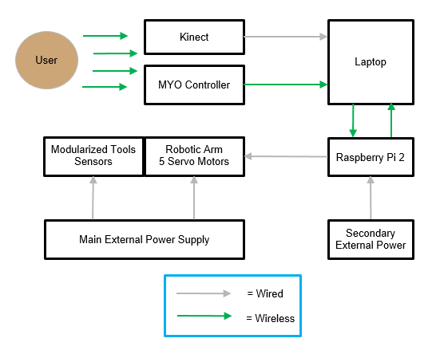

Figure 1.1: System Block Diagram

The primary system can be divided into two separate physical parts. Figure 1.2 shows the annotated parts of the control and power. Figure 1.3 shows the annotated parts of the user and the interface.

Figure 1.2: Annotated Picture - Control and Power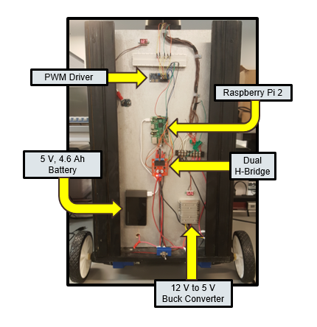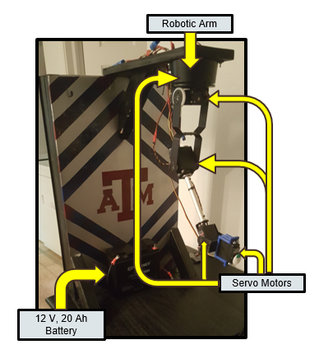

Figure 1.3: Annotated Picture - User Interface

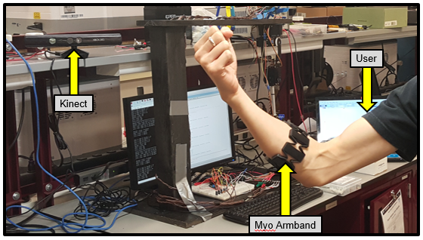

### Background

Keep in mind, the project overview should explain what the overall project will do. Focus on an “end-user” perspective. Who will use it, what is the application, high level goals. Keep this section short but write it so that a reader will understand the who, what, and why of your project. Who will use it, what will it do, why would they use it.

## Final System Design

Present the final status of the system from the top-down viewpoint (big picture) of the design. Discuss the major functional parts/subsystems and major requirements. A block diagram should be included but should not precede text. Remember that all figures/tables must be referenced in the text, as Figure 1.1. Use numbering segmented by chapters for the figures in this document. Large figures may be set on a page by themselves and may be set landscape. Landscape pages should be oriented so the bottom of the content is to the right of the page. References/citations should follow the IEEE format, use of a reference manager is recommended.

The final system design is portrayed by the system block diagram in Figure 1.1. All subsystems have been completed since the midterm and most of the integration was completed. There were only a few software bugs found and is discussed within each subsystem design.

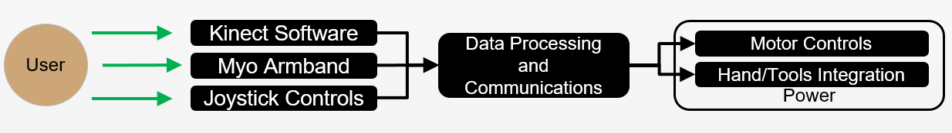

Figure 1.1: System block diagram.

The sketch in Figure 1.2 shows the major components of the system. The major aspect to note is that the user movements and interactions are captured and then are sent wirelessly to the mobile robot.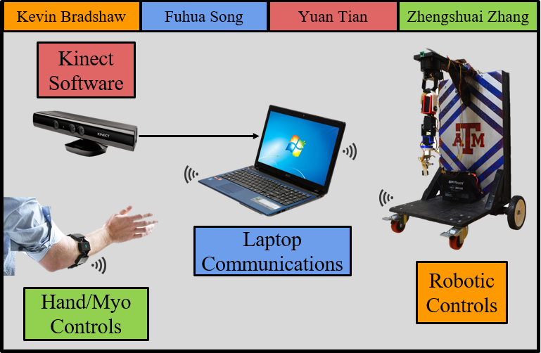

Figure 1.2: Annotated picture of system.

## Project Deliverables

The system delivered will consist of these main goals listed:

1. A robotic arm that correctly mimics user arm movements
2. A GUI that displays user movements, angles, and status of the connection between the control and the user.
3. Communication protocol for the control and interface systems to be linked properly.
4. Software packages with the code necessary to run the entire system.

The major components produced in this project include three software packages. One consists of the Software Development Kit (SDK) provided by Microsoft that is modified with an algorithm which calculates all the angles and vectors needed for the controls. The second is the communication code and instructions that allow for the computer to send the correct data packets to the robotic arm. Lastly, the third consists of the physical mount, power system circuitry, and the control program used for the desired output. The components purchased or borrowed include the Microsoft Kinect with it’s downloaded SDK, the Myo Armband with its downloaded SDK, the Lynxmotion Robotic Arm, Raspberry Pi 2, Adafruit’s PWM Driver with its downloaded functions, a Stepper Motor Driver, Dual H-Bridge, USB Programmable Joystick, and the power supplies. The modification to the codes to enable the combination of all this hardware and software is a significant part of this project. It constitutes the actual movement synchronization with the replicated movement to the robotic arm. The accuracy of the output should be observable with physical movement tests. The overall benefit of this system is the wireless control of a system interface independent of the robotics. This means with a much more refined and financial investment, this machine could be used in areas where high stake situations that require a human’s perspective, instincts, and movements.

### Project Specifications

The following specification for each subsystem is required for later subsystem integration. These are also summarized shown in Table 1.1:

Control Specification

To correctly translate user movement to the robotic movement, the position of the arm control system has to have specific boundaries of position. This is so that each movement looks comparatively similar when later it’s synchronized to the user. When the arm is set to a specific position, the output data displayed must be less than ±10° accuracy for angle inputs. The output data should also be less than ±3-inch radial for each position it’s set to. In combination with this, the overall power consumption to the main external supply is less than 200 Watts for over 1 hour.

Software Specification

In order to correctly interpret user movement, the software system must be able to interpret each position with less than ±10° accuracy for angle inputs. The output data should also be less than ±3-inch radial for each position it’s set to. Filter functions should eliminate data variations so that smooth robotic arm movements can be achieved. In addition, the graphic user interface, which is included in software design, has to provide a easy control on the entire system throughout the sampling and mimicking stages.

Communication Specification

Communication between the various components of the system must be rapid yet secure. The total maximum bit transfer rate from the Raspberry Pi to the computer (largest data package sent) is estimated to be 13.06Mbs with a maximum time estimation of 0.045s assuming the transfer is instantaneous between devices and not accounting for disruptions. For range, the communication between the robotic extension and the laptop must be taken into highest consideration. The range is dependent on wireless range of the router. However, for this application, the range is approximated have at least 10-meter range.

Hand/Tool Specification

The Myo armband should be able to read user’s gestures and rolling orientation data. To close and open the fingers, the stepper motor should be able to rotate in proper direction and degrees as user’s input. The motor rotates in 1.8 degrees per step. The force sensor on the fingertips should be able to detect and show how much force is applied. And the stepper motor rotates continuously until the force’s values reach the designed value. And the servo motor on the wrist should be able to rotate continuously in proper direction and degrees as user’s rolling data.

Table 1.1  
Specification Compliance Matrix

|  |  |  |  |
| --- | --- | --- | --- |
| Specification | Min | Nominal | Max |
| Power: The full power draw of motors and peripherals is less than 30 Watts for over 2.5 hours. | 50 W | 55 W | 65 W |
| Control: Less than ±10° accuracy for angle inputs, ±3 inch radial for position. | ~0 | ±5° | ±10° |
| Communication: The system sends data at a minimum distance of 10 m. | 10 m | 15 m | 20 m |
| Software: The accuracy of software system is less than ±10°. | -10° | 5° | 10° |
| Hand/Tools: The accuracy of the force sensor is less than ±10% | 0 | ±5% | ±10% |

### Project test Validation

In this section, you need to implement all tests plans that verify the project functionalities performances in accordance with the project deliverables. DO NOT be to wordy in this section, think out of the box in terms implementations; for example for analog stuff, you can use circuit test setup to represent the test configurations which with very few steps of explanations the reader can understand the setup.

## Task Ownership

Kevin Bradshaw is responsible for both the power and control subsystem. For the power subsystem, this includes the overall design that ensures each component draws the amount of power needed to run safely under testing conditions. This also includes building the mount and wiring the physical system together. To test, the main battery will be directly monitored continuously for current draw. The second battery will be tested by checking the length of time it can run in normal conditions of operating the control subsystem. For the control subsystem, this includes the proper connection for the Raspberry Pi 2, PWM Driver, and each individual servo motor. This also includes coding on the Pi which enables the proper movement of the arm. Lastly, the position of the arm will be tested by physical observation and position measurement to match the code’s position calculation.

Yuan Tian is responsible for taking the Microsoft Kinect SDK and incorporating it in a GUI designed for this project. This GUI includes the algorithm necessary for calculating the vectors from the skeletal tracking done by the Kinect, then finding the specific angles for each joint compared to a defined origin. These angles are then displayed on the GUI and sent through the Communications subsystem. Yuan Tian is also responsible to design filter functions that can help reduce jitters of the robotic arm movements.

Fuhua Song is responsible for designing the communication protocol between the various components making up the physical system. The physical system consists of the mechanical extension, laptop, Myo gesture controller, joystick, and the Kinect. Between these components, different protocols have to be followed for these components to efficiently send data package between one another. To test the adequacy of the communication protocol between components, the latency of the data packets being transmitted as well as the estimation of the size of future packages had to be determined.

Zhengshuai Zhang is responsible for the hand and tool subsystem. The physical structure of the hand needs to be designed and built. For the control of the hand, the stepper motor is the core. The stepper motor is connected to the Raspberry Pi 2 through a stepper motor driver. The driver is powered by an external power supply, and it draws control information from two GPIO pins on the Raspberry Pi. His responsibility is to write the code that’s programmed on the Raspberry Pi which allows it to be able to control the stepper motor with a user’s input. To control the stepper motor wirelessly, Myo armband is used. Myo reads the gestures and controls the stepper motor with the communication between them both. Writing this code on the Myo SDK is a big part of this subsystem. And he is also responsible for writing code for controlling the servo motor on the wrist by the orientation data from the Myo armband. And the force sensors on the fingertips also need to be set up and his responsibility is to write code on the raspberry pi to read the force value and combine the sensor’s code and stepper motor control’s code together to realize the interruption.

Table 1.2  
Responsibility Matrix

|  |  |  |
| --- | --- | --- |
| Subsystem | Responsible Member | Responsibilities |
| Power | Kevin Bradshaw | Maintain the power subsystem finished last semester for the project. If any extra hardware is necessary in 404, design and build the requirement. Maintain the physical structure. |
| Control | Kevin Bradshaw | Design, build, and calibrate the control requirements to move the robotic arm accordingly. |
| Software | Yuan Tian | Design and build the software requirements needed to interpret the data from the user. Design and build the main user interface. |
| Communication | Fuhua Song | Design and build the communication requirements needed to send and receive the proper data packets through the system. |
| Hand | Zhengshuai Zhang | Build the physical structure of the hand. Control the hand and wrist wirelessly through MYO armband. Set up force sensors and design tools for the hand to grab and use. |

## ABET Constraints

### Safety

The project is designed and built under the ABET constraints. The voltages and currents are designed under the limits to make sure the safety is up to speed. The power cables are sized adequately to handle the power load. Since the components of the robotic arm vehicle are low powered, there wasn’t much safety concerns that had to be taken into consideration .

### Environmental

The materials used in this project environmental-friendly. All of the components used on the vehicle can be recycled for example the battery and the parts such as the plastic wheels and whatnot. Furthermore, the vehicle is electrically powered thus the energy source is environmentally friendly. There’s no output such as CO2, etc.

### Economic

The component of the vehicle is very cheap. For example, the frame is made and constructed with wood which is not only cost efficient but very sturdy. Furthermore, the wheels are controlled with recycled DC motors extracted from drills.

### Ethical

This vehicle has the potential to save lives in the future. Since the goal is for this vehicle to be a bomb disposal robot, we expect this to have a very bright future.

### Manufacturability

The project is a prove of concept. The physical structure of the vehicle and the development methods of the project is not standardized. Thus, the design cannot be replicated easily, and is not suitable for mass production. To achieve desired manufacturability, numerous modifications have to be done to the primitive design before the introduction to the industry.

## Project Timeline

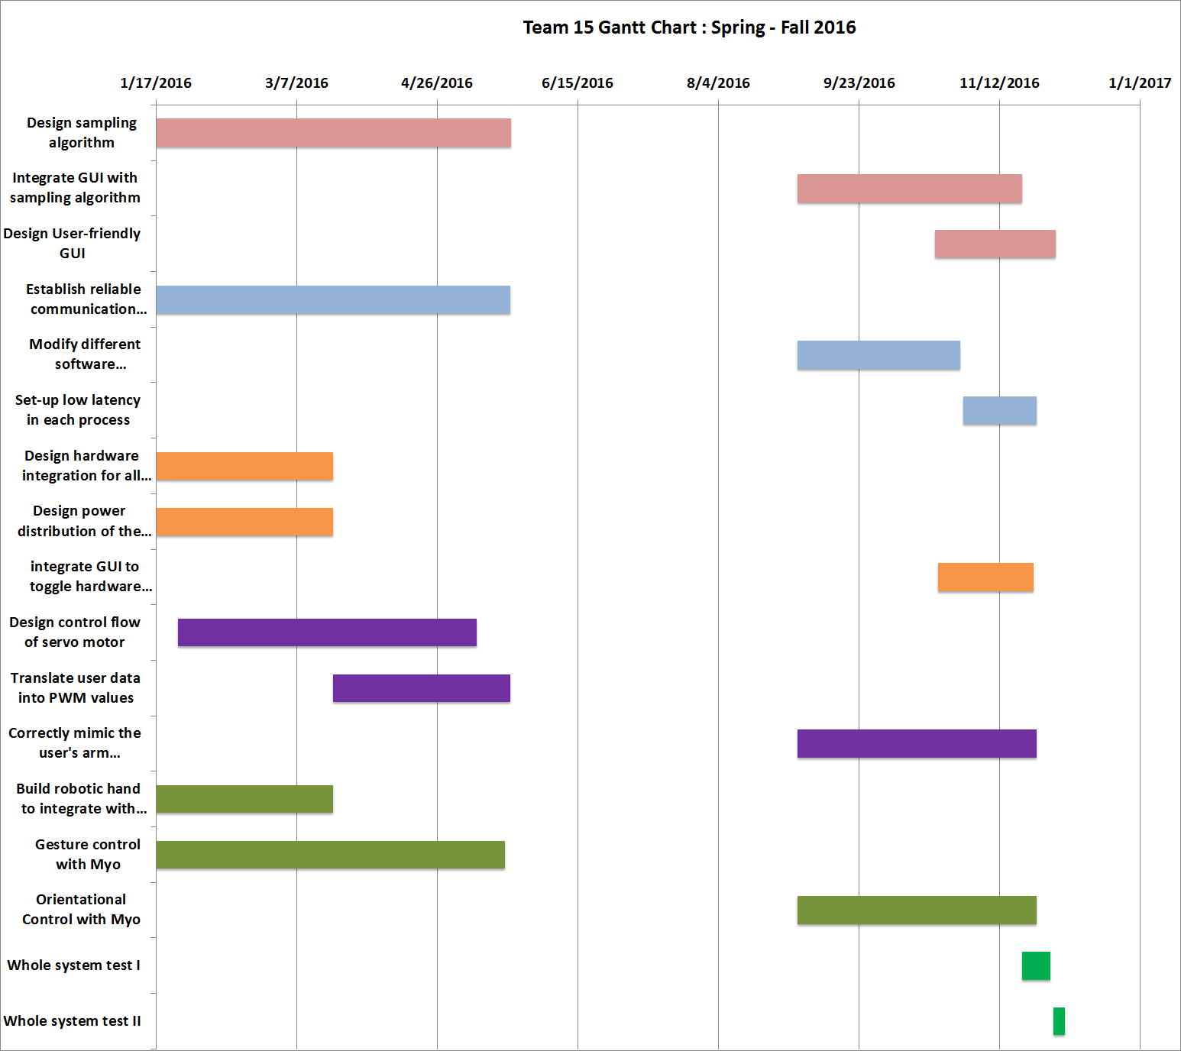

# Final System Status

The final system contained all four integrated subsystems, and two tests were conducted to obtain the accuracy and the latency of the entire system.

## Final System Performance

The purpose of this test is to clearly define the accuracy of positions from the user to the robotic arm. The first test conducted contained a comparison between each joint on the user to the robotic arm but then it was realized since inverse kinematics was used, only the endpoint of the wrist of the user should be compared to the robotic arm.

#### Test Setup

After the robot was turned on, the user calibrated the Kinect to their arm length and positioning data was obtained. First the sampling algorithm was paused at a certain position, the user’s wrist end point was measured as well as the robotic arm. The end point was measured by a protractor for the two angles depicted in Figure 2.1.

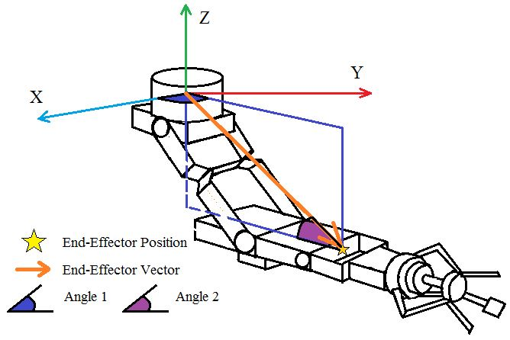

#### Figure 2.1: End Point Angles Measured

#### Data

Table 2.1 shows the angles measured for both the user and the robot for 4 tests that depict the end ranges of motion as well as positions where the arm is in front of itself. The largest degree of error measured was approximately 15 degrees but varied mainly between 5 to 10 degrees.

Table 2.1: Position Tests 1 through 4

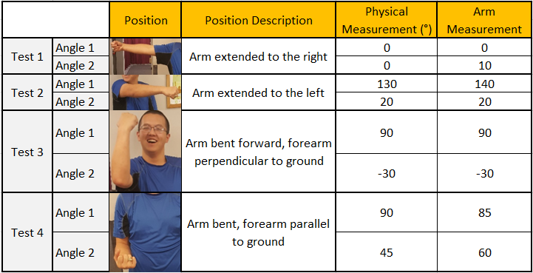

Table 2.2 shows the angles measured for 4 other tests where the arm was either in front of the body or in front of nothing. The largest degree of error measured was approximately 25 degrees but also mainly varied around 10 degrees.

Table 2.2: Position Tests 5 - 8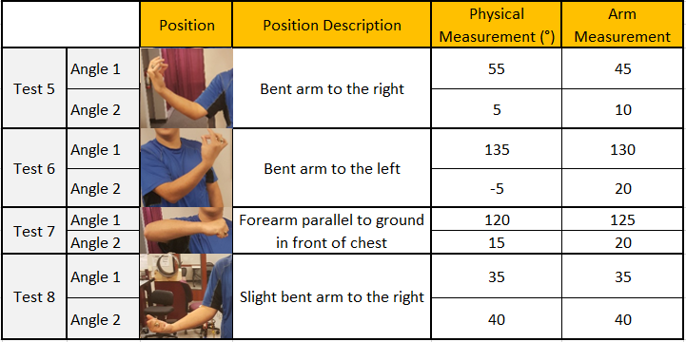

#### 

#### Test Conclusion

The specification for accuracy was ten degrees for every angle measured to compare in between each subsystem. This means ten degree difference from the user to what the kinect measured and ten degree difference from the kinect to measured to the controlled output. All positions passed except for Test 6 which fails this overall twenty degree difference for the system (where the arm is bent directly in front of the body). The time was recorded for the largest sweeps and the longest latency measured from the movement to the user all the way to the output of the robotic arm was approximately half a second.

## Final System Standards and Constraints

## System Constraints: Must be within a wireless connection that both the laptop and the robot can connect to. Packets of data will be streamed constantly from either the laptop to the robot or vice versa and the recipient of the data would receive it. If packets are not received, it will not be retransmitted.

Operational Temperature: -10° C to 50° C (14°F to 122°F).

Budget: $500.

Operational Terrain: Flat plane without any projections.

Charge Power Supply: Must not run under full load for over one hour and fifteen minutes.

System Latency: For observable robotic movements, must not have an overall system latency greater than 1 second for each component.

please add any more constraints you guys can think of

## System Performance Improvements

The major changes made was the mobility of the robot. Since it was it’s own unit, the driving capability of the vehicle was added. Since this was added and the actual process contained large amounts of data packets being sent continuously, it limited the allowable connection strength. The connection should be strong enough to hold at least three processes from the four in order to have complete mobility, arm movements, or video streaming. Another major change was the length of the robotic arm and some of the mechanical pieces that had to be changed because of the motor changes. This was due to the fact that there wasn’t enough torque on the shoulder motor to lift the weight of the hand after it was integrated. Along with changing mechanical pieces of the arm, the stepper motor was reduced to a smaller one for the clamp. After all these changes and calibration, the arm was able to lift the clamp. The trade off with a smaller stepper was that it had much smaller torque and we lost a lot of gripping capability because of that.

The main software changes included the change from memory sharing to data dumping into a common file. This was because the first method was too complicated for barely any difference in latency between data point measurements. This change helped complete the integration stage and we were able to run calibration tests on the entire system. The last major change included the switch from typical angle calculations of the skeleton to 2D inverse kinematics. This was due to the limitation of the degree of freedom for the elbow. Since the elbow on the robotic arm only moves in one direction, the end-point positioning was used to calculate angles to place the arm for any position where the end point was seen by the Kinect. This did away with the random angle outputs from the Kinect because of unidentified user positions.

# Control Subsystem - Kevin Bradshaw

Currently, the robotic arm can be tested for independent movement and position. Each motor was tested to find minimum and maximum pulse lengths that control the motors in respect to positions of a human arm. These ranges are pulses out of 4096 because of the specific PWM Driver being used has a 12-bit resolution. A physical origin defined by a PWM signal can also be set to calibrate to the user. This origin signal is the pulse length that needs to be set for the motors to move the robotic arm to a relaxed hanging position to match that of the users. The result for ECEN 404 will be to have approximately ±10° accuracy, (±3-inch radial offset) movement according to the user’s position for any given position. Figure 3.1 shows the flowchart for Mode 1 written in the code. This code enables the user to control the arm with keyboard inputs for each individual motor direction. Figure 3.2 shows the flowchart for Mode 2 written in the code. This code enables the user to input particular angles and the robotic arm will be set to that position. This mode will be integrated to correspond with the Kinect’s continuous angle output data.

Figure 3.1: Mode 1 Flow Chart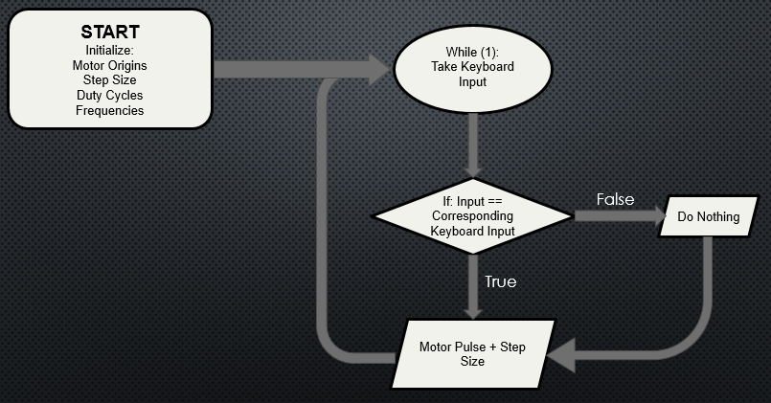

Figure 3.2 Mode 2 Flow Chart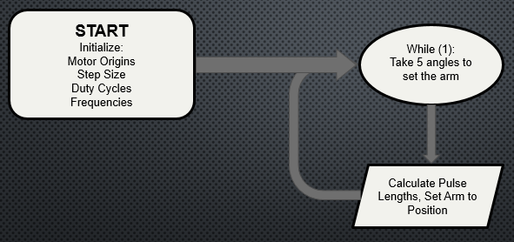

## Significant Changes in Direction

Although tests were accurate last semester for the robotic arm, the addition of the hand was too heavy and certain positions were no longer able to be set. The main changes to this subsystem were mechanical constraints because the elbow and wrist motors were not providing sufficient torque to . One extra servo motor was purchased (HS-805BB) because it has the same torque requirements and power draw of the second shoulder motor. The servo that was previously used on the elbow joint is now being used as the wrist motor. New brackets had to be 3D printed and fitted onto the arm for proper support. With these modifications, the positioning tests were much more accurate.

The second main modification from last semester is the mobility of the robot. Last semester, the robot wasn’t going to be mobile at all but since the Conceptual Design Review (CDR), we’ve been able to implement mechanical support, build electrical connections, and program motor calibration to make the robot move around wirelessly using cheap, high torque brushed DC motors. The power calculations and tests were done for this at the beginning of the semester for the CDR.

## Subsystem Status

This semester, there has been much progress for the mechanical, hardware, and software parts of this subsystem. First being the physical mount, mechanical structure of the arm, hardware configuration, and the addition of wheels. Figure 3.3.1 shows the physical mount and configuration of the systems used at the end of last semester. Figure 3.3.2 shows the current configuration of the project. Currently the mechanical aspects in progress include 3D printing another motor bracket in more durable material and a PCB mounted on the back panel of the robot.

Figure 3.3.1: ECEN 403 Final Configuration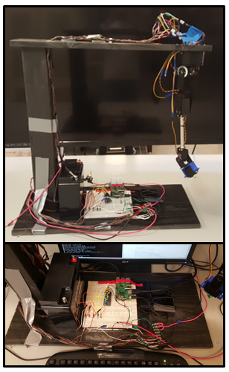

Figure 3.3.2 ECEN 404 Current Configuration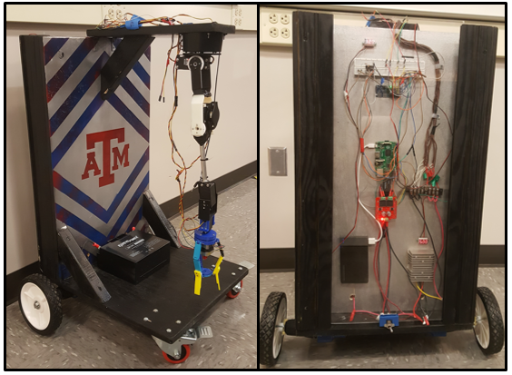

The shoulder motor is swept through its range, then the elbow motor is swept through its range within the shoulder motor sweep, then the wrist motor is swept through its range within the elbow motor sweep that’s within the shoulder motor sweep. This creates a range of validating which positions are too inaccurate and need to be calibrated with an duty cycle that’s offset depending on the other motors current duty cycle. The hand attachment has been the most difficult part to calibrate too because of the weight of it compared to the other parts of the arm. We were able to finish the mechanical parts needed and test user movements for the entire robotic arm.

Currently we have the wheel motors fully integrated with joystick controls to wireless data communication to the robot. The current joystick variation includes three different set speeds according to the different analog values of the joystick in an X-Y coordinate system. The three speeds are set at 5%, 8%, and 12%.

Table 3.1  
Control Subsystem specification Compliance Matrix

|  |  |  |  |
| --- | --- | --- | --- |
| Specification | Min | Nominal | Max |
| Control: Less than ±10° accuracy for angle inputs, ±3-inch radial for position. | ~0 | ±5° | ±10° |

## Subsystem Challenges and Solutions

The main subsystem challenge was the integration with the clamp because of the weight of the entire part. The shoulder motor that provides forward and backward movement has an approximate torque of 1.6-foot pounds. With the original clamp and metal parts

## Subsystem Technical Details

The angles from the Software Subsystem follow the constraints of the human arm which mean that the mechanical arm must have similar constraints. Table 3.5.1 shows the range of motion for each motion, along with it’s defined origin, according to its physical location on the mount.

Table 3.5.1: Range of Motion Coordinate Mapping

|  |  |  |  |
| --- | --- | --- | --- |
| **Motor** | **Coordinate Mapping** | **Range of Motion** | **Defined Origin** |
| Shoulder Motor 1 | X-Y | 0 ~ 180° | 90° |
| Shoulder Motor 2 | Y-Z | 0 ~ 135° | 90° |
| Elbow Motor | Y-Z | 0 ~ 135° | 0° |
| Wrist Motor 1 | X-Z | 0 ~ 180° | 90° |
| Wrist Motor 2 | Y-Z | 0 ~ 180° | 90° |

The continuously changing angle from the Software Subsystem is sent to the Raspberry Pi and this is matched to the approximate angle that the robotic arm can be set. There are two modes of operation designed for this subsystem. The first being keyboard input which has five if statements controlling each motor. Each branch is similarly calculated and set. Looking at one block individually, an if statement looks at a character being pressed. If that character is being pressed, it gets set in a while loop so that the user can continuously press that character and continue to rotate the motor. Code 3.1 shows this implementation.

Code 3.1: Keyboard Input Implementation

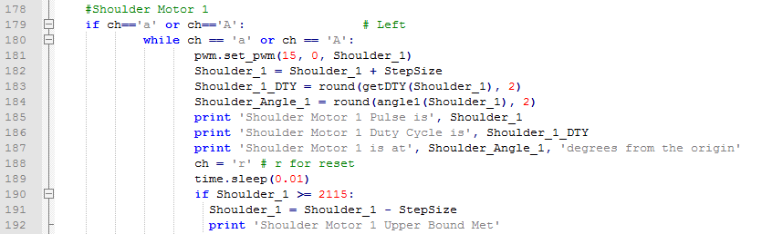

In the while loop, the pulse variable called *Shoulder_1* is incremented by a variable named *StepSize* that is also defined in the code. This step size corresponds to how many pulses increase or decrease while the input is being pressed. The pulse is then put in a defined function called *getDTY( )* which defines the duty cycle of each PWM signal. Equation 3.1 shows this calculation.

Duty Cycle = (Pulse Length) / 4096 (3.1)

This outcome is later displayed to the user through the terminal window. The same original variable that contained the pulse variable is then put in another function called *getangle1( )* which defines an angle mapped to the pulse range based on Equation 3.2.

Angle = [(Pulse - Minimum Pulse) / (Maximum Pulse - Minimum Pulse)] * 180 (3.2)

This angle calculation is then displayed to the user through the terminal window. Lastly another if statement is employed by checking if the pulse maximum is met. This same procedure is used for each letter. The only differences that arise are for the letters that correspond to the opposite movement, which decrement the step size in every loop. The second mode of operation takes in five angles corresponding for each motor. This mode is having ranges built in for each motor which is dependent on the calibration done in mode 1. The angle for each motor is mapped to a duty cycle pertaining to a motor which would follow Equation 3.1.

Pulse = [(Angle / 180) * (Maximum Pulse - Minimum Pulse)] + Minimum Pulse (3.3)

This pulse is then directly used in driving the PWM signal for each motor. This requires knowing the minimum and maximum pulses for each motor that correspond with the range of motion required for that motor. Code 3.2 shows this implementation

Code 3.2: Pulse Calculation Implementation

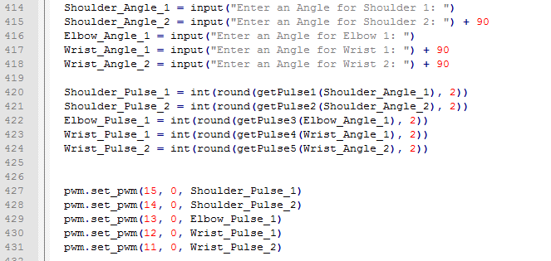

The current software modification to allow for increased duty cycles for positions that require the motors to have larger torque is implemented using three different functions. Each function is an angle correction that takes in the three motors that have the largest torque variations: Shoulder 2, Elbow, and Wrist 1. For the wrist motor, the angle corrections only occur when the elbow is at approximately 45 degrees (from its respective origin) while the shoulder is at 45 as well (from its respective origin). This is then given a plus or minus 10 degrees offset to allow for positions close to that will also be corrected. This angle correction varies from around 20 degrees. In the same way, the elbow and shoulder motors are angle corrected for positions that require more torque. Table 3.5.2 shows a summary of what the constraints are as well as what the offset is for each function.

Table 3.5.2: Angle Correction Functions Summary

|  |  |  |  |  |
| --- | --- | --- | --- | --- |
|  | **Critical Angle** | **Ranges of Correction** | **Dependent Variables** | **Degrees Offset in Correction** |
| **Wrist Angle Correction Constraint 1** | 45° | 35° - 55° | Shoulder: 125° - 145°  Elbow: 35° - 55° | 20° |
| **Wrist Angle Correction Constraint 2** | 45° | 40° - 50° | Shoulder: 40° - 50°  Elbow: 40° - 50° | 10° |
| **Elbow Angle Correction Constraint 1** | 45° | 35° - 55° | Shoulder: 35° - 55°  Wrist: 75° - 115° | 20° |
| **Elbow Angle Correction Constraint 2** | 0° | 0° - 25° | Shoulder: 80° - 100°  Wrist: 0° - 25° | 25° |
| **Shoulder Angle Correction Constraint 1** | 90° | 85° - 95° | Elbow: 75° -105° | 10° |
| **Shoulder Angle Correction Constraint 2** | 45° | 30° - 60° | Elbow: 35°- 55°  Wrist: 45° - 135° | 30° |
| **Shoulder Angle Correction Constraint 2** | 180° | 180° | Elbow: 0° - 55°  Wrist: 0° - 55° | 20° |

The reason why the software modification is being implemented is because a hardware modification was going to be implemented but every test for it failed. The hardware modification consisted of an ADC and a current sensor to create a feedback loop. The idea was that the positions with large torque would draw more current and the feedback sent to the controller would be adjusted by comparing to a reference. Every test completed proved to be way too inaccurate for this and the design was scrapped. The ADC component and connections for it were kept and implemented in part of an integration plan with the Hand/Integration Subsystem. There have been some issues regarding the software modification, mainly due to the hard-set lines of angle correction and further testing is required to implement different angle corrections depending on the degrees away from each critical angle.

The data from the Joystick connected to the laptop carried by the Communication Subsystem will be utilized to drive the motors on the robot. In the socket communication, an array of two variables is sent, where the first element is always according to the x-axis of the joystick, and the second element is always according to the y-axis. These values build a coordinate plane with ranges in between -1 and 1 for each axis. In the current implementation on the controls side, the representation in Figure 3.4.1 shows the variation in analog values given through the joystick in a coordinate plane. The origin corresponds from -0.25 to 0.25 on each axis for no movement of the motors. The yellow represent the initial speed, orange represents increased speed as the values increase, and red represents the maximum speed. The joystick analog values are currently divided into these three different speeds because the joystick is very sensitive, it has a 16-bit resolution, and the speed calculations for the PWM Calculation function from Yuan Tian was not fully integrated. This was because it was way too sensitive when tested for physical movement.

Figure 3.5.1: Speed Variations Based on Joystick Values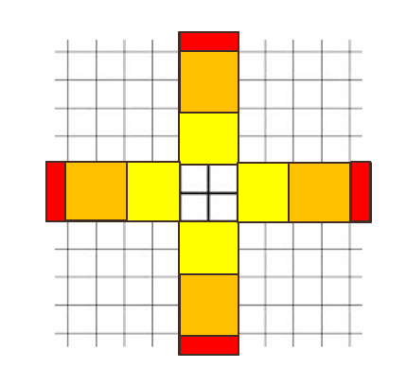

In the definition of the motor movement, three different values are defined for the three speeds of analog values given by the joystick. The speed of each motor versus the duty cycle of the PWM signal sent to each motor was used to determine calibration output. the output to the motors is PWM signals that are similar in RPM for both motors, and this controls each direction of the robot.

Lastly, to implement all the different processes on the Raspberry Pi, a GUI was created to toggle between all the processes. This GUI was saved as main.py in the folder called ‘MAIN’ on the Raspberry Pi. It was organized such that the ‘MAIN’ folder contained all the python files that run the entire system. The main.py file just opens the GUI which calls all the other processes as a subprocess. This GUI is portrayed in Figure 3.5.2.

Figure 3.5.2: Main.py GUI Display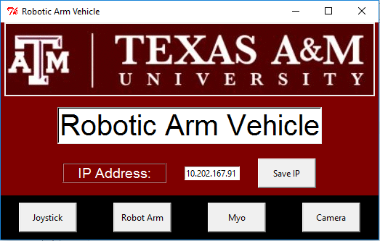

## Subsystem Testing

The first mode of operation for the code was tested by measuring the pulses for each physical angle range of the robotic arm. The code was run, and each motor was moved to its minimum, middle, and maximum positions defined and the pulse measurements were recorded.

### 3.6.1 Mode 1 Operation Testing - Keyboard Movement

The purpose of this test is to clearly define the ranges of pulses that the robotic arm can move in that it matches the movement of a human arm. This test passes if each pulse range can clearly be defined in between the resolution of the PWM driver (12 bits, 4096 pulses). This test was done three different times to get the most precise pulse ranges to clearly define what the range of motion for the robotic arm should be. Each position can also be physically seen in the Power Subsystem testing section.

#### Test Setup

The power supply was set to 5V connected to only the motors. The corresponding decrementing keyboard input was pressed until the motor moved to the minimum position that was measured to be the angle range minimum. The same was done for the incrementing keyboard input to the measured angle range maximum. The pulse minimum was subtracted from the maximum and that value was divided by two and added back to the minimum pulse. This was set to be the middle pulse and then compared visually to the middle angle for each position. Lastly, the step size for each was set to 5 pulses and the angles for the first three tests were approximated in the essence of time.

#### Data

Since ECEN 403, the hardware configuration has only changed once and the output has hence stayed the same after change. This means the motors only needed to be calibrated once, every test afterwards is approximately the same. The results from this test are shown in Table 3.6.1. There was only one direct connection at one time for each motor which included the power, signal, and ground.

Table 3.6.1: Motor Positions - Pulse Test 1

|  |  |  |
| --- | --- | --- |
| Motor | Minimum Position  (Out of 4096) | Maximum Position  (Out of 4096) |
| Shoulder Motor 1 | 485 | 2025 |
| Shoulder Motor 2 | 540 | 1880 |
| Elbow Motor 1 | 800 | 1520 |
| Wrist Motor 1 | 520 | 2040 |
| Wrist Motor 2 | 400 | 2100 |

#### Test Conclusion

Using Equation 3.1 and the pulses that were recorded in Table 3.6.1, the duty cycles for each position was calculated and they are shown in Table 3.6.2. The pulses and duty cycles obtained show that the tests pass for being able to find definite ranges for each in order to map to physical ranges of motion. The high frequency noise observed by the servo chatter was very unexpected but there are physical ways to fix this while still keeping the same configuration for the loads. The PWM signals themselves may be separated if the servo chatter still does not seem to be reduced (keeping in mind that it also is partially affected by motor torque requirements).

Table 3.6.2: Motor Positions - Refined Test 3 Duty Cycles

|  |  |  |
| --- | --- | --- |
| Motor | Minimum Position  (Out of 4096) | Maximum Position  (Out of 4096) |
| Shoulder Motor 1 | 11.87 % | 49.44 % |
| Shoulder Motor 2 | 13.18 % | 45.90 % |
| Elbow Motor 1 | 19.53 % | 37.11 % |
| Wrist Motor 1 | 12.70 % | 49.80 % |
| Wrist Motor 2 | 9.77 % | 51.27 % |

### 3.6.2 Mode 2 Operation Testing - Angle Inputs

The purpose of this test is to see how accurate the positioning of the robotic arm is if the user inputs the angles for each motor directly. The test passes if each motor can accurately be placed in the position set by the user. This position is entirely set on the angles defined according to the origin.

#### Test Setup

Each motor was powered through the terminal block together. Six random user positions were tested. Each position consisted of five different angles. Each physical angle measured was measured from the respective origins of the motors and was approximated.

#### Data

Table 3.6.3 shows the corresponding angles tested and the physical angles measured for the first test. Figure 3.6.1 shows the position of the robotic arm for those inputs. This is compared to the same test done in ECEN 403. Note that this test now also has the mechanical clamp design attached to it. This position corresponds to the origin position defined in the initialization of the code.

Table 3.6.3: Angle Inputs - Test 1

|  |  |  |  |
| --- | --- | --- | --- |
| Motor | Angle Set | Angle Measured 403 | Angle Measured 404 |
| Shoulder Motor 1 | 90° | 95° | 90° |
| Shoulder Motor 2 | 0° | 0° | 0° |
| Elbow Motor 1 | 0° | 0° | 5° |
| Wrist Motor 1 | 0° | 0° | 0° |
| Wrist Motor 2 | 0° | 0° | 0° |

Figure 3.6.1: Angle Test 1, ECEN 403 Vs. ECEN 404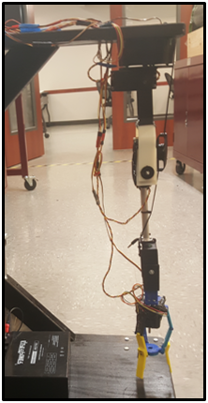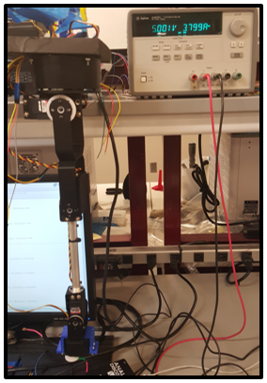

Table 3.6.4 shows the corresponding angles tested and the physical angles measured for the second test. Figure 3.6.2 shows the position of the robotic arm for those inputs. This position corresponds to having the elbow pointed directly out, parallel with the ground and the forearm being perpendicular to the ground.

Table 3.6.4: Angle Inputs Test 2, ECEN 403 Vs. ECEN 404

|  |  |  |  |
| --- | --- | --- | --- |
| Motor | Angle Set | Angle Measured 403 | Angle Measured 404 |
| Shoulder Motor 1 | 90° | 95° | 90° |
| Shoulder Motor 2 | 90° | 93° | 85° |
| Elbow Motor 1 | 90° | 95° | 90° |
| Wrist Motor 1 | 0° | 3° | 0° |
| Wrist Motor 2 | 0° | 3° | 0° |

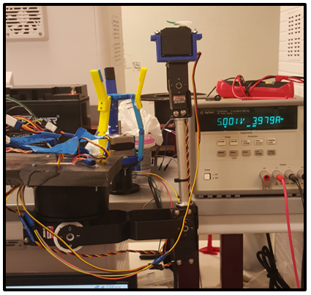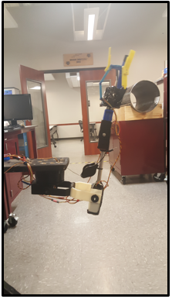

Figure 3.6.2 Angle Test 2, ECEN 403 Vs. ECEN 404

Table 3.6.5 shows the corresponding angles tested and the physical angles measured for the third test. Figure 3.6.3 shows the position of the robotic arm for those inputs. This position corresponds to having the upper arm extended out with the forearm parallel with the ground. This was the first test where the torque capabilities were noticed in ECEN 403 because the elbow motor couldn’t supply continuous torque to move to that position without a little help from the user moving it there.

Table 3.6.5: Angle Inputs Test 3, ECEN 403 Vs. ECEN 404

|  |  |  |  |
| --- | --- | --- | --- |
| Motor | Angle Set | Angle Measured 403 | Angle Measured 404 |
| Shoulder Motor 1 | 90° | 95° | 90° |
| Shoulder Motor 2 | 45° | 35° | 35° |
| Elbow Motor 1 | 45° | 25° | 30° |
| Wrist Motor 1 | 90 || 22.5° | 90° | 20° |
| Wrist Motor 2 | 90° | 90° | 90° |

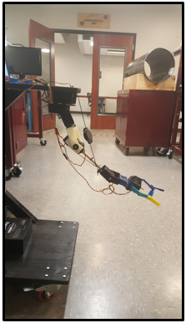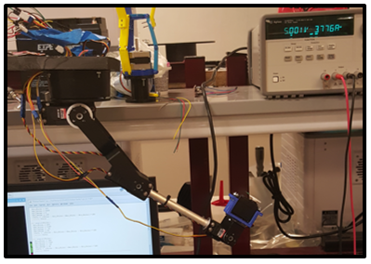

Figure 3.6.3 Angle Test 3, ECEN 403 Vs. ECEN 404

Table 3.6.6 shows the corresponding angles tested and the physical angles measured for the fourth test. Figure 3.6.4 shows the position of the robotic arm for those inputs. This position corresponds to having the arm sticking out as if it were flexing but forward. Compared to the last test, it was expected to not be that accurate, but this was much closer to the values put into the terminal window.

Table 3.6.6: Angle Inputs Test 4, ECEN 403 Vs. ECEN 404

|  |  |  |  |
| --- | --- | --- | --- |
| Motor | Angle Set | Angle Measured 403 | Angle Measured 404 |
| Shoulder Motor 1 | 90° | 95° | 90° |
| Shoulder Motor 2 | 45° | 45° | 30° |
| Elbow Motor 1 | 112.5° | 115° | 105° |
| Wrist Motor 1 | 0° | 2° | 5° |
| Wrist Motor 2 | 45° | 43° | 90° |

Figure 3.6.4: Angle Test 4, ECEN 403 Vs. ECEN 404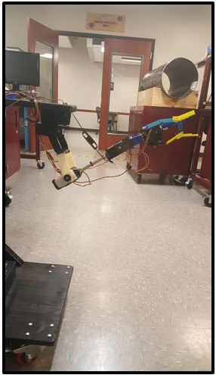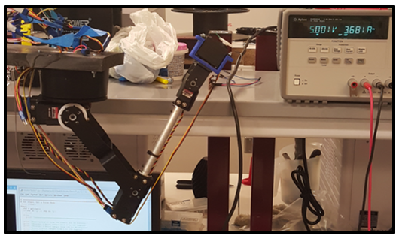

Table 3.6.7 shows the corresponding angles tested and the physical angles measured for the fifth test. Figure 3.6.5 shows the position of the robotic arm for those inputs. This position corresponds to having the elbow coming inwards while lifting the forearm close to being parallel but not exactly.

Table 3.6.7: Angle Inputs Test 5, ECEN 403 Vs. ECEN 404

|  |  |  |  |
| --- | --- | --- | --- |
| Motor | Angle Set | Angle Measured 403 | Angle Measured 404 |
| Shoulder Motor 1 | 90° | 90° | 90° |
| Shoulder Motor 2 | -45° | -37° | -55° |
| Elbow Motor 1 | 90° | 100° | 95° |
| Wrist Motor 1 | 0° | 0° | 0° |
| Wrist Motor 2 | 90° | 90° | 90° |

Figure 3.6.5: Angle Test 5, ECEN 403 Vs. ECEN 404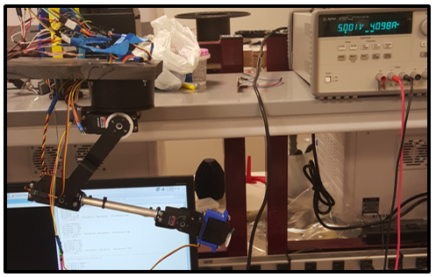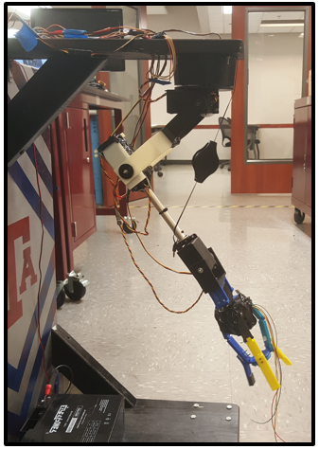

Table 3.6.8 shows the corresponding angles tested and the physical angles measured for the sixth test. Figure 3.6.6 shows the position of the robotic arm for those inputs. This position corresponds to having the arm sticking out as if it were flexing but slanted outwards instead of forward.

Table 3.6.8: Angle Inputs Test 6, ECEN 403 Vs. ECEN 404

|  |  |  |  |
| --- | --- | --- | --- |
| Motor | Angle Set | Angle Measured 403 | Angle Measured 404 |
| Shoulder Motor 1 | 45° | 45° | 45° |
| Shoulder Motor 2 | 45° | 40° | 35° |
| Elbow Motor 1 | 115° | 115° | 110° |
| Wrist Motor 1 | 45° | 45° | 45° |
| Wrist Motor 2 | 0° | 0° | 0° |

Figure 3.6.6: Angle Test 6 -ECEN 403 Vs. ECEN 404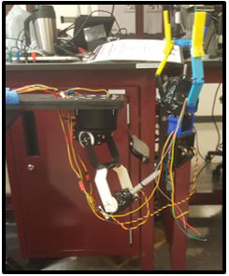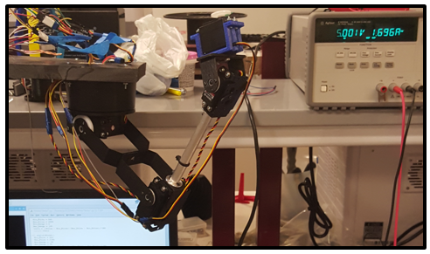

#### Test Conclusion

Overall the subsystem passed but there were several positions where the motors were too needed help getting to that position so the spring/pulley was added, especially for Test 3. This shows that further calibration needs to be done for the software modification. This calibration must also take into account the torque on heavy load conditions. This also showed us that the elbow modified with the larger motor that has a larger torque rating helped for lifting the weight of the hand. Lastly, the torque characteristics for each motor were a bit unexpected, just like last semester, which showed that the duty cycle for servo motor mapping to angles isn’t exactly a one to one relationship.

### 3.6.3 Mobile Testing - Joystick Movement

The purpose of this test is to clearly define the range of motion while the robot is driving. This is so that the user will have full accurate control of the robot while moving it at any desired speed designated by the user. Although this test was not necessary for the specifications of the robot, it was still conducted to test the full mobility of the robot.

#### Test Setup

The power supply (12V) was connected to only the wheel motors. The Robotic Arm Vehicle was placed in a 10 ft. by 3 ft. rectangle and was driven forward and backward to test if we could accurately move it within the given constraint at the operational speeds programmed to the analog joystick.

#### Data

Since ECEN 403, this hardware has become mobile hence, this is the first round of calibrated tests. Table 3.6.9 shows the speeds tested and if it was able to stay within the given constraint. Figure 3.6.7 shows the test setup, the initial position, and the final position.

Table 3.6.9: Motor Positions - Pulse Test 1

|  |  |
| --- | --- |
| Motor | Stayed Within 10 ft x 3 ft Box |
| PWM = 5 % | Yes |
| PWM = 10 % | Yes |
| PWM = 15 % | Yes |

Figure 2.5.7: Test Setup (Left), Initial Position (Middle), Final Position (Right)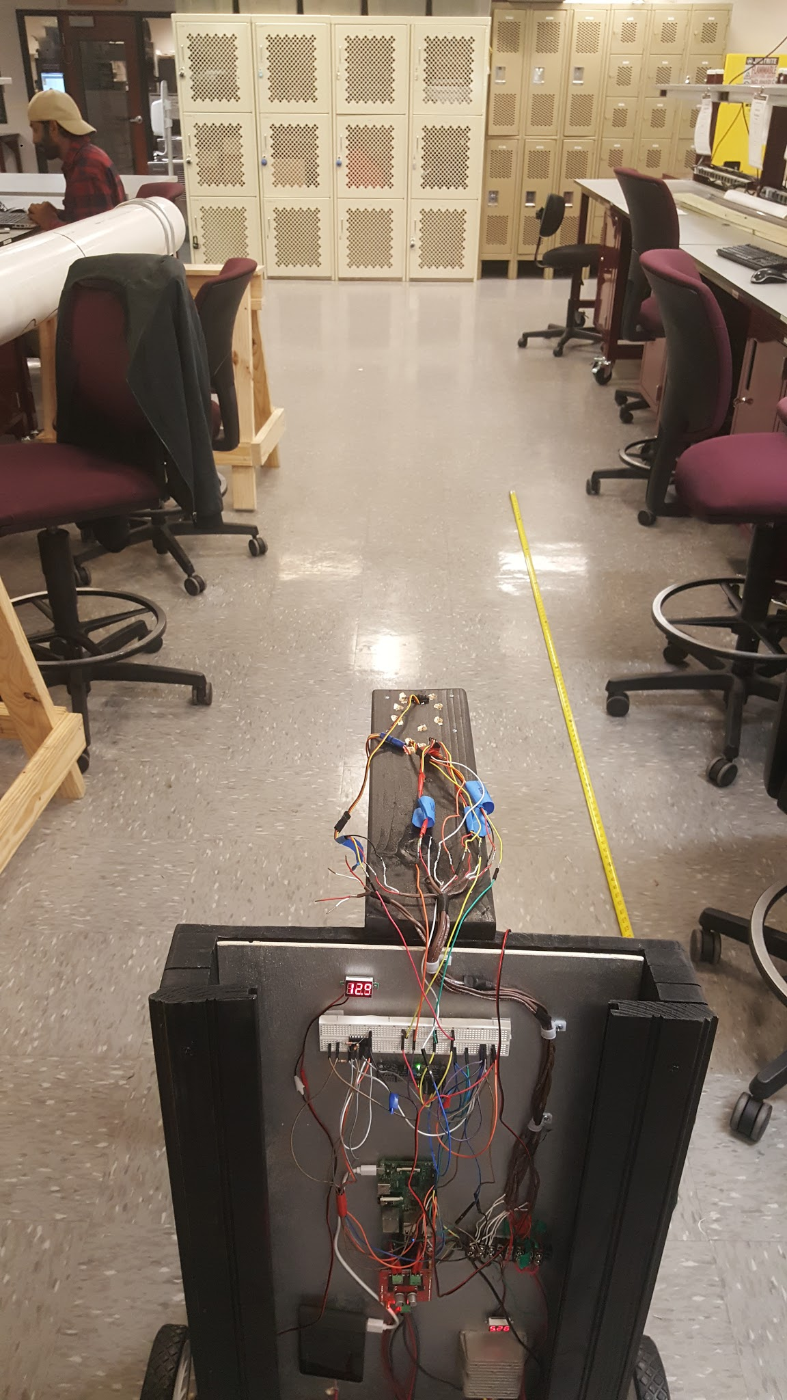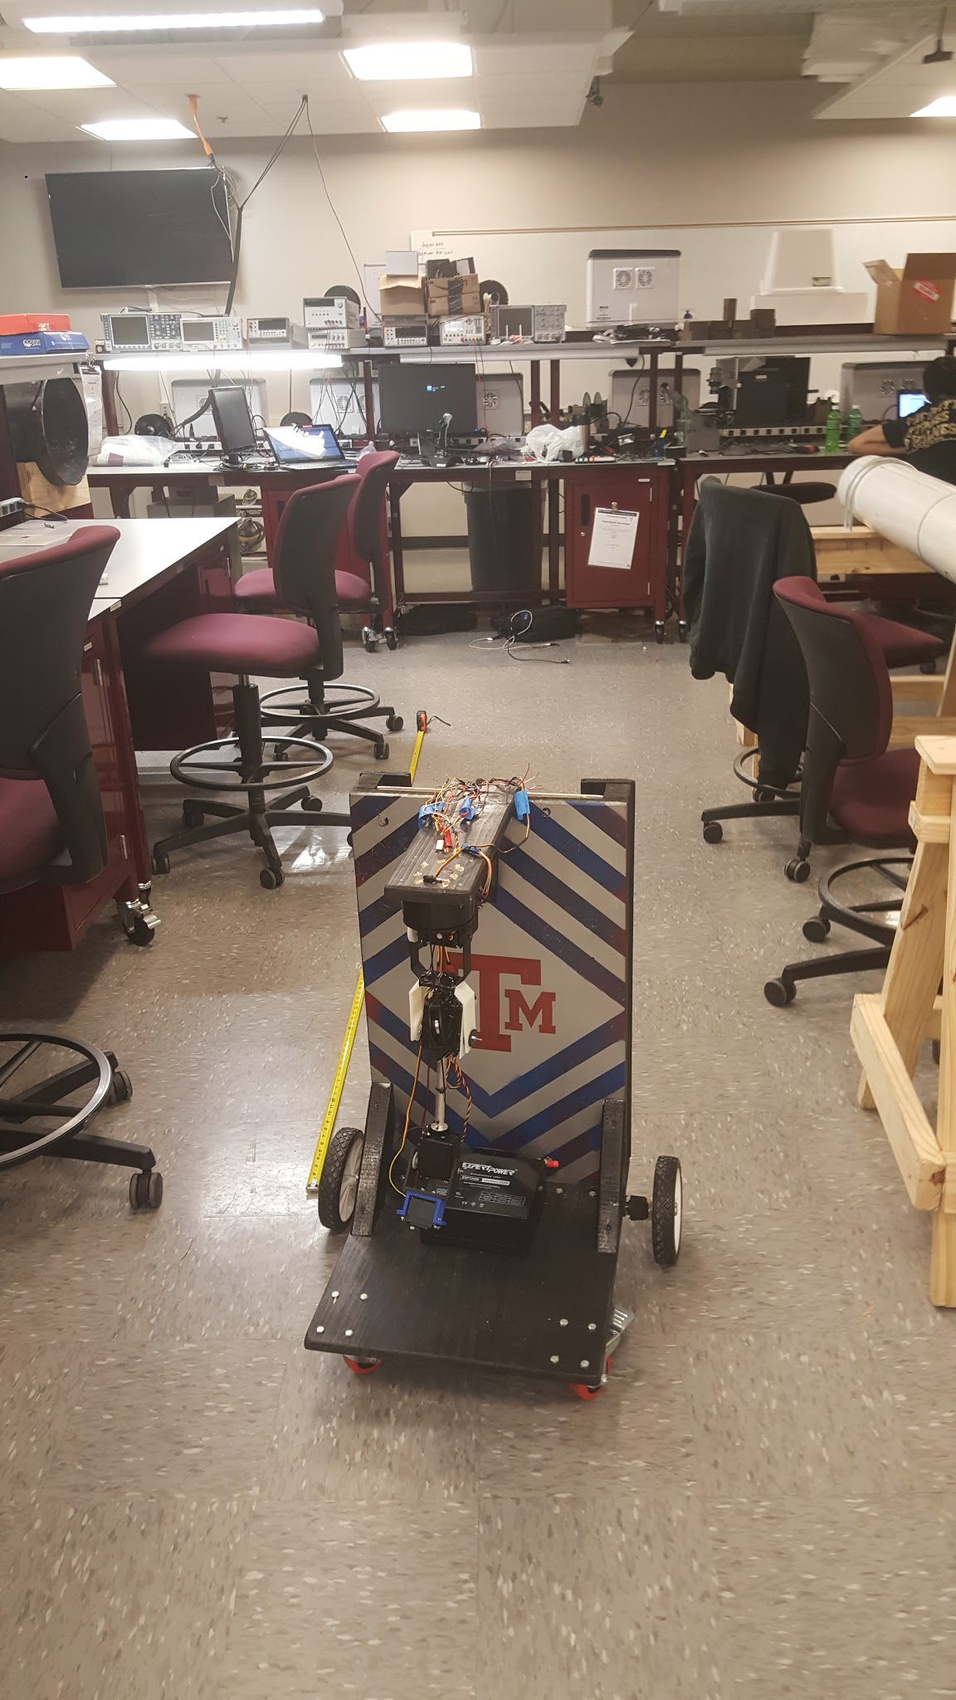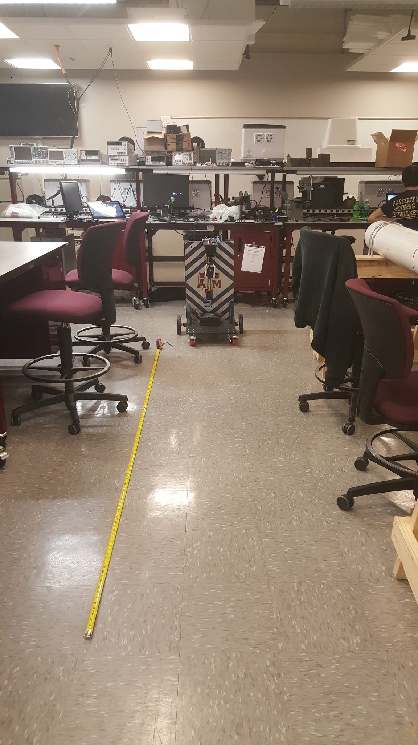

#### Test Conclusion

This test shows that the joystick was able to be programmed accurately to the motor output of the wheels of the robot. It also showed that we can now wirelessly control the robot by sending just an array of two floats.

# Communications Subsystem - Fuhua Song

Communication is fundamental to the integration of all the various subsystems. There are multiple networks as and different platforms that the various components communicate and send data to each other. The primary objective of this subsystem is to allow for the smooth transportation of data packages between the Raspberry Pi, computer, Kinect, Myo, etc. Below is a general block diagram of the communication network interface of the physical system.

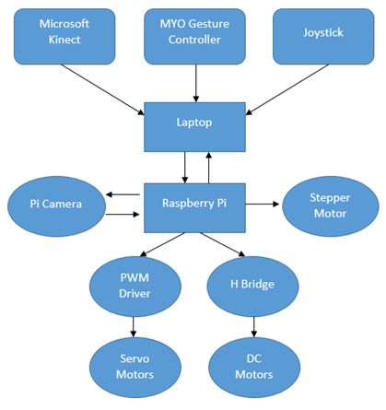

Figure 4.1 (Flowchart)

## 4.1 Significant Changes in Direction

There have been significant amount of changes in the direction of this subsystem since the last semester. Due to latency issues and other miscellaneous obstacles, different path had to be taken in order to implement certain functions.

**Kinect System to the Robotic Hand**

From the Kinect System from the robotic hand, socket communication has been adopted and implemented as the primary method of communication. Originally, the method that was planned was using external 3rd DNS server to transport data and information. However, the latency for that method was too high and was very problematic and inefficient to stream live data. Furthermore, there was significant difficulties connecting to the DNS server from the Pi due to the IP address automatically supplied to the server being Public rather than the private IP. Thus, Socket communication was used instead. This method allowed for much faster transport of data packages from one program to the other. Live streaming had very low latency of around 20 ms per package sent from the Kinect to the Computer.

**Computer to Picamera**

From the computer to the Picamera, the platform for the visual feedback has been changed. Originally, the VLC Player was the platform to handle and process the visual data. However, the latency for this platform was a 2 second delay despite the resolution and frame rate being set very low. This was unacceptable based on the criteria set for visual latency to be less than 20ms. Thus, the platform was changed. The method of raw visual feedback transportation has also changed. Originally Using the netcat utility which establishes the TCP/IP connection between the Pi and the computer, Visual feedback is received through the pipeline and processed with the Mplayer platform. This platform can substantially decrease the latency to less than 20 ms.

**Joystick to Motor Control**

The original goal was to navigate vehicle with the keyboard. However, to enhance the immersiveness of the control, the addition of the joysticks was implemented. The one criterion when implementing the addition of the Joystick was that there must not be significant change in latency thus this was tested after the Joystick was implemented.

## Subsystem Status

Everything is working as expected. The latency test is done for the different subsystems and we able to establish connection for everything.

**Kinect to Arm**

From the Kinect to the robotic arm, there’s 3 stages. First the data is retrieved from the Kinect using Visual Studios which is then transported over to Python is the main transport point. This data is then transported over to the Pi which further processes this data to control the different motors. Currently, the segment between the Kinect to Visual Studios and from the Python to the Pi is established and working at minimum latency. The following is explained in more depth in the Technical Details Section

**Computer to Picamera**

The communication network between the computer and the Picamera is complete. Visual Feedback can be received at a latency well below the 20ms criteria. Furthermore, the visual interface runs smoothly at 240x240 with a framerate of 25fps with little choppiness effect. Furthermore, the camera interface is turned into an executable which is ran by toggling the button on the GUI created by Kevin.

**Joystick to Motor**

The communication network between the Joystick to the Motor is almost complete. The Joystick is now able to navigate the vehicle platform autonomously at an average latency of 20ms per instruction received. However, the processing of this data on the Pi increases the latency substantially thus further simplification and truncation of the code is needed to speed up the reaction. Furthermore, fail safes are still needed to be implemented since often the connection breaks do to overloading or out of range errors. Currently, the try-except fail safe is being written to handle the any errors causing the connection to break prematurely.

**Myo Gesture Control to Hand**

The connection complete. Currently, the Myo is run using a Lua script and information is dumped onto a notepad document and transported over Putty which is then received and processed by the Pi to control the hand motor. However, the communication protocol intended for the Myo is for the script to dump this information onto Pycharm, the python interpreter and then sent along with the other raw data to the Pi.

## Subsystem Challenges and Solutions

There were major challenges linking everything together especially since a lot of the components are on different platforms. Thus, each of the code have to be modified different while attempting the same thing.

## Subsystem Technical Details

For the communication network, 4 primary path/sections are considered. The communication between the Myo Gesture Controller with the stepper motor, the communication between the Kinect to the robotic arm, from the Pi-camera to the computer, and between the joystick to the DC motor controlling the vehicle itself.

For Kinect, the communication is through USB 3.0 that allow secure flow of data at 3 Mhz. Since this is a wired USB connection, the transmission size as well as speed is extremely rapid. This data is received on the microsoft visual studio and processed using c++. The c++ code then converts the raw data into 3 angles and stores it in a shared array using the numpy function. This array is accessed from the Main python file which acts as the Main port to transfer data between the Pi and the computer. After data accessed by Python file, it is then packaged and streamed to the Pi through socket communication. On the Pi, this information is processed and used to activate instructions for turning on different servo motors on the arm.

For the communication from the Myo Gesture Controller to the Stepper motor, the communication protocol start from the Myo Hand Gesture Controller to the computer and the communication method is Bluetooth. In order to allow for communication between the Myo Gesture control and the computer, the Myo Connect software is necessary to act as the linker in order to permit the exchange of data packages. The software runs a LUA source code that’s written which then streams data continuously on a notepad file. This data is then transmitted through Putty wirelessly and is dumped onto a python file that’s written which in turn controls the stepper motor.

For the communication from the Joystick to the DC motor, the methodology is still the same as the communication protocol for the Kinect. Socket communication is used to send the data and information extracted from the joystick which is sent at a frequency of 20ms per instruction.

Lastly, for the communication from the Pi-camera to the computer, netcat is used to establish a TCP/IP connection between the laptop and the Pi. Visual feedback is then sent over through this connection and processed using the Mplayer platform which displays this in the form of a live video.

These processes are all ran through UDP protocol. Originally everything was written for TCP connection but that was not stable since if a package was lost, the connection will keep attempt to send that same package.

## Subsystem Testing

### Kinect to Hand /Joystick to Vehicle

From the Kinect to the hand, the two tests for this subsystem is mainly latency and the range of the control. The purpose of latency limitation is to assure that the arm can be controlled wirelessly and as smoothly as possible. This is especially important since the data that’s sent from the Kinect is continuous stream thus the data has to reach the hand to avoid possible glitches. Furthermore, the range was tested to make sure that the communication would still stable from a remote distance. This is important since the purpose of the robotic arm vehicle is to navigate beyond the view of the person controlling the robot thus the arm has to be able to function at a high range.

#### Test Setup

#### Since the primary conditions to consider are latency and range, the test setup is extremely easy. Simply add a time.time() function in the beginning and end of the streaming loop and subtract the two such as the code below.

* + - 1. start = time.time() ... do something elapsed = (time.time() - start)
      2. This would in turn allow the user to see the latency per package deliverance and single loop cycle. For the range testing, simply go from one end of the EIC to the other end of the EIC and attempt sending data package like normal.

#### Data

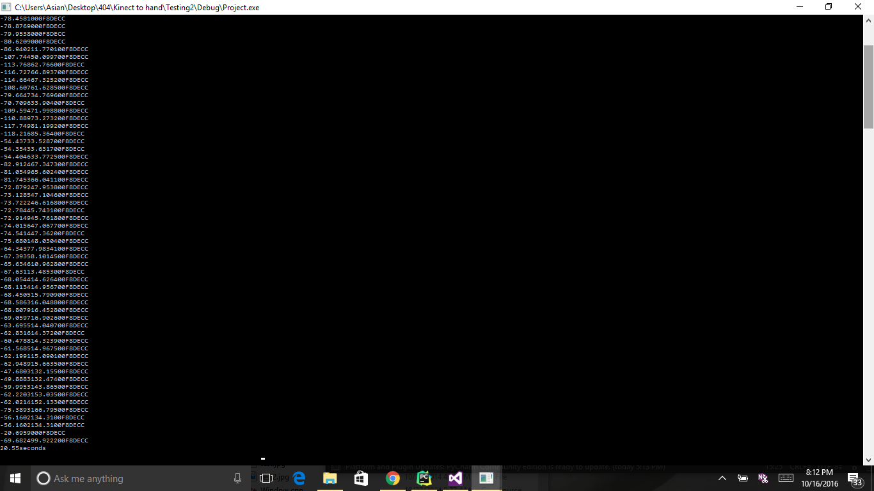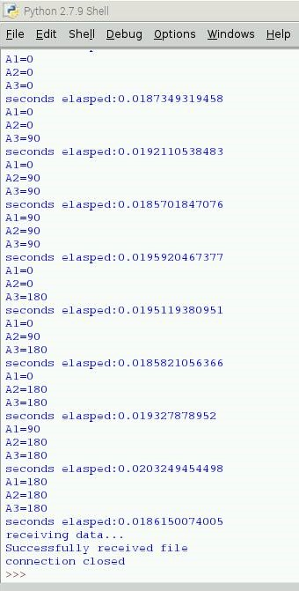

Figure 4.2

In the figures above, these display the data from Kinect being transported across different platforms.

For the figure on the left, this displays the data currently received from the kinect on Visual Studio C++. The data is received at a rate of 10ms per package which is sufficient. The figure on the middle displays the data after it’s forwarded from the c++ file to the main Python file. It’s able to send the data successfully over the socket but unfortunately, the client Python side is unable to decode the data that’s sent. Currently, the numpy package is being explored and experimented with at the moment to set up a shared array between the Python and the C++ script. For the figure on the right, this shows the data that’s received on the Pi. Pseudo Code was written on the computer side since the connection between the C++ to python is having issue to test the latency of data deliverance. Currently, the average latency is around 20ms. However, when testing the range, the latency did not change despite running and sending the package from one side of the EIC to the other end.

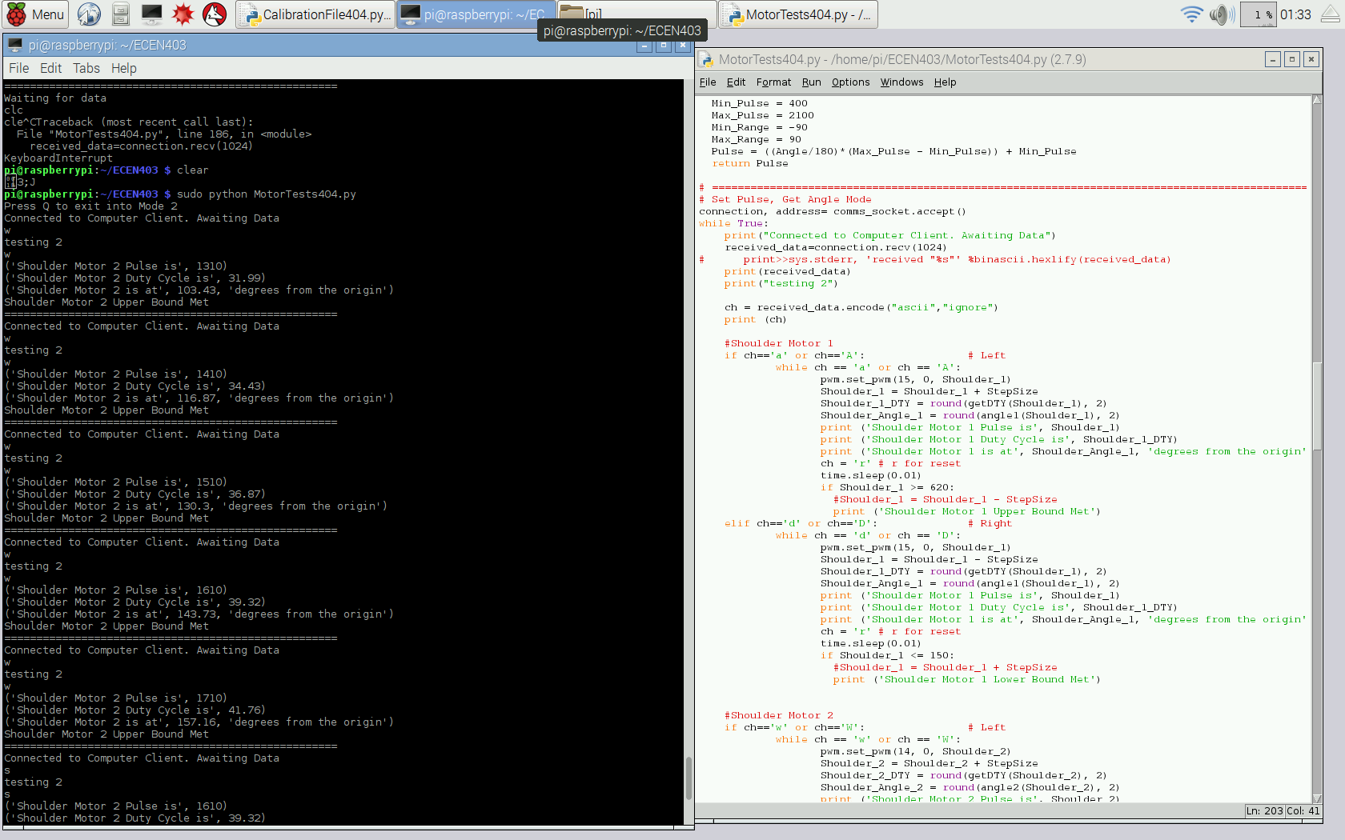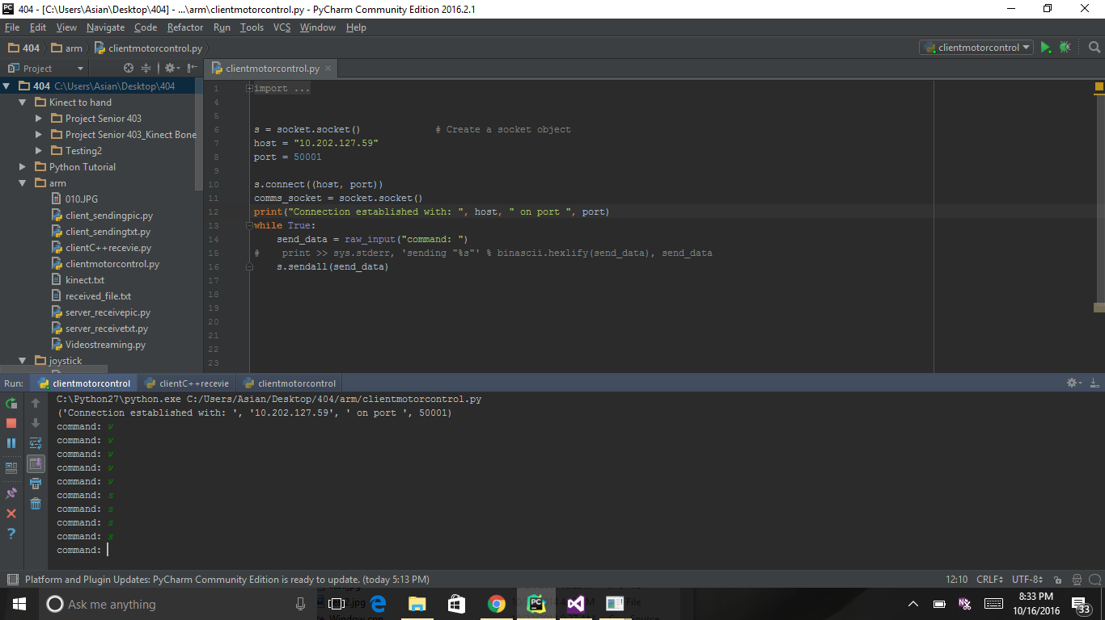

The following is an example of the communication established from the Pi to the computer when testing the arm control. This is the same protocol used for the vehicle communication with the Joystick.

#### Test Conclusion

From the Kinect to the Arm, the latency transporting raw data from the computer to the Pi averaged around 20ms which met the specification requirements. Furthermore, the data is able to be received from one end of the EIC to the other without breaking of the connection nor noticeable difference in latency. However, the connection between the C++ code on Visual studios still needs modification to send data packages that can be decoded in Python. For the Joystick to the vehicle however, the transportation is far smoother and working as intended.

### Computer to Pi-camera

The purpose of this test is to see and determine the latency of the visual feedback to the computer. Since visual feedback streams a large amount of data from the Pi, the latency must be taken into the greatest consideration. Furthermore, the range was tested to see if there was any impact on the latency for visual feedback at a greater distance.

#### Test Setup

In order to test the latency of the Pi-camera at different resolutions and frame rates, the specifications for the resolution and the frame rates had to be manually changed. After the program on the Pi and the laptop was run, the timer would be run on the computer. The camera will then be pointed at the time itself which would in turn allow a side-by-side comparison of real time and Pi-camera timer. The timer would then be started, and a video of the screen can be taken. When reviewing the video, the latency difference can easily be calculated by subtracting the timer displayed from the Pi-camera compared to the real-time timer on the laptop.

#### Data

|  |  |  |  |  |  |  |  |
| --- | --- | --- | --- | --- | --- | --- | --- |
| **Resolution** | **Frame Rate** | **Delay 1**  **(ms)** | **Delay 2**  **(ms)** | **Delay 3**  **(ms)** | **Delay 4**  **(ms)** | **Delay 5**  **(ms)** | **Avg Latency** |
| 480x480 | 20 | 0.27 | 0.18 | 0.21 | 0.16 | 0.18 | 0.2 |
| 480x640 | 20 | 0.28 | 0.2 | 0.34 | 0.2 | 0.18 | 0.24 |
| 640x640 | 20 | 0.24 | 0.3 | 0.17 | 0.2 | 0.28 | 0.238 |
| 720x640 | 20 | 0.17 | 0.14 | 0.33 | 0.16 | 0.22 | 0.204 |
| 720x720 | 20 | 0.39 | 0.26 | 0.17 | 0.18 | 0.16 | 0.232 |
| 1028x720 | 20 | 0.42 | 0.24 | 0.33 | 0.43 | 0.14 | 0.312 |
| 480x480 | 25 | 0.13 | 0.12 | 0.17 | 0.18 | 0.14 | 0.148 |
| 480x640 | 25 | 0.16 | 0.14 | 0.15 | 0.14 | 0.16 | 0.15 |
| 640x640 | 25 | 0.15 | 0.15 | 0.2 | 0.16 | 0.26 | 0.184 |
| 720x640 | 25 | 0.23 | 0.17 | 0.13 | 0.2 | 0.22 | 0.19 |
| 720x720 | 25 | 0.15 | 0.17 | 0.25 | 0.16 | 0.27 | 0.2 |
| 1028x720 | 25 | 0.52 | 0.18 | 0.34 | 0.29 | 0.65 | 0.396 |
| 480x480 | 30 | 0.13 | 0.13 | 0.17 | 0.18 | 0.33 | 0.188 |
| 480x640 | 30 | 0.14 | 0.16 | 0.27 | 0.15 | 0.2 | 0.184 |
| 640x640 | 30 | 0.13 | 0.19 | 0.16 | 0.13 | 0.26 | 0.174 |
| 720x640 | 30 | 0.32 | 0.23 | 0.2 | 0.21 | 0.21 | 0.234 |
| 720x720 | 30 | 0.36 | 0.33 | 0.28 | 0.16 | 0.25 | 0.276 |
| 1028x720 | 30 | 0.28 | 0.28 | 0.64 | 0.38 | 0.33 | 0.382 |

The following chart displays a sample of the latency that was measured for different resolution and frame rates.

* + - 1. 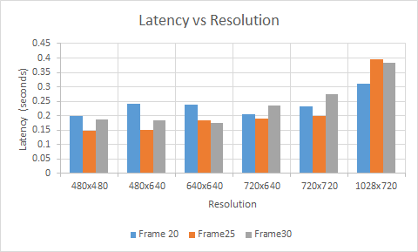
      2. As observed from the following graph above, it is evident that resolution below 720x720 have relatively low yet similar latency. However, beyond this threshold, the latency increases substantially. Furthermore, when conducting the test, another variable arose which was choppiness of the video, which cannot be measured quantitatively. It was evident that the higher the resolution and framerate, the more choppy the video feedback was. Thus a low resolution/low frame rate video would have the smoothest display.
      3. 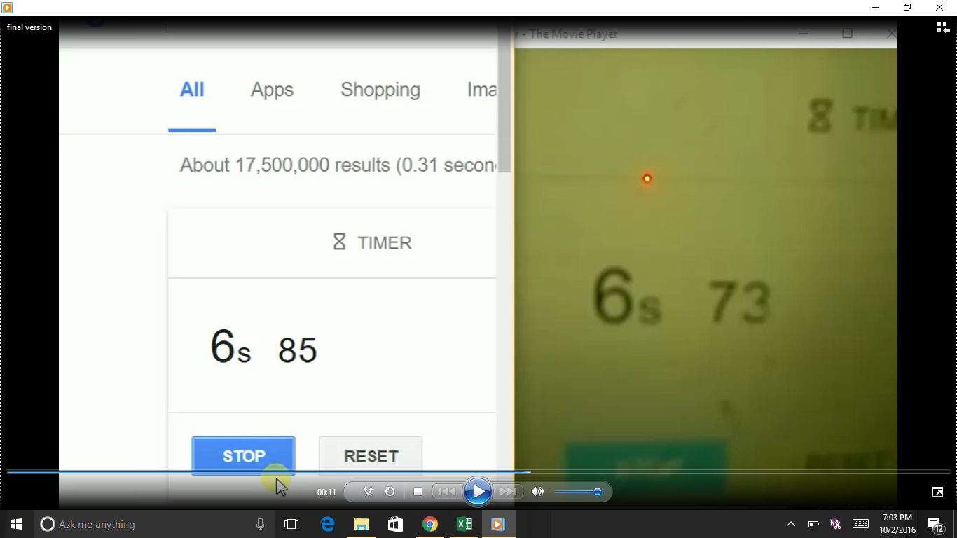
      4. The figure above displays one of the latency measurements taken. The resolution for the test was at 480x640 at frame rate of 25 fps. Observe how the latency was only 12ms.

#### Test Conclusion

* + - 1. All of the test passed for the Pi-camera to computer communications network. The latency is well below the set criteria and can be transmitted over Wi-Fi reliably over long distance.
      2. 4.1.3 Latency
      3. **Test Setup:**
      4. To conduct the latency test, 4 types of tests are done. The first test include testing for the latency for single load. For the second test, we tested to see the latency of certain components when two loads are run. For the third test, 3 loads are run and lastly for the 4 load testing, all of the processes are ran simultaneously.
      5. **Data Collected:**

***Single Load Latency Data***

|  |  |  |  |  |
| --- | --- | --- | --- | --- |
| ***single load*** | ***Robotic Arm*** | ***Myo*** | ***DC Motor*** | ***Camera*** |
| ***1*** | ***30*** | ***15*** | ***5*** | ***39*** |
| ***2*** | ***25*** | ***15*** | ***5*** | ***28*** |
| ***3*** | ***30*** | ***15*** | ***5*** | ***39*** |
| ***4*** | ***30*** | ***15*** | ***5*** | ***30*** |
| ***5*** | ***25*** | ***15*** | ***5*** | ***34*** |
| ***6*** | ***30*** | ***15*** | ***5*** | ***22*** |
| ***7*** | ***25*** | ***15*** | ***5*** | ***36*** |
| ***8*** | ***25*** | ***15*** | ***5*** | ***32*** |
| ***9*** | ***35*** | ***15*** | ***5*** | ***24*** |
| ***10*** | ***25*** | ***15*** | ***5*** | ***38*** |
| ***avg(ms)*** | ***28*** | ***15*** | ***5*** | ***32.2*** |

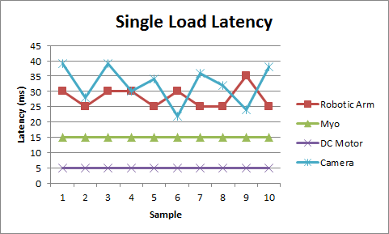

|  |  |  |  |  |  |  |  |  |  |  |  |  |
| --- | --- | --- | --- | --- | --- | --- | --- | --- | --- | --- | --- | --- |
| ***2 loads*** | ***Camera Primary*** | | | ***Arm Primary*** | | | ***Motor*** | | | ***Myo Primary*** | | |
|  | ***Arm*** | ***Motor*** | ***Myo*** | ***Camera*** | ***Motor*** | ***Myo*** | ***Camera*** | ***Arm*** | ***Myo*** | ***Camera*** | ***Arm*** | ***Motor*** |
| ***1*** | ***35*** | ***5*** | ***15*** | ***45*** | ***5*** | ***15*** | ***64*** | ***20*** | ***15*** | ***50*** | ***25*** | ***5*** |
| ***2*** | ***40*** | ***5*** | ***15*** | ***35*** | ***5*** | ***15*** | ***50*** | ***30*** | ***15*** | ***36*** | ***35*** | ***5*** |
| ***3*** | ***35*** | ***5*** | ***15*** | ***43*** | ***5*** | ***15*** | ***48*** | ***30*** | ***15*** | ***40*** | ***25*** | ***5*** |
| ***4*** | ***30*** | ***5*** | ***15*** | ***45*** | ***5*** | ***15*** | ***62*** | ***30*** | ***15*** | ***52*** | ***25*** | ***5*** |
| ***5*** | ***30*** | ***5*** | ***15*** | ***27*** | ***5*** | ***15*** | ***57*** | ***30*** | ***15*** | ***32*** | ***30*** | ***5*** |
| ***6*** | ***25*** | ***5*** | ***15*** | ***34*** | ***5*** | ***15*** | ***50*** | ***25*** | ***15*** | ***59*** | ***30*** | ***5*** |
| ***7*** | ***30*** | ***5*** | ***15*** | ***54*** | ***5*** | ***15*** | ***47*** | ***30*** | ***15*** | ***52*** | ***35*** | ***5*** |
| ***8*** | ***25*** | ***5*** | ***15*** | ***45*** | ***5*** | ***15*** | ***54*** | ***30*** | ***15*** | ***57*** | ***30*** | ***5*** |
| ***9*** | ***25*** | ***5*** | ***15*** | ***43*** | ***5*** | ***15*** | ***40*** | ***30*** | ***15*** | ***50*** | ***15*** | ***5*** |
| ***10*** | ***30*** | ***5*** | ***15*** | ***38*** | ***5*** | ***15*** | ***52*** | ***25*** | ***15*** | ***53*** | ***25*** | ***5*** |
| ***avg*** | ***30.5*** | ***5*** | ***15*** | ***40.9*** | ***5*** | ***15*** | ***52.4*** | ***28*** | ***15*** | ***48.1*** | ***27.5*** | ***5*** |

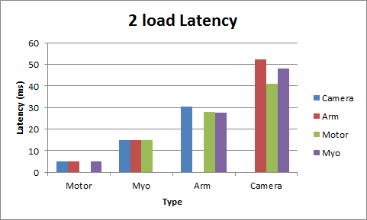

|  |  |  |  |  |  |  |  |  |  |  |  |  |
| --- | --- | --- | --- | --- | --- | --- | --- | --- | --- | --- | --- | --- |
| ***3 loads*** | ***Arm*** | | ***Arm*** | | ***Arm*** | | ***Myo*** | | ***Myo*** | | ***Motor*** | |
|  | ***Camera*** | | ***Motor*** | | ***Myo*** | | ***Camera*** | | ***Motor*** | | ***Camera*** | |
|  | ***Myo*** | ***Motor*** | ***Myo*** | ***Camera*** | ***Motor*** | ***Camera*** | ***Motor*** | ***Arm*** | ***Camera*** | ***Arm*** | ***Myo*** | ***Arm*** |
| ***1*** | ***15*** | ***5*** | ***15*** | ***40*** | ***5*** | ***43*** | ***5*** | ***30*** | ***27*** | ***25*** | ***15*** | ***35*** |
| ***2*** | ***15*** | ***5*** | ***15*** | ***20*** | ***5*** | ***45*** | ***5*** | ***35*** | ***26*** | ***20*** | ***15*** | ***30*** |
| ***3*** | ***15*** | ***5*** | ***15*** | ***30*** | ***5*** | ***56*** | ***5*** | ***35*** | ***32*** | ***20*** | ***15*** | ***30*** |
| ***4*** | ***15*** | ***5*** | ***15*** | ***33*** | ***5*** | ***41*** | ***5*** | ***35*** | ***27*** | ***20*** | ***15*** | ***30*** |
| ***5*** | ***15*** | ***5*** | ***15*** | ***26*** | ***5*** | ***65*** | ***5*** | ***35*** | ***35*** | ***25*** | ***15*** | ***35*** |
| ***6*** | ***15*** | ***5*** | ***15*** | ***35*** | ***5*** | ***48*** | ***5*** | ***35*** | ***38*** | ***20*** | ***15*** | ***35*** |
| ***7*** | ***15*** | ***5*** | ***15*** | ***36*** | ***5*** | ***71*** | ***5*** | ***30*** | ***33*** | ***20*** | ***15*** | ***30*** |
| ***8*** | ***15*** | ***5*** | ***15*** | ***45*** | ***5*** | ***45*** | ***5*** | ***35*** | ***33*** | ***20*** | ***15*** | ***30*** |
| ***9*** | ***15*** | ***5*** | ***15*** | ***36*** | ***5*** | ***45*** | ***5*** | ***35*** | ***26*** | ***25*** | ***15*** | ***35*** |
| ***10*** | ***15*** | ***5*** | ***15*** | ***35*** | ***5*** | ***32*** | ***5*** | ***30*** | ***20*** | ***30*** | ***15*** | ***30*** |
| ***avg*** | ***15*** | ***5*** | ***15*** | ***33.6*** | ***5*** | ***49.1*** | ***5*** | ***33.5*** | ***29.7*** | ***22.5*** | ***15*** | ***32*** |

#### Test Conclusion

The latency test revealed that although latency changed slightly, there’s really not that much difference since the latency of all of them are quite low.

# Software Subsystem - Yuan Tian

## 5.1 Overview of the Subsystem

The software subsystem includes the Kinect sampling algorithm and the graphical user interface. The Kinect sampling algorithm is responsible for converting the raw data from the Kinect into the PWM data that can be used to drive the servo motors on the robotic arm. The graphical user interface is designed for delivering concise system feedbacks to the user, while providing guidance to the user by outputting necessary instruction messages throughout the entire calibration and sampling stage. The software subsystem is essential because it interprets the user’s real arm configuration and supply the representation angles to control subsystem through communication subsystem. Also, it provides easy control on the entire system to the user.

## Significant Changes in Direction

In the last validation test, it was found that the limited accuracy of the Kinect causes troubles for the sampling algorithm to generate correct angle representations when sampling some specific arm configurations. Also, the human arm has more degree of freedom, which results in ambiguity of mapping some special human arm movements with the degree of freedom exceeding to that of the robotic arm. Because it is impossible to change the hardware specification of the Kinect, a new sampling algorithm has to be developed to replace the older version that is based on the use of vector analysis. After some research, the new sampling algorithm featuring the use of inverse-kinematics was developed, tested and successfully applied.

## Subsystem Status

The software subsystem includes the Kinect sampling algorithm and the graphical user interface.

In terms of the Kinect sampling algorithm, a sampling algorithm featuring inverse-kinematics was developed and applied to the project. In addition, various of tests have been done to verify that the sampling algorithm meets the functional requirements. To further verify and refine the sampling algorithm, more tests will be conducted after the integration of overall system is finished. Until then, the algorithm can be tested using the robotic arm.

As for the graphic user interface, a set of refined user interface windows was developed using Microsoft FLTK. The performance of the windows meets the functional requirements. At present, the graphic user interface is mainly responsible for assisting project development by providing essential system feedbacks to developers. Later, the design of the user interface will focus on user-friendly and providing better experience to users.

## Subsystem Challenges and Solutions

For the interface development, major difficulty I encountered is to design an animation that can display real-time configuration of the robotic arm. I was able to consult with FLTK pros to pinpoint the issue and to use alternative approach to solve the problems. In teams of the sampling algorithm, the challenges I faced is to study a subject that is completely new to myself and deliver a plausible solution to design a reliable sampling algorithm that features inverse-kinematic.

## Subsystem Technical Details

As mentioned in the previous sections, the software subsystem mainly consists of the graphic user interface designing and the Kinect sampling algorithm.

5.5.1 User interface

In terms of the interface designing, the developed user interface windows must be able to display the system status and the system data clearly and correctly. This is illustrated in the figure 5.5.1 to figure 5.5.3 below. In the early development stage, The GUI windows are designed as simple as possible only containing essential information that the user needs to know. More functions were added as the project development proceeded.

Window 5.5.1.1

Window 5.5.1.1 is designed to be the welcome window. The planned functionalities for the welcome window include displaying the title, contributors, manual and pictures of the project and allowing the user to select desired sampling frequency. This window will show up after the user opens the executable file of the project. As you can see in the figure, the window only contains one function which allows the user to select the desired sampling frequency for the Kinect. After the user clicks confirm, the welcome window will close, and the selected frequency will be assigned to be the Kinect’s sampling frequency. At the same time, the second window pops out.

Figure 5.5.1.1. Welcome Window

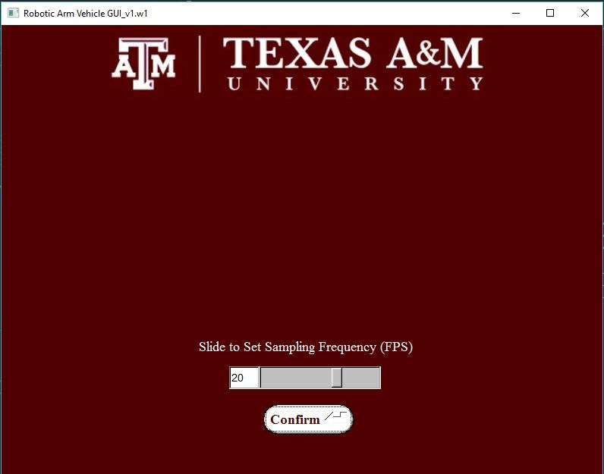

Window 5.5.1.2

Window 5.5.1.2 is designed to be the calibration stage window. The designed functionalities for the calibration stage window includes displaying text and graphic instructions to guide the user through the calibration stage. Since each user has his or her own unique arm length, to obtain the optimal arm length data for later use, the user needs to follow the instructions to proceed the calibration stage. The calibration stage window will show up after the user clicks the confirm button on the previous window. As you can see in the figure 5.5.1.2, the window contains text instruction shown in at top of the window, and graphic instruction shown at right of the window. After the user clicks the start button, the calibration stage process starts. In the calibration stage, the user can exit the entire calibration and sampling stages by click the end button. If the user successfully finishes the calibration process, the system will enter the sampling stage, and the window will change accordingly

Figure 5.5.1.2. Calibration Stage Window

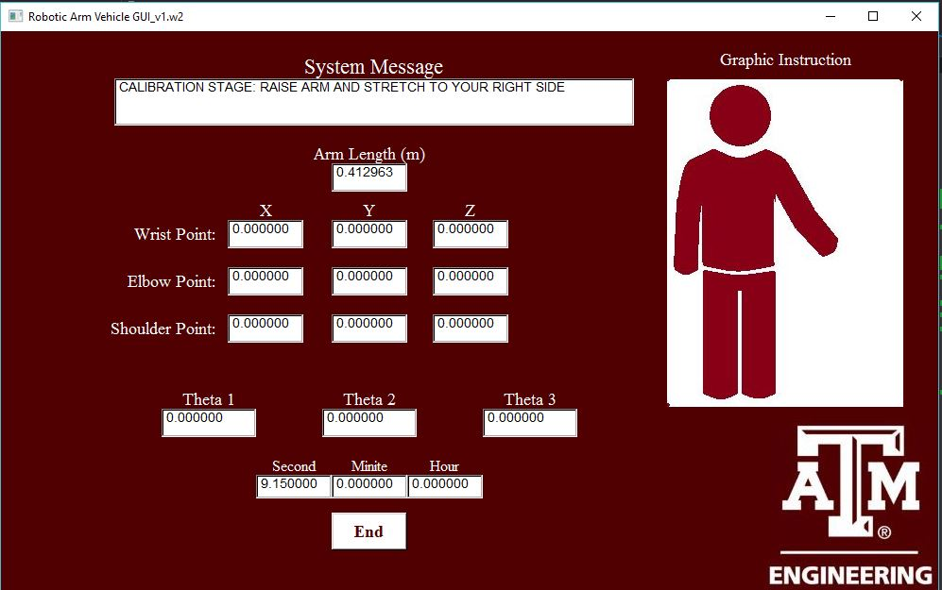

Window 5.5.1.3

Window 4.3.1.3 is designed to be the sampling stage window. The designed functionalities for the system window include displaying angle representation data and graphing the robotic arm configuration based on the angle data in real-time. The system will display this window automatically after the user successfully accomplish the calibration process. As you can see in the figure 5.5.1.3.1, the window contains multiple text boxes that display the user’s arm coordinate data. And the highlighted blue boxes display the angle representation data that is sent to control subsystem to drive the servo motors on the robotic arm. Moreover, the user instructions and system feedbacks are displayed at the top of the window. The user is also able to pause the sampling process by pressing the pause button. When paused, the window will freeze up (see Figure 5.5.1.3.2), which allows the user to leave the sampling scope of Kinect. The user can resume to the sampling process anytime by clicking the resume button. If user clicks the end button, the sampling process will terminate, the sampling window will close and the elapsed time will be recorded. At the same time, the end window pops out.

Figure 5.5.1.3.1 Sampling Window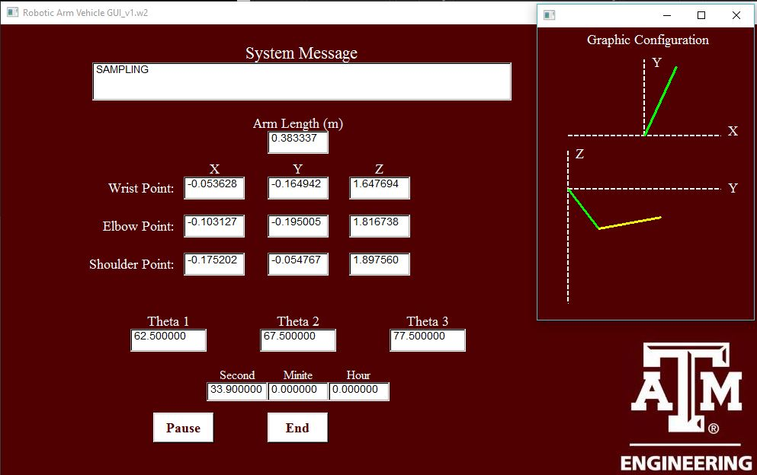

Figure 5.5.1.3.2 Sampling Window (Paused)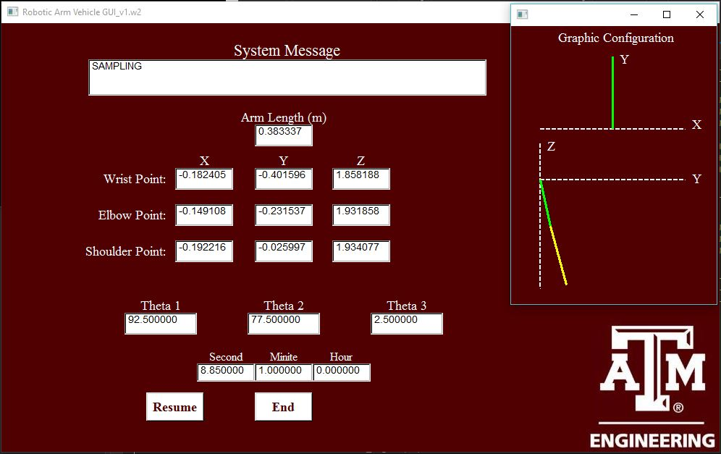

Window 5.5.1.4

Window 5.5.1.4 is designed to be the end window. The designed functionalities for the system window include displaying elapsed time, calculating power consumption, and giving an estimated number on battery usage. The window will remind user to recharge the battery when the estimated battery left is low. The end window is displayed in figure 5.5.1.4. The end window will show up after the user clicks the end button on the previous window. As you can see in the figure 5.5.1.4,

Figure 5.5.1.4. End Window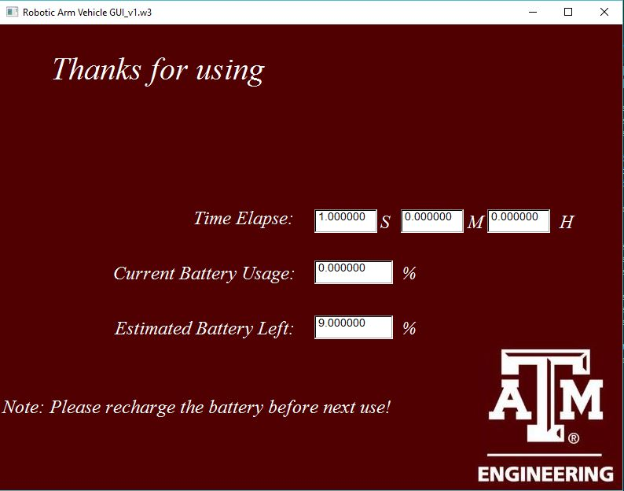

5.5.2. Sampling Algorithm

The Kinect sampling algorithm is responsible for converting the raw data from the Kinect into the pwm data that can be used to drive the servo motors on the robotic arm. The algorithm is structurally embedded in the coding of the User Interface. The newest version of the sampling algorithm is designed to be task-oriented featuring the Inverse Kinematic technique. The general idea of the algorithm is shown in Figure 5.5.2.1. The angle representations in degrees generated by the algorithm are used to drive the servo motors of the robotic arm. Because the algorithm is task-oriented, the angle representations for Servo motors are not necessarily equal to or close to the real angles between the upper limb and lower limb of human arms. Which indicates only the end-effector position of the human arm matters in the calculation instead of the actual configuration of the human arm.

Based on the figure, the three angle representations theta1, theta2, and theta3 are used to drive servo motor 1, 2 and 3 respectively. The method used to calculate theta1 is vector analysis. For the Theta 2 and Theta3, the 2D inverse-kinematics is used to calculate the angles.

Figure 5.5.2.1. Algorithm Concept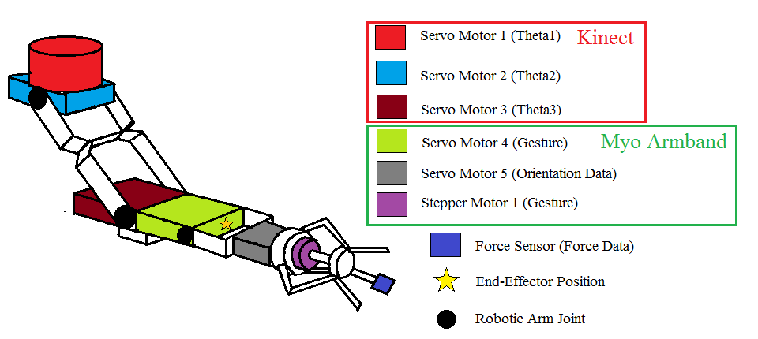

5.5.2.1. Theta 1 Calculation (Vector Analysis)

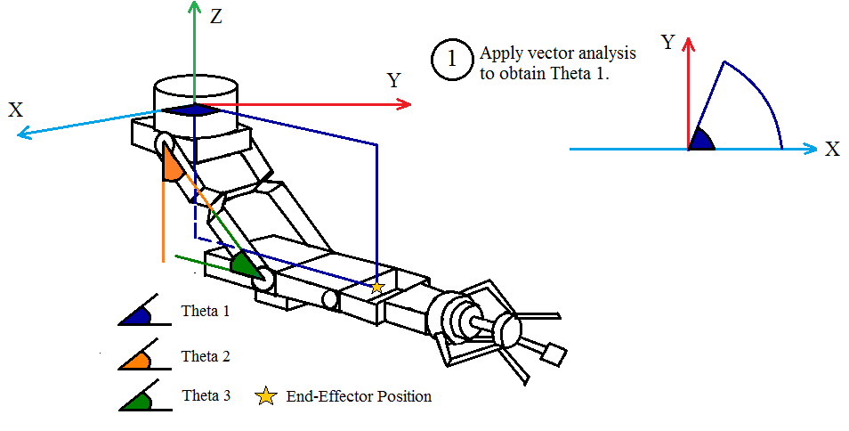

Servo motor 1 rotates to change the direction of the robotic arm vectors in X-Y plane, and the defined range for the direction vector in X-Y plane is 0° ~ 180°. Thus a 2-D direction vector is used to output the numerical values of ‘theta 1’ indicated in figure 4.3.2.1. The 2-D vector is defined by the difference between the wrist point X-Y coordinate and the elbow point X-Y coordinate. After the direction vector is defined, the angle can be found using the mathematical formula shown below:

*Angle=57.2arctan(YX)*

In the case that the angle is over 90°, the formula shown below is used instead:

*Angle=180-57.2arctan(YX)*

5.5.2.2 Theta 2 and Theta 3 Calculation (2D inverse-kinematics)

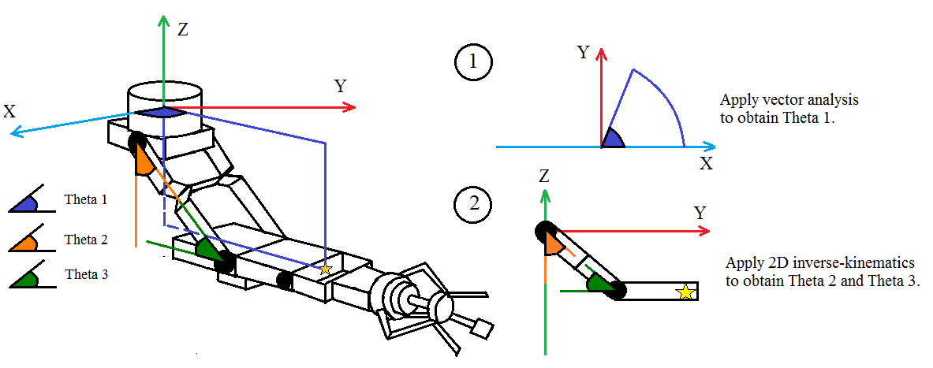

After transferring the problem into a 2D plane by solving the theta1 first, the method of 2D inverse-kinematics can be used to solve the Theta 2 and Theta 3. The detailed analytical approach is omitted due to its complexity. The general modeling of the method is shown in figure 5.5.2.3. The Θ1 in the figure is Theta 2, and Θ2 is Theta 3.

Figure 5.5.2.3. Mathematical Modeling of 2D Inverse-kinematic

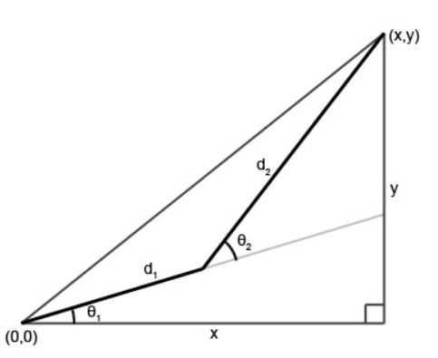

5.5.3. Joystick Algorithm

The joystick algorithm designing is not included in software subsystem, but is a unalienable part for control subsystem. The task of the Joystick algorithm is to convert the raw data from the joystick into pwm signal that can be used to drive the motors so that the user can use the joystick to control the vehicle moving around. The joystick used in the project is called “Saitek T290 Programmable Joystick”. The raw data is in form of unit circle coordinate data, which is shown in figure 5.5.3.1. And the data transferring method is through USB to PC.

Figure 5.5.3.1. Raw Data Boundary of Joystick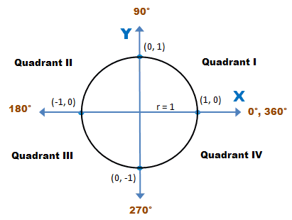

The vehicle is expected to accomplish following tasks.

1. Forwarding

This requires the user to move the joystick strictly in the positive Y direction, which results in same positive PWM on both left motor and right motor.

1. Reversing

This requires the user to move the joystick into the negative Y area, which results in same negative PWM on both left motor and right motor.

1. Forwarding and Turning

This requires the user to move the joystick into area of positive Y area excluding the positive Y axis, which results in different positive PWM on left motor and right motor.

1. Pivot Turning

This requires the user to move the joystick strictly in the positive or negative X direction, which results in a positive PWM on one motor and a zero PWM on the other one.

In addition, it’s desired to limit the PWM for pivot turning because the high turning speed may infringe the stability of the vehicle. To do so, the PWM values on both motors needs to be reduced exponentially in the turning process. As a result, the range of pwm1 and pwm2 is distributed exponentially in terms of theta and radius in positive-y area, and linearly in terms of radius in negative-y area. The general description of the joystick algorithm is shown below in figure 5.5.3.2.

Figure 5.5.3.2. General Concept of Joystick Algorithm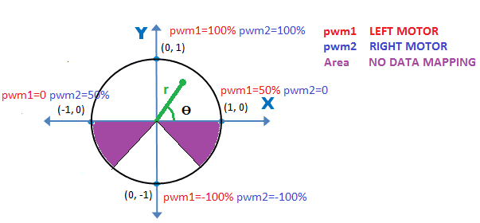

## Subsystem Testing

The purpose of the test was to prove that the user interface can provide clear system feedbacks and concise instructions to guide the users in the sampling process, also to verify that the angle representations generated by the Kinect Sampling Algorithm are accurate enough to meet the system requirements.

#### Test Setup

The hardware for setting up the User Interface and the Kinect Software includes a Kinect console and a personal computer. The Kinect console is connected to the PC by a USB cable. The data generated by the Kinect will be transmitted to the PC through the USB cable. In the development stage, The Visual Studio is required to installed on the PC to run the subsystem program. In the final stage of the development, the newest version of the program will be integrated into a package, which would be an executable file that can be open and ran by any PC.

### 5.6.1 <User interface>

To test the User Interface, the users need to open the executable file on the PC. After the window pops out, which is shown in Figure 5.5.1.2, the users need to press the ‘start’ button that is on the window. After the button is pressed, the sampling system will enter the searching and calibration stage, where the Kinect verifies if there is a human standing in front in the required distance, if so, the Kinect will start to track the human skeleton and yield the coordinates data. Meanwhile, the window will output messages that instruct the users to pose certain arm positions for the data calibration process.

To test if the User Interface meets the design requirements, random participants that have no knowledge of the system will be invited to conduct the test. The participants’ feedbacks will be collected to determine if the User Interface fulfills its requirements to provide clear system feedbacks and concise instructions.

#### Data

N/A

#### Test Conclusion

Most test participants can conduct sampling process correctly following the instructions provided by the user interface, so the primitive user interface meets the functional requirements. However, it’s found that some modification can be done to improve user experience.

### 5.6.2 <Sampling Algorithm>

#### Test Setup

In the test, the end-effector position generated by the algorithm will be compared to the end-effector position of the human arm to determine if the algorithm achieves the desirable accuracy. To verify the accuracy, a quantitative test method has to be designed. In addition, the coordinate data extracted from the Kinect has a constant variation due to the limited accuracy of the Kinect sensors. In case of jitters caused by the unsteady data value supplied to the robotic arm, a filter function will be developed to filter out the small data variation so that steady robotic movements can be achieved. The optimal filter function characteristics will be determined after analyzing the post data from the Kinect.

5.6.2.1 Quantification Method

As seen in figure 4.4.3.1, the Kinect coordinate data is used to set up a reference frame denoted by “Kinect frame”, at the same time the real space three-dimensional coordinate data of the user’s wrist point will be measured using the metric system, which forms the other reference frame denoted by “User’s Frame” in the figure. Moreover, the coordinate data generated from the Kinect is also in metric unit, as a result, the process that mapping one onto the other can be achieved using vector analysis. The result is that the coordinate data of endpoints in both frames can be compared because they are converted into the same metric unit. The accuracy requirement for the test is shown chart 5.6.3.1 below.

Figure 5.6.3.1. Data Mapping Concept for Test

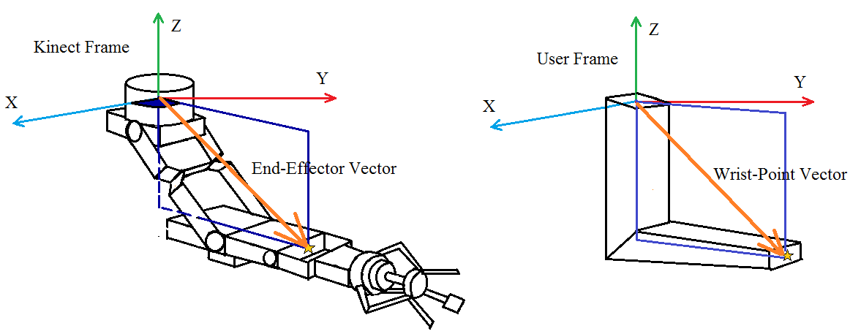

Chart 5.6.3.1 Accuracy Requirements

|  |  |
| --- | --- |
| Test Subject | Error Tolerance (cm) |
| (X, Y, Z) - (X1, Y1, Z1) | (±5, ±5, ±5) |

#### Data

To verify if the sampling algorithm can yield correct angle representations for the user’s arm configuration, various tests are conducted. In the tests, we measured angles related wrist-point vector in user frame, and compared the results with that of end-effector vector in Kinect frame. The test result and data comparison are shown in the overall system test section.

To understand the ‘noise’ that is included in the generated coordinate data from Kinect, the holding motion test is conducted. In the test, the user is asked to hold his arm in a certain position for a period of time. The three angle representation data is plotted in terms of time to test the accuracy of sampling algorithm. One section of the coordinate data in the process is analyzed and displayed in Figure 5.6.3.2. below.

Figure 5.6.3.2. Holding Motion Test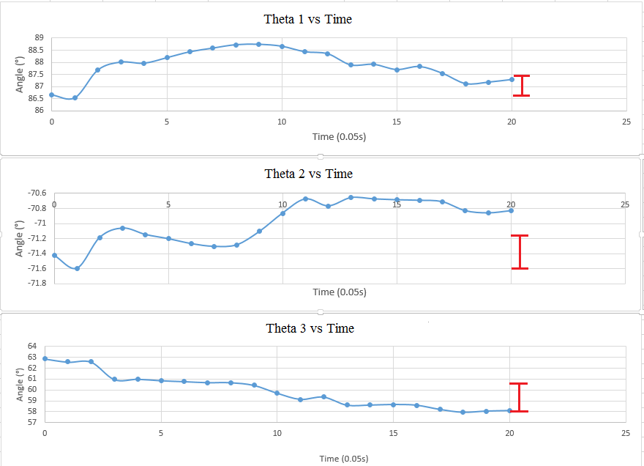

The data variation caused by the ‘noise’ of the Kinect hardware will cause unwanted jitters on the robotic arm. So, a filter function is desired to be designed to eliminate the data variation so that smooth robotic arm movements can be achieved.

Basing on the figure shown above, the largest data variation is less than 3 degrees. So, the filter function has to eliminate the data variation. The logic of the filter function goes like this:

If the difference of the current data value and previous data value is less than 3 degrees, we can assume that the user’s arm is mostly staying still, so we can supply the previous data. otherwise, the user’s arm is moving, we can supply current data value. The filter logic is shown in figure 5.6.3.3.

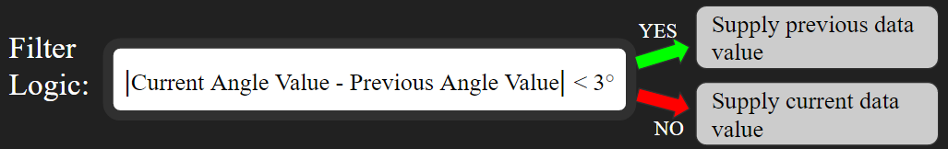

Figure 5.6.3.3. Filter Logic

The result of filtering is shown in figure 4.4.3.5 and 4.4.3.6. The figure 4.4.3.5 shows the sampling data before filtering. The figure 4.4.3.6 shows the sampling data after filtering. By comparing those two figures, the robotic arm jitters are eliminated by filtering out the data variation.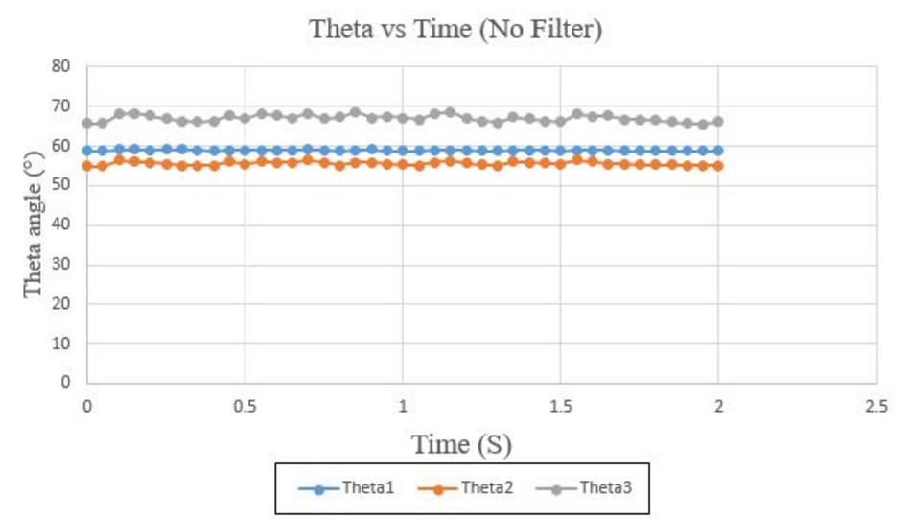

Figure 5.6.3.4. Sampling Data before Filtering

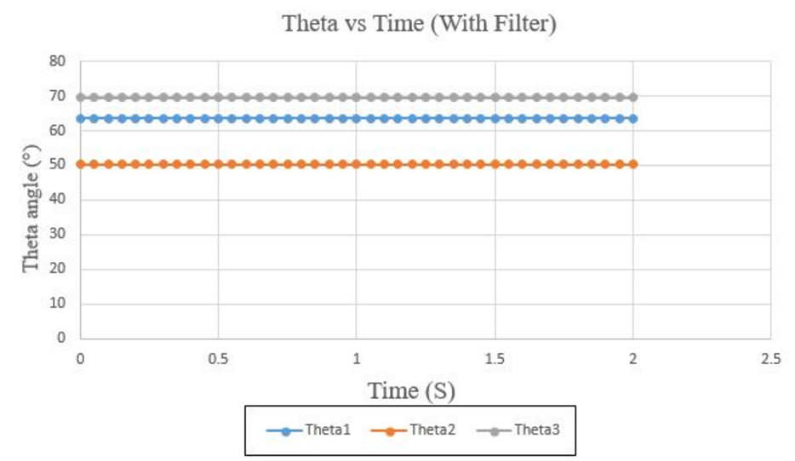

Figure 5.6.3.5. Sampling Data after Filtering

#### Test Conclusion

The test plan shows the inevitable error caused by the hardware limitation. However, the error would be compensated with designed filter algorithms. The test plan aims to help refining the user interface and improving the algorithm accuracy. Some alternative methods may be developed and applied when needed.

.

# Hand & Myo Armband Subsystem - Zhengshuai Zhang

The hand/tools system is connected to the rest of the arm and designed to mimic the movements of user’s gestures and wrist movements. The system consists of four main components: Myo armband, stepper motor, force sensor and servo motor. The Myo armband reads and sends gestural data to the laptop and laptop sends these data to the raspberry pi, then the raspberry pi sends these gestural data to the stepper motor through a stepper motor driver. The force sensor reads the force that applied on the fingertips and send the data to the raspberry pi through analog to digital converter. The Myo armband also reads orientation data of rolling and sends the orientation data the servo motor in the same way. The subsystem block diagram is shown below:

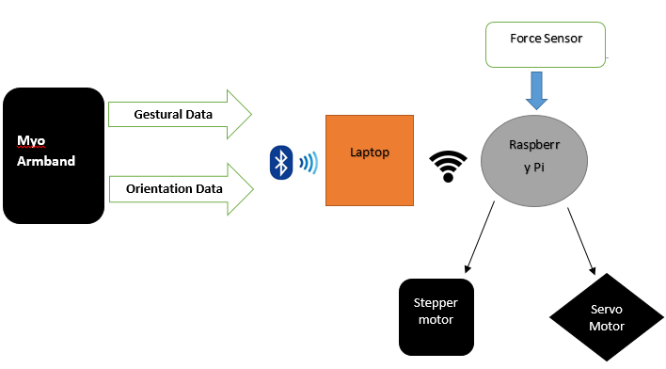

Figure 6.1 Hand & Myo Armband Subsystem Flowchart

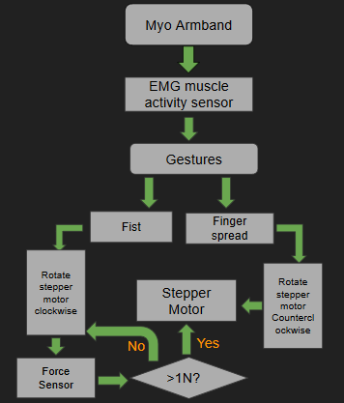

Figure 6.2 Gestural Control Flowchart

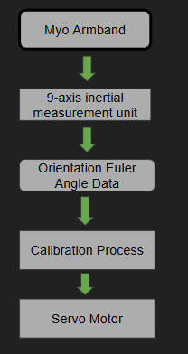

Figure 6.3 Orientation Control Flowchart

## Significant Changes in Direction

The previous design of stepper motor rotating angle was 270 degrees, but the new requirement is that the stepper motor keeps rotating until the value that read by force sensor reaches a designed value. And the previous requirement of the client-side code was to send data directly to Putty, however, the new communication method required the client side code saving real-time data into text file. So, we moved the client-side code from lua to C++.

## Subsystem Status

The first part is the hand control. The hand is controlled by the stepper motor and the stepper motor is controlled by the gestural data that read by Myo armband. Now the stepper motor control is done, and it is able to rotate in expected directions and degrees. The second part is the force sensor. The force sensor is installed on the fingertips, and it can detect the value of the forces that applied on the fingertips. And these values can be read and displayed on the Raspberry pi. The part that hasn’t been finished for the hand system is to realize the interruption between force sensor and stepper motor. The values that the force sensor reads should be used to decide the range of the forces that the hand can lift up tools. And the stepper motor should keep rotating until the force sensor detects forces in the designed range.

The third part is the wrist control. Now the system can mimic the movements of rolling arm. There are two servo motors on the wrist: one is designed to mimic rolling and the other one is designed to mimic pitch. The servo motor can read orientation data from Myo armband and rotate in expected directions and angles. The part that hasn’t been finished is to control the other servo motor by EMG data from Myo and realize the movement of pitching.

Table 6.1  
<Hand & Myo subsystem> specification Compliance Matrix

|  |  |  |  |
| --- | --- | --- | --- |
| Specification | Min | Nominal | Max |
| The accuracy of the force value that read by force sensor is less than ±10% | 0 | ±5% | ±10% |
| The accuracy of the servo motor is less than ±10% | 0 | ±5% | ±10% |
|  |  |  |  |

## Subsystem Challenges and Solutions

* **Major Hurdle:** Saving real time data into text file on client side was the major hurdle that we met.
  + **Solution:** The original code was written in lua and run-on MYO CONNECT software, however, the MYO CONNECT software doesn’t allow developer saving real time data into files. So, we moved the client-side code to C++ then run it on Visual Studio. Finally, saving real time data into text file was realized.

## Subsystem Technical Details

Stepper motor is controlled by the gestural data from Myo armband. The Myo armband is able to read two gestures: fist and finger spread. The code of reading gestures is written in lua as shown below:

code 5.1 Reading gestures

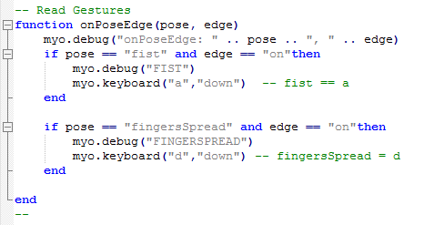

The Myo armband sends these gestural data to the laptop through Bluetooth. And each type of gestures is designed to match a key on the keyboard. Making a fist is equivalent to pressing ‘a’ on the keyboard and spreading fingers is equivalent to pressing ‘d’. The laptop is communicated with Raspberry pi through putty and the laptop sends the key input data to the Raspberry pi. The Raspberry pi reads the key input data and sends it to the stepper motor through a stepper motor driver. The code of reading the key input data is written in python as shown below:

code 5.2 Reading key input

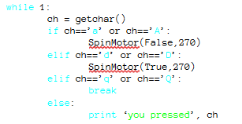

When the stepper motor reads ‘a’ or ‘A’, the stepper motor rotates in clockwise and vice versa. Table 5.1 shows all the keyboard input and movements they correspond to:

Table 5.1 Corresponding Movements for keyboard inputs

|  |  |  |
| --- | --- | --- |
| Gestures | Keyboard Input | Direction of Rotating |
| Fist | ‘a’ or ‘A’ | Clockwise |
| Fingerspread | ‘d’ or ‘D’ | Counterclockwise |

The force sensors read the force applied on the fingertips and send these data to Raspberry pi through ADC.

The servo motor on the wrist is controlled by the orientation data from Myo armband. Myo armband can read orientation data of rolling and send the data to the laptop through bluetooth. And it communicates with raspberry pi by the same protocol as reading gestural data. A ‘center’ function is used in the code, and it makes the user arm always be the x axis to realize reading exact data in every position. The orientation data is in the form of degrees and output as keyboard input. The code of reading and output orientation data is written in lua as shown below:

code 5.3 Output Orientation data

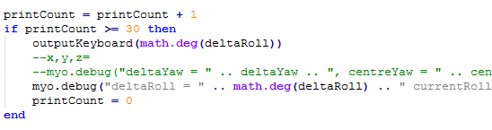

|  |  |  |
| --- | --- | --- |
|  |  |  |

## Subsystem Testing

### <Gesture Reading Test>

***Test Overview***

The purpose of the test was to check if the Myo armband reads designed gestures correctly and sends the gestural data to the laptop accordingly. And the debug console on the laptop was tested if it shows the gestures correctly. The main purpose of the test was to test if the gestures can control the designed keys on the keyboard.

***Test Setup***

Install MYO CONNECT on the laptop. The software allows users to open the application associated with the gesture reading. Open Application Manager on the software and turn on the application whose name is ‘Gesture reading’. A debug console should be open after the application is activated. Wear the Myo armband on the right/left arm and do wave-out gesture to synchronize the armband with the application manager. The software shows if the sync is completed. After the sync is completed, make double tap gesture to unlock the Myo armband. The debug console should show the armband is unlocked. Then make a fist or spread fingers to test if the debug console can show the gestures correctly. Next, open Notepad. Make a fist again to test if the keyboard input a ‘D’ or ‘d’ to the Notepad. And spread finger to test if the keyboard input a ‘A’ or ‘a’ .

***Data***

The figure below shows that user is making a fist. The circle at the right-bottom corner tells that the user is making a fist by animation. And the debug console also shows the user is making a fist in the red square box. Meanwhile, the laptop input a character ‘a’ on Notepad.

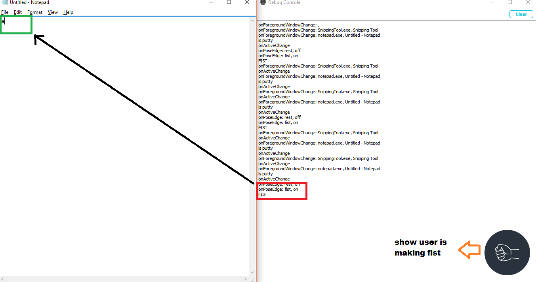

Same, the figure below shows the user is spreading fingers and the laptop inputs a character ‘d’ on Notepad.

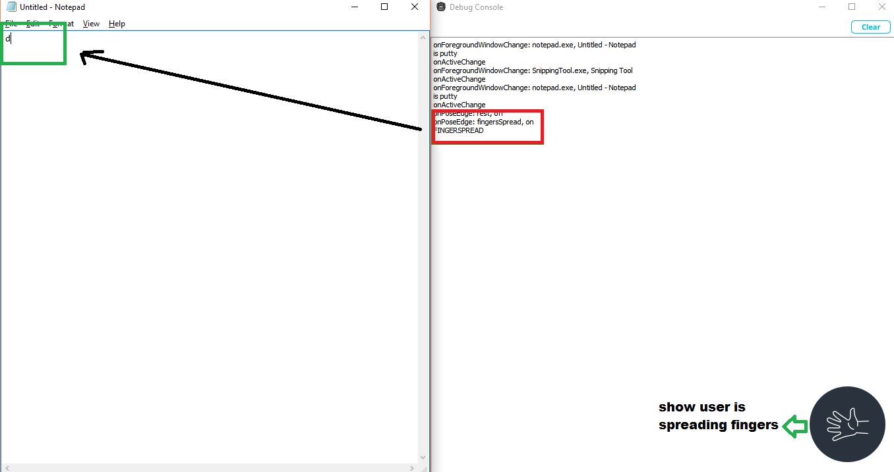

***Conclusion***

The test confirmed that Myo armband can read users’ gestures and send the gestural data to the laptop correctly. And it confirmed that the armband can control designed keys on the keyboard.

### <Stepper Motor Control Test>

***Test Overview***

The purpose of the test was to check if the stepper motor can be controlled by input of keyboard. The controlling method includes two parts: key (button) controlling and keyboard input controlling. The test of key controlling is to test if the stepper motor can receive the gestural instructions correctly and rotates in designed angle (180 degrees). And the test of keyboard input controlling is to test if the stepper motor can receive the rolling instructions correctly and rotates in accurate directions and literally precise angles.

***Test Setup***

Connect the stepper motor to the motor driver with red and yellow wires in loop A and green and grey wires in loop B. The driver is powered by the 5V input from Raspberry Pi. The direction pin on the drivers is connected to pin 18 (GPIO pin 24) on the raspberry and the steps pin is connected to pin 16 (GPIO pin 23). For the gestural (key) control, run “motorcontrol.py” on the Raspberry Pi. Then the terminal shows “You pressed:”. And press ‘d’ or ‘D’ to test if the stepper motor rotates clockwise in 180 degrees. Press ‘a’ or ‘A’ to test if the stepper motor rotates counterclockwise in 180 degrees. For the rolling (keyboard input) control, run “motorcontrol1.py” on the Raspberry Pi. Then the terminal shows “Input a value:”. Input any value to test if the stepper motor rotates in the correct direction which ‘+’ for clockwise and ‘-’ for counterclockwise. Also test if the stepper motor rotates in precise angle from input values.

***Data***

The figure below shows the stepper motor reads the gestural instruction which the user spreads fingers (Press ‘a’ or ‘A’ on the keyboard) and rotates 180 degrees counterclockwise.

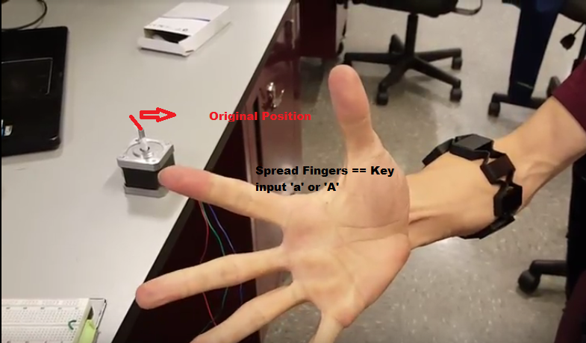

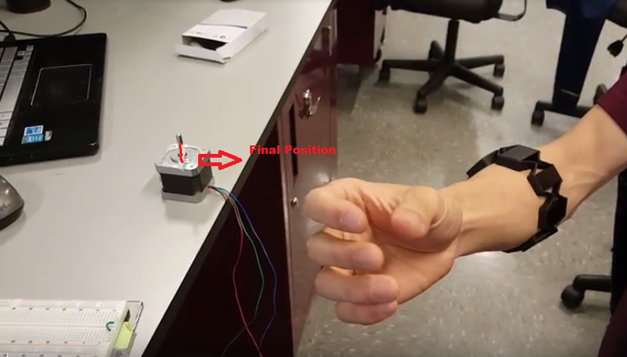

The figure below shows the stepper motor reads the gestural instruction which the user makes a fist (Press ‘d’ or ‘D’ on the keyboard) and rotates 180 degrees counterclockwise.

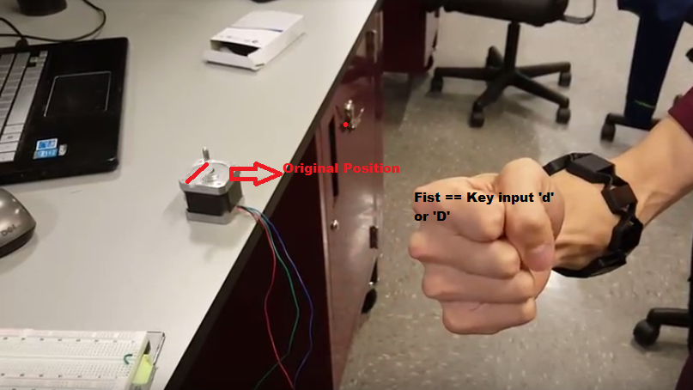

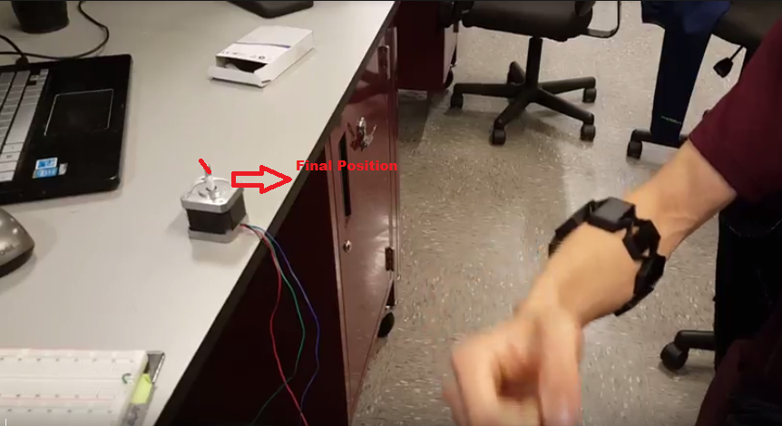

The figures below show the stepper motor reads orientation data which the user rolls counterclockwise and clockwise and rotates in literally same angle as user’s arm.

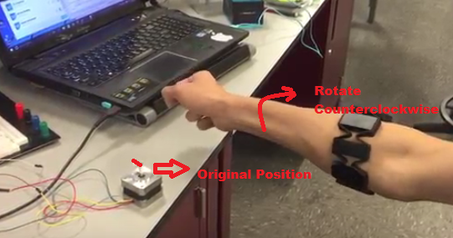

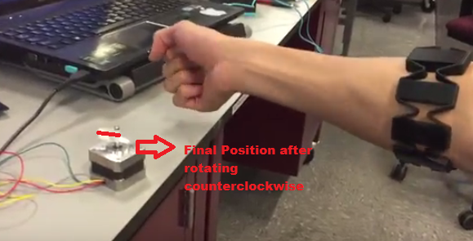

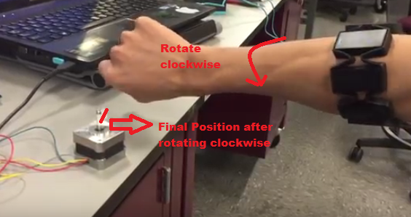

***Conclusion***

The test confirmed that the stepper motor can read both key (gestural) input and keyboard (orientation) input correctly from the Raspberry Pi. And the stepper motor can do the correct movements as expected.

5.5.3 <Myo Orientation Data Reading Test>

***Test Overview***

The purpose of the test was to check if the Myo armband can read and output orientation data of rolling. The main purpose of the test was to see if the output orientation data is matching to the user’s arm’s movement, especially when the user rolls clockwise or counterclockwise.

***Test Setup***

Install MYO CONNECT on the laptop. The software allows users to open the application associated with the gesture reading. Open Application Manager on the software and turn on the application whose name is ‘Output Orientation’. A debug console should be open after the application is activated. Wear the Myo armband on the right/left arm and do wave-out gesture to synchronize the armband with the application manager. The software shows if the sync is completed. After the sync is completed, open a Notepad terminal.

***Data***

The figure below shows the output orientation data when the user rolls his arm. The Myo armband can output two types of data: current angle and the angle change. The angle changes is used in the project which are showed in the red square box and the values of the data is approximated to integer. Then the laptop input these values to the Notepad terminal. When the user rolls clockwise, the values are positive. When the user rolls counterclockwise, the values are negative.

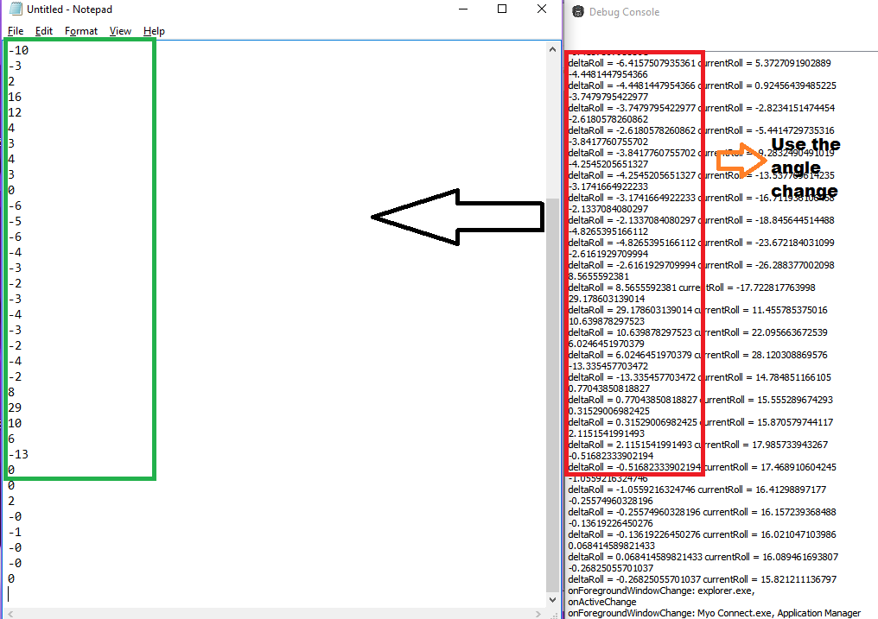

***Conclusion***

The test confirmed that the Myo armband can read the orientation data of rolling and it can send the data to the laptop. And the laptop can grab the data that the project needs and send it as keyboard input.

# Conclusions

This report shows the completion of the entire system for the Robotic Arm Vehicle. There have been many milestones accomplished with this project for each subsystem presented. It combines electronics, software, and mechanics heavily and it’s important to document the progression of each side because of how much the team has learned from designing, coding, and building each subsystem. Currently, all the subsystems are working and have been fully integrated with each other. The focus of this semester has primarily been on the programs necessary to run the system and the background protocols. This team has done a lot of work on many different types of electrical design, and we are very grateful to have had the opportunity to finish this project with all the subsystems fully integrated.

Budget Table

Table A-1: Project Budget

|  |  |  |  |  |
| --- | --- | --- | --- | --- |
| Description | Quantity | Item Cost | Shipping | Subtotal |
| Lynxmotion Robotic Arm | 1 | $0 | 0 | $0 |
| Keyboard | 1 | $10.70 | 0 | $10.70 |
| Wood | 4 | $20.20 | 0 | $20.20 |
| Screws | 50 | $2.48 | 0 | $2.48 |
| Corner Bracket | 4 | $2.98 | 0 | $2.98 |
| Drill Bits | 10 | $15.98 | 0 | $15.98 |
| Spray Pin | 20 | $5.88 | 0 | $5.88 |
| Buck Converter | 1 | $12.60 | 0 | $12.60 |
| Panda Wireless PAU06 | 1 | $19.99 | 0 | $19.99 |
| Raspberry Pi 2 Model B | 1 | $49.99 | 0 | $49.99 |
| AD/DA Expansion Board | 1 | $38.99 | 0 | $38.99 |
| PB4600 External Power Supply | 1 | $19.99 | 0 | $19.99 |
| EXP12200 12 Volt 20 Ah Battery | 1 | $40.00 | 0 | $40.00 |
| 12 V Battery Charger | 1 | $19.88 | 0 | $19.88 |
| Saitek ST290 Programmable Joystick | 1 | $25.95 | 0 | $25.95 |
| Adafruit Accessories Flex Cable For camera | 1 | $8.99 | 0 | $8.99 |
| Hitec 31805S HS-805BB Mega Giant Scale 2BB Servo | 1 | $38.99 | 0 | $38.99 |
| H-bridge | 1 | $8.00 | 0 | $8.00 |
|  |  |  | Total | $341.59 |

Control Subsystem Code

*#Calibration File for Servo Motor Controls*

*#MotorTests404.py*

*#============================================================================================*

*#!/usr/bin/python  
  
from __future__ import division  
import time  
import socket  
import binascii  
import sys  
import Adafruit_PCA9685  
  
# Initialise the PWM device using the default address  
pwm = Adafruit_PCA9685.PCA9685()  
  
#============================================================================================  
# ORIGIN INITIALIZATION AND DEFINITIONS  
#============================================================================================  
  
# Adafruit's Servo Motor Definition found at:* [*https://learn.adafruit.com/downloads/pdf/adafruit-16-channel-servo-driver-with-raspberry-pif*](https://learn.adafruit.com/downloads/pdf/adafruit-16-channel-servo-driver-with-raspberry-pif)

*setServoPulse(channel, pulse):  
 pulseLength = 1000000 # 1,000,000 us per second  
 pulseLength /= 60 # 60 Hz  
 print ("%d us per period" % pulseLength)  
 pulseLength /= 4096 # 12 bits of resolution  
 print ("%d us per bit" % pulseLength)  
 pulse *= 1000  
 pulse /= pulseLength  
 pwm.set_pwm(channel, 0, pulse)  
  
   
# All pulse lengths are out of 4096  
Shoulder_Origin_1 = 1255 # Middle pulse = 1262.5  
Shoulder_Origin_2 = 1210 # Middle pulse = 1187.5   
Elbow_Origin_1 = 800 # Minimum pulse   
Wrist_Origin_1 = 1280 # Middle pulse  
Wrist_Origin_2 = 1250 # Middle pulse  
  
#Initialize Pulses at the specified origin of the User  
StepSize = 10 # Decrease for Precision, Increase for speed  
Shoulder_1 = Shoulder_Origin_1  
Shoulder_2 = Shoulder_Origin_2  
Elbow_1 = Elbow_Origin_1  
Wrist_1 = Wrist_Origin_1  
Wrist_2 = Wrist_Origin_2  
  
#Initialize Duty Cycles  
Shoulder_1_DTY = 0  
Shoulder_2_DTY = 0  
Elbow_1_DTY = 0  
Wrist_1_DTY = 0  
Wrist_2_DTY = 0  
  
# Set PWM Driver Frequency  
SlowFreq = 550  
MediumFreq = 600  
FastFreq = 650  
   
# Set Arm to origin position until user calibration  
pwm.set_pwm(15, 0, Shoulder_Origin_1)  
pwm.set_pwm(14, 0, Shoulder_Origin_2)  
pwm.set_pwm(13, 0, Elbow_Origin_1)  
pwm.set_pwm(12, 0, Wrist_Origin_1)  
pwm.set_pwm(11, 0, Wrist_Origin_2)  
  
#pwm.set_pwm_freq(SlowFreq) # Set frequency to 60 Hz  
#pwm.set_pwm_freq(MediumFreq) # Set frequency to 60 Hz  
#pwm.set_pwm_freq(FastFreq) # Set frequency to 60 Hz  
  
#=====================================================================================================  
# ARM MOVEMENT DEFINITIONS  
#=====================================================================================================  
# Returns a single character from standard input  
# This definition was obtained from: http://stackoverflow.com/questions/22397289/finding-the-values-of-the-arrow-keys-in-python-why-are-they-triples  
  
def getchar():  
 import tty, termios, sys  
 fd = sys.stdin.fileno()  
 old_settings = termios.tcgetattr(fd)  
 try:  
 tty.setraw(sys.stdin.fileno())  
 ch = sys.stdin.read(1) #get input from keyboard  
 finally:  
 termios.tcsetattr(fd, termios.TCSADRAIN, old_settings)  
 return ch  
  
print ('Press Q to exit into Mode 2')  
  
# Returns a single Duty Cycle for the specific motor excited  
def getDTY(Pulse):  
 DTY = float((Pulse/4096)*100)  
 return DTY  
  
# ----------------------------------------------------------------------------------------  
#Returns a single angle for the position of the specific motor with respect to the origin  
#Shoulder 1  
def angle1(Pulse):  
 Min_Pulse = 485  
 Max_Pulse = 2025  
 Min_Range = 0  
 Max_Range = 180  
 theta = ((Pulse - Min_Pulse)/(Max_Pulse - Min_Pulse))*180  
 return theta  
#Shoulder 2  
def angle2(Pulse):  
 Min_Pulse = 540  
 Max_Pulse = 1880  
 Min_Range = 0  
 Max_Range = 180  
 theta = ((Pulse - Min_Pulse)/(Max_Pulse - Min_Pulse))*135  
 return theta  
#Elbow 1  
def angle3(Pulse):  
 Min_Pulse = 800   
 Max_Pulse = 1520  
 Min_Range = 0  
 Max_Range = 135  
 theta = ((Pulse - Min_Pulse)/(Max_Pulse - Min_Pulse))*135  
 return theta  
#Wrist 1  
def angle4(Pulse):  
 Min_Pulse = 520  
 Max_Pulse = 2040  
 Min_Range = -90  
 Max_Range = 90  
 theta = ((Pulse - Min_Pulse)/(Max_Pulse - Min_Pulse))*180  
 return theta  
#Wrist 2  
def angle5(Pulse):  
 Min_Pulse = 400  
 Max_Pulse = 2100  
 Min_Range = -90  
 Max_Range = 90  
 theta = ((Pulse - Min_Pulse)/(Max_Pulse - Min_Pulse))*180  
 return theta  
  
# ----------------------------------------------------------------------------------------  
# Specific Angles are calculation   
def getPulse1(Angle):  
 Min_Pulse = 485  
 Max_Pulse = 2025  
 Min_Range = 0  
 Max_Range = 180  
 Pulse = ((Angle/180)*(Max_Pulse - Min_Pulse)) + Min_Pulse  
 return Pulse  
  
def getPulse2(Angle):  
 Min_Pulse = 540  
 Max_Pulse = 1880  
 Min_Range = 0  
 Max_Range = 135  
 Pulse = ((Angle/135)*(Max_Pulse - Min_Pulse)) + Min_Pulse  
 return Pulse  
  
def getPulse3(Angle):  
 Min_Pulse = 800   
 Max_Pulse = 1520  
 Min_Range = 0  
 Max_Range = 135  
 Pulse = ((Angle/135)*(Max_Pulse - Min_Pulse)) + Min_Pulse  
 return Pulse  
   
def getPulse4(Angle):  
 Min_Pulse = 520  
 Max_Pulse = 2040  
 Min_Range = -90  
 Max_Range = 90  
 Pulse = ((Angle/180)*(Max_Pulse - Min_Pulse)) + Min_Pulse  
 return Pulse  
   
def getPulse5(Angle):  
 Min_Pulse = 400  
 Max_Pulse = 2100  
 Min_Range = -90  
 Max_Range = 90  
 Pulse = ((Angle/180)*(Max_Pulse - Min_Pulse)) + Min_Pulse  
 return Pulse  
   
# ================================================================================================  
# Set Pulse, Get Angle Mode  
while True:  
   
 ch = getchar()  
  
 #Shoulder Motor 1  
 if ch=='a' or ch=='A': # Left  
 while ch == 'a' or ch == 'A':  
 pwm.set_pwm(15, 0, Shoulder_1)  
 Shoulder_1 = Shoulder_1 + StepSize  
 Shoulder_1_DTY = round(getDTY(Shoulder_1), 2)  
 Shoulder_Angle_1 = round(angle1(Shoulder_1), 2)  
 print ('Shoulder Motor 1 Pulse is', Shoulder_1)  
 print ('Shoulder Motor 1 Duty Cycle is', Shoulder_1_DTY)  
 print ('Shoulder Motor 1 is at', Shoulder_Angle_1, 'degrees from the origin')  
 ch = 'r' # r for reset  
 time.sleep(0.01)  
 if Shoulder_1 >= 620:  
 #Shoulder_1 = Shoulder_1 - StepSize  
 print ('Shoulder Motor 1 Upper Bound Met')  
 elif ch=='d' or ch=='D': # Right  
 while ch == 'd' or ch == 'D':  
 pwm.set_pwm(15, 0, Shoulder_1)  
 Shoulder_1 = Shoulder_1 - StepSize  
 Shoulder_1_DTY = round(getDTY(Shoulder_1), 2)  
 Shoulder_Angle_1 = round(angle1(Shoulder_1), 2)  
 print ('Shoulder Motor 1 Pulse is', Shoulder_1)  
 print ('Shoulder Motor 1 Duty Cycle is', Shoulder_1_DTY)  
 print ('Shoulder Motor 1 is at', Shoulder_Angle_1, 'degrees from the origin')  
 ch = 'r' # r for reset  
 time.sleep(0.01)  
 if Shoulder_1 <= 150:  
 #Shoulder_1 = Shoulder_1 + StepSize  
 print ('Shoulder Motor 1 Lower Bound Met')  
  
   
 #Shoulder Motor 2   
 if ch=='w' or ch=='W': # Left  
 while ch == 'w' or ch == 'W':  
 pwm.set_pwm(14, 0, Shoulder_2)  
 Shoulder_2 = Shoulder_2 + StepSize  
 Shoulder_2_DTY = round(getDTY(Shoulder_2), 2)  
 Shoulder_Angle_2 = round(angle2(Shoulder_2), 2)  
 print ('Shoulder Motor 2 Pulse is', Shoulder_2)  
 print ('Shoulder Motor 2 Duty Cycle is', Shoulder_2_DTY)  
 print ('Shoulder Motor 2 is at', Shoulder_Angle_2, 'degrees from the origin')  
 ch = 'r' # r for reset  
 time.sleep(0.01)  
 if Shoulder_2 >= 510:  
 #Shoulder_2 = Shoulder_2 - StepSize  
 print ('Shoulder Motor 2 Upper Bound Met')  
   
 elif ch=='s' or ch=='S': # Right  
 while ch == 's' or ch == 'S':  
 pwm.set_pwm(14, 0, Shoulder_2)  
 Shoulder_2 = Shoulder_2 - StepSize  
 Shoulder_2_DTY = round(getDTY(Shoulder_2), 2)  
 Shoulder_Angle_2 = round(angle2(Shoulder_2), 2)  
 print ('Shoulder Motor 2 Pulse is', Shoulder_2)  
 print ('Shoulder Motor 2 Duty Cycle is', Shoulder_2_DTY)  
 print ('Shoulder Motor 2 is at', Shoulder_Angle_2, 'degrees from the origin')  
 ch = 'r' # r for reset  
 time.sleep(0.01)  
 if Shoulder_2 <= 250:  
 #Shoulder_2 = Shoulder_1 + StepSize  
 print ('Shoulder Motor 2 Lower Bound Met')  
  
  
   
 #Elbow Motor 1   
 if ch=='t' or ch=='T': # Left  
 while ch == 't' or ch == 'T':  
 pwm.set_pwm(13, 0, Elbow_1)  
 Elbow_1 = Elbow_1 + StepSize  
 Elbow_1_DTY = round(getDTY(Elbow_1), 2)  
 Elbow_Angle_1 = round(angle3(Elbow_1), 2)  
 print ('Elbow Motor 1 Pulse is', Elbow_1)  
 print ('Elbow Motor 1 Duty Cycle is', Elbow_1_DTY)  
 print ('Elbow Motor 1 is at', Elbow_Angle_1, 'degrees from the origin')  
 ch = 'r' # r for reset  
 time.sleep(0.01)  
 if Elbow_1 >= 530:  
 #Elbow_1 = Elbow_1 - StepSize  
 print ('Elbow Motor 1 Upper Bound Met')  
  
 elif ch=='g' or ch=='G': # Right  
 while ch == 'g' or ch == 'G':  
 pwm.set_pwm(13, 0, Elbow_1)  
 Elbow_1 = Elbow_1 - StepSize  
 Elbow_1_DTY = round(getDTY(Elbow_1), 2)  
 Elbow_Angle_1 = round(angle3(Elbow_1), 2)  
 print ('Elbow Motor 1 Pulse is', Elbow_1)  
 print ('Elbow Motor 1 Duty Cycle is', Elbow_1_DTY)  
 print ('Elbow Motor 1 is at', Elbow_Angle_1, 'degrees from the origin')  
 ch = 'r' # r for reset  
 time.sleep(0.01)  
 if Elbow_1 <= 165:  
 #Elbow_1 = Elbow_1 + StepSize  
 print ('Elbow Motor 1 Lower Bound Met')  
  
  
  
 #Wrist Motor 1  
 if ch=='j' or ch=='J': # Left  
 while ch == 'j' or ch == 'J':  
 pwm.set_pwm(12, 0, Wrist_1)  
 Wrist_1 = Wrist_1 + StepSize  
 Wrist_1_DTY = round(getDTY(Wrist_1), 2)  
 Wrist_Angle_1 = round(angle4(Wrist_1), 2)  
 print ('Wrist Motor 1 Pulse is', Wrist_1)  
 print ('Wrist Motor 1 Duty Cycle is', Wrist_1_DTY)  
 print ('Wrist Motor 1 is at', Wrist_Angle_1, 'degrees from the origin')  
 ch = 'r' # r for reset  
 time.sleep(0.01)  
 if Wrist_1 >= 650:  
 #Wrist_1 = Wrist_1 - StepSize  
 print ('Wrist Motor 1 Upper Bound Met')  
  
 elif ch=='l' or ch=='L': # Right  
 while ch == 'l' or ch == 'L':  
 pwm.set_pwm(12, 0, Wrist_1)  
 Wrist_1 = Wrist_1 - StepSize  
 Wrist_1_DTY = round(getDTY(Wrist_1), 2)  
 Wrist_Angle_1 = round(angle4(Wrist_1), 2)  
 print ('Wrist Motor 1 Pulse is', Wrist_1)  
 print ('Wrist Motor 1 Duty Cycle is', Wrist_1_DTY)  
 print ('Wrist Motor 1 is at', Wrist_Angle_1, 'degrees from the origin')  
 ch = 'r' # r for reset  
 time.sleep(0.01)  
 if Wrist_1 <= 140:  
 #Wrist_1 = Wrist_1 + StepSize  
 print('Wrist Motor 1 Lower Bound Met')  
  
  
 #Wrist Motor 2  
 if ch=='i' or ch=='I': # Left  
 while ch == 'i' or ch == 'I':  
 pwm.set_pwm(11, 0, Wrist_2)  
   
  
 Wrist_2 = Wrist_2 + StepSize  
 Wrist_2_DTY = round(getDTY(Wrist_2), 2)  
 Wrist_Angle_2 = round(angle5(Wrist_2), 2)  
 print ('Wrist Motor 2 Pulse is', Wrist_2)  
 print ('Wrist Motor 2 Duty Cycle is', Wrist_2_DTY)  
 print ('Wrist Motor 2 is at', Wrist_Angle_2, 'degrees from the origin')  
 ch = 'r' # r for reset  
 time.sleep(0.01)  
 if Wrist_2 >= 610:  
 #Wrist_2 = Wrist_2 - StepSize  
 print ('Wrist Motor 2 Upper Bound Met')  
  
 elif ch=='k' or ch=='K': # Right  
 while ch == 'k' or ch == 'K':  
 pwm.set_pwm(11, 0, Wrist_2)  
 Wrist_2 = Wrist_2 - StepSize  
 Wrist_2_DTY = round(getDTY(Wrist_2), 2)  
 Wrist_Angle_2 = round(angle5(Wrist_2), 2)  
 print ('Wrist Motor 2 Pulse is', Wrist_2)  
 print ('Wrist Motor 2 Duty Cycle is', Wrist_2_DTY)  
 print ('Wrist Motor 2 is at', Wrist_Angle_2, 'degrees from the origin')  
 ch = 'r' # r for reset  
 time.sleep(0.01)  
 if Wrist_2 <= 100:  
 Wrist_2 = Wrist_2 + StepSize  
 print ('Wrist Motor 2 Lower Bound Met')  
  
   
# Vary PWM Frequency  
 if ch=='b' or ch=='B': # Left  
 while ch == 'b' or ch == 'B':  
 FastFreq = FastFreq + 1  
 pwm.set_pwm_freq(FastFreq)   
 print ('Current Frequency is', FastFreq)  
 ch = 'r' # r for reset  
 time.sleep(0.01)  
 elif ch=='n' or ch=='N': # Right  
 while ch == 'n' or ch == 'N':  
 FastFreq = FastFreq - 1  
 pwm.set_pwm_freq(FastFreq)   
 print ('Current Frequency is', FastFreq)  
 ch = 'r' # r for reset  
 time.sleep(0.01)  
   
   
# Reset Arm and Change Step Size  
 if ch=='o' or ch=='O': # Left  
 while ch == 'o' or ch == 'O':  
 print ('Current StepSize:', StepSize)  
 StepSize = input("Enter a new StepSize: ")  
 pwm.set_pwm(15, 0, Shoulder_Origin_1)  
 pwm.set_pwm(14, 0, Shoulder_Origin_2)  
 pwm.set_pwm(13, 0, Elbow_Origin_1)  
 pwm.set_pwm(12, 0, Wrist_Origin_1)  
 pwm.set_pwm(11, 0, Wrist_Origin_2)  
 ch = 'r' # r for reset  
 time.sleep(0.01)  
  
# Quit Mode  
 elif ch=='q' or ch=='Q':  
 pwm.set_pwm(15, 4096, 0)  
 pwm.set_pwm(14, 4096, 0)  
 pwm.set_pwm(13, 4096, 0)  
 pwm.set_pwm(12, 4096, 0)  
 pwm.set_pwm(11, 4096, 0)  
 break  
 else:  
 print ('====================================================')  
  
def AngleCorrection(SAngle, EAngle):  
 if (SAngle > 35 and EAngle > 35) and (SAngle < 75 and EAngle > 75) :  
 SAngle = SAngle + 10  
 return SAngle  
 else:  
 return SAngle  
  
def EAngleCorrect(SAngle, EAngle, WAngle):  
 if EAngle <= 15 and (WAngle >= 150 and WAngle <= 180) and (SAngle >= 90 and SAngle <= 110):  
 EAngle = EAngle - 20  
 return EAngle  
  
def EAngleCorrect2(EAngle): #, SAngle):  
 if EAngle > 90 and EAngle < 135: # and SAngle < 22.5:  
 EAngle = EAngle - 20  
 elif EAngle > 135:  
 EAngle = EAngle - 22.5  
 return EAngle  
  
def WAngleCorrect(WAngle):  
 if WAngle > 0 and WAngle < 22.5:  
 WAngle = WAngle + 15  
 elif WAngle < 0 and WAngle > -22.5:  
 WAngle = WAngle - 15  
 return WAngle  
  
   
# ================================================================================================  
# Set Angle, Get a Pulse Mode   
while (True):  
#Quit  
 ch2 = getchar()  
 if ch2 == 'q' or ch2 == 'Q':  
 break  
 elif ch2 == 't' or ch2 == 'T':  
 pwm.set_pwm(15, 4096, 0)  
 pwm.set_pwm(14, 4096, 0)  
 pwm.set_pwm(13, 4096, 0)  
 pwm.set_pwm(12, 4096, 0)  
 pwm.set_pwm(11, 4096, 0)  
 else:  
 print ('====================================================')  
  
 #All views are from behind the robot!  
 #Shoulder 1, Left is 180, Right is 0 (Not on tests)  
 #Shoulder 2, Forward is 0, Backward is 135 (Follows Test)  
 #Elbow, Down is 0, Up is 135 (Follows Test)  
 #Wrist 1, Forward is 0, Backward is 180 (Follows Test)  
 #Wrist 2, Controlled by Myo (Not on tests)  
   
 #print ('Mapping Angles from the Kinect are as follows:')  
 #print ('Shoulder 1 Motor ranges from 0 to 180 degrees')  
 #print ('Shoulder 2 Motor ranges from 0 to 180 degrees')  
 #print ('Elbow 1 Motor ranges from 0 to 150 degrees')  
 #print ('Wrist 1 Motor ranges from 0 to 180 degrees')  
 #print ('Wrist 2 Motor ranges from 0 to 180 degrees')  
 #print ('')  
 #print ('Shoulder 1 Origin = 90 degrees')  
 #print ('Shoulder 2 Origin = 0 degrees')  
 #print ('Elbow 1 Origin = 0 degrees')  
 #print ('Wrist 1 Origin = 0 degrees')  
 #print ('Wrist 2 Origin = 0 degrees')  
 #print ('')  
 #print ('')  
  
 Shoulder_Angle_1 = input("Enter an Angle for Shoulder 1: ")  
 Shoulder_Angle_2 = -input("Enter an Angle for Shoulder 2: ") + 90  
 Elbow_Angle_1 = input("Enter an Angle for Elbow 1: ")  
 Wrist_Angle_1 = -input("Enter an Angle for Wrist 1: ") + 90  
 Wrist_Angle_2 = input("Enter an Angle for Wrist 2: ") + 90  
   
 Shoulder_Angle_2 = AngleCorrection(Shoulder_Angle_2, Elbow_Angle_1)  
 Elbow_Angle_1 = EAngleCorrect(Shoulder_Angle_2, Elbow_Angle_1, Wrist_Angle_1) # Shoulder_Angle_2)  
   
 Shoulder_Pulse_1 = int(round(getPulse1(Shoulder_Angle_1), 2))  
 Shoulder_Pulse_2 = int(round(getPulse2(Shoulder_Angle_2), 2))  
 Elbow_Pulse_1 = int(round(getPulse3(Elbow_Angle_1), 2))  
 Wrist_Pulse_1 = int(round(getPulse4(Wrist_Angle_1), 2))  
 Wrist_Pulse_2 = int(round(getPulse5(Wrist_Angle_2), 2))  
  
   
 pwm.set_pwm(15, 0, Shoulder_Pulse_1)  
 pwm.set_pwm(14, 0, Shoulder_Pulse_2)  
 pwm.set_pwm(13, 0, Elbow_Pulse_1)  
 pwm.set_pwm(12, 0, Wrist_Pulse_1)  
 pwm.set_pwm(11, 0, Wrist_Pulse_2)  
   
 #print ('Shoulder 1 Pulse:', Shoulder_Pulse_1)  
 print ('Shoulder 2 Pulse:', Shoulder_Pulse_2)  
 print ('Elbow 1 Pulse:', Elbow_Pulse_1)  
 print ('Wrist 1 Pulse:', Wrist_Pulse_1)  
 #print ('Wrist 2 Pulse:', Wrist_Pulse_2)  
   
 time.sleep(1)*

*###===================================###*

*###===================================###*

*###===================================###*

#Joystick code

#Joystick5.py

**from** __future__ **import** division

**import** RPi.GPIO **as** GPIO

**import** Adafruit_GPIO.SPI **as** SPI

**import** Adafruit_MCP3008

**import** smbus

**import** sys

**import** time

**import** math

**import** os, struct, array

**import** socket *# Import socket module*

**import** pickle

**import** numpy **as** np

**from** fcntl **import** ioctl

comms_socket = socket.socket()

comms_socket.bind((**'0.0.0.0'**, 50001))

comms_socket.listen(10)

s, address = comms_socket.accept()

GPIO.setwarnings(False)

GPIO.setmode(GPIO.BCM)

**def** motorGo(motor, direction, JVar1, JVar2, turning):

**if** turning == True:

JVar = JVar1

*#print('Turning')*

Step3 = 15

Step2 = 10

Step1 = 5

**else**:

JVar = JVar2

*#print('NOT Turning')*

Step3 = 15

Step2 = 10

Step1 = 5

**if** motor <= 1:

**if** direction <= 4:

**if** direction <= 1:

GPIO.output(InputCW[motor], GPIO.HIGH)

**else** :

GPIO.output(InputCW[motor], GPIO.LOW)

**if** direction == 0 **or** direction == 2:

GPIO.output(InputCCW[motor], GPIO.HIGH)

**else**:

GPIO.output(InputCCW[motor], GPIO.LOW)

**if** abs(JVar) > 0.67:

p1.start(Step3)

p2.start(Step3 + 3)

**if** (JVar2 < -0.15):

p1.start(Step3)

p2.start(Step3 + 1)

**elif** (JVar2 > 0.15):

p1.start(Step3)

p2.start(Step3 + 5)

**elif** abs(JVar) < 0.67 **and** abs(JVar) > 0.34:

p1.start(Step2)

p2.start(Step2 + 3)

**elif** abs(JVar) < 0.34 **and** abs(JVar) > 0.10:

p1.start(Step1)

p2.start(Step1 + 3)

**else**:

p1.start(0)

p2.start(0)

**return**

**def** motorStop(motor):

**if** motor == 0:

p1.start(0)

**elif** motor == 1:

p2.start(0)

**return**

*# 4 GPIO's*

*# 2 PWM's*

InputCW = [27, 23] *# 27 = Motor 1, 23 = Motor 2*

InputCCW = [22, 24] *# 22 = Motor 1, 24 = Motor 2*

MOTORA1 = 27 *# J13*

MOTORB1 = 22 *# J15*

MOTORA2 = 23 *# J16*

MOTORB2 = 24 *# J18*

PWMch1 = 4 *# J7*

PWMch2 = 17 *# J11*

CW = 1

CCW = 2

PWMvalLeft = 40

PWMvalRight = 40

PWMfreq = 500

*# Motor 1*

GPIO.setup(MOTORA1, GPIO.OUT)

GPIO.setup(MOTORB1, GPIO.OUT)

GPIO.setup(PWMch1, GPIO.OUT)

GPIO.output(MOTORA1, GPIO.LOW)

GPIO.output(MOTORB1, GPIO.LOW)

p1 = GPIO.PWM(PWMch1, PWMfreq)

*# Motor 2*

GPIO.setup(MOTORA2, GPIO.OUT)

GPIO.setup(MOTORB2, GPIO.OUT)

GPIO.setup(PWMch2, GPIO.OUT)

GPIO.output(MOTORA2, GPIO.LOW)

GPIO.output(MOTORB2, GPIO.LOW)

p2 = GPIO.PWM(PWMch2, PWMfreq)

*###===================================###*

*###===================================###*

*###===================================###*

*#print '%d axes found: %s' % (num_axes, ', '.join(axis_map))*

*#print '%d buttons found: %s' % (num_buttons, ', '.join(button_map))*

*# Forward: y = -1*

*# Reverse: y = 1*

*# Left: x = -1*

*# Right: x = 1*

CurrentDirection = 0

Forward = False

Reverse = False

Left = False

Right = False

direction = CW

StoppedMotor = 0

TurningMotor = 0

Turning = False

*###===================================###*

*###===================================###*

*###===================================###*

*# Main event loop*

**while** True:

data = [None]

data = s.recv(4096)

a = pickle.loads(data)

a = np.around(a, 3)

*#print(a)*

*#Joystick Movement*

**if** (a[0] <= 0.35 **or** a[0] >= -0.35) **and** a[1] > 0.25:

direction = 1 *# CW = 1*

Turning = False

motorGo(0, direction, a[0], a[1], Turning)

motorGo(1, direction, a[0], a[1], Turning)

*#print('Forward')*

**elif** (a[0] <= 0.35 **or** a[0] >= -0.35) **and** a[1] < -0.25:

direction = 2 *# CCW = 2*

Turning = False

motorGo(0, direction, a[0], a[1], Turning)

motorGo(1, direction, a[0], a[1], Turning)

*#print('Backward')*

**elif** a[0] > 0.25 **and** (a[1] <= 0.35 **or** a[1] >= -0.35):

TurningMotor = 0 *# Left = 0*

StoppedMotor = 1

Turning = True

motorGo(TurningMotor, CCW, a[0], a[1], Turning)

motorStop(StoppedMotor)

*#print('Left')*

**elif** a[0] < -0.25 **and** (a[1] <= 0.35 **or** a[1] >= -0.35):

TurningMotor = 1 *# Right = 1*

StoppedMotor = 0

Turning = True

motorGo(TurningMotor, CCW, a[0], a[1], Turning)

motorStop(StoppedMotor)

**else**:

motorStop(0)

motorStop(1)

*###===================================###*

*###===================================###*

*###===================================###*

#GUI code

#main.py

**from** __future__ **import** division

**import** socket

**import** binascii

**import** pickle

**import** sys

**import** subprocess

**from** subprocess **import** Popen

**import** time

**import** re

**import** os

**import** smtplib

**from** Tkinter **import** *

**def** get_os():

version = os.uname()[0]

**print 'Version: '** + version

**return** version

**def** get_internal_ip(version):

**if** version == **'Darwin'**:

internal_ip = subprocess.check_output([**'/sbin/ifconfig'**,**'en0'**])

**print** internal_ip

internal_ip = re.search(**'inet ([\d\.]*)'**, internal_ip)

**if** version == **'Linux'**:

internal_ip = subprocess.check_output([**'/sbin/ifconfig'**,**'wlan0'**])

internal_ip = re.search(**'inet addr:([\d\.]*)'**, internal_ip)

**print** internal_ip

internal_ip = internal_ip.group(1)

**return** internal_ip

time.sleep(5)

version = get_os()

internal_ip = get_internal_ip(version)

**print**(**'IP Adress: '**, internal_ip)

*# Open lastip.txt*

**with** open(**'/home/pi/MAIN/lastip.txt'**,**'rt'**) **as** last_ip:

last_ip = last_ip.read()

*# Check to see if IP has changed*

**if** last_ip == internal_ip:

**print**(**"IP is the same"**)

**else**:

**print**(**"NEW IP"**)

**with** open(**'/home/pi/MAIN/lastip.txt'**,**'wt'**) **as** last_ip:

last_ip.write(internal_ip)

*# Create a TCP/IP socket*

comms_socket= socket.socket(socket.AF_INET, socket.SOCK_DGRAM)

*# Bind the socket to the port*

server_address = (internal_ip, 50001)

comms_socket.bind(server_address)

ToggleJoystick = False

ToggleArm = False

ToggleMyo = False

ToggleCamera = False

**def** runJoystick(Toggle):

*#global ToggleJoystick*

*#ToggleJoystick = not ToggleJoystick*

*#print(ToggleJoystick)*

**if** Toggle == True:

**global** JoystickProcess

JoystickProcess = subprocess.Popen([sys.executable,**'Joystick5.py'**])

**else**:

JoystickProcess.terminate()

*#time.sleep(3)*

**def** runRobotArm(Toggle):

*#global ToggleArm*

*#ToggleArm = not ToggleArm*

*#print(ToggleArm)*

**if** Toggle == True:

**global** ArmProcess

ArmProcess = subprocess.Popen([sys.executable, **'MotorTests404.py'**])

**else**:

ArmProcess.terminate()

*#time.sleep(3)*

**def** runMyo(Toggle):

*#global ToggleMyo*

*#ToggleMyo = not ToggleMyo*

*#print(ToggleMyo)*

**global** MyoProcess

**if** ToggleMyo == True:

MyoProcess = subprocess.Popen([sys.executable, **'Myo.py'**])

**else**:

MyoProcess.terminate()

*#time.sleep(3)*

**def** runCamera(Toggle):

*#global ToggleCamera*

*#ToggleCamera = not ToggleCamera*

*#print(ToggleCamera)*

**global** CameraProcess

**if** ToggleCamera == True:

CameraProcess = subprocess.Popen([sys.executable, **'Test4.py'**])

**else**:

CameraProcess.terminate()

*#time.sleep(3)*

previous0 = 2

previous1 = 2

previous2 = 2

previous3 = 2

**while** True:

connection, address = comms_socket.recvfrom(4096)

a = pickle.loads(connection)

*#b = map(int,a.split())*

**print**(**'Whole ARRAY: '**, a)

**if** a[0] <> previous0:

**if** a[0] == 1:

ToggleJoystick = True

runJoystick(ToggleJoystick)

**print**(**'a[0]: '**, a[0])

**elif** a[0] == 0:

ToggleJoystick = False

runJoystick(ToggleJoystick)

**print**(**'a[0]: '**, a[0])

**else**:

**pass**

previous0 = a[0]

**else**:

**pass**

**if** a[1] <> previous1:

**if** a[1] == 1:

ToggleArm = True

runRobotArm(ToggleArm)

**print**(**'a[1]: '**, a[1])

**elif** a[1] == 0:

ToggleArm = False

runRobotArm(ToggleArm)

**print**(**'a[1]: '**, a[1])

**else**:

**pass**

previous1 = a[1]

**else**:

**pass**

**if** a[2] <> previous2:

**if** a[2] == 1:

ToggleMyo = True

runMyo(ToggleMyo)

**print**(**'a[2]: '**, a[2])

**elif** a[2] == 0:

ToggleMyo = False

runMyo(ToggleMyo)

**print**(**'a[2]: '**, a[2])

**else**:

**pass**

previous2 = a[2]

**else**:

**pass**

**if** a[3] <> previous3:

**if** a[3] == 1:

ToggleCamera = True

runCamera(ToggleCamera)

**print**(**'a[3]: '**, a[3])

**elif** a[3] == 0:

ToggleCamera = False

runCamera(ToggleCamera)

**print**(**'a[3]: '**, a[3])

**else**:

**pass**

previous3 = a[3]

**else**:

**pass**

*###===================================###*

*###===================================###*

*###===================================###*

#Email IP code

#get_ip.py

**import** re

**import** os

**import** subprocess

**import** smtplib

**import** time

*# Setup our login credentials*

from_address = **'kevintbradshaw@tamu.edu'**

to_address = **'kevintbradshaw@tamu.edu'**

subject = **'Raspberry Pi IP Address'**

username = **'kevobh@gmail.com'**

password = **'993887Ktb'**

**def** get_os():

version = os.uname()[0]

**print 'Version: '** + version

**return** version

**def** get_internal_ip(version):

**if** version == **'Darwin'**:

internal_ip = subprocess.check_output([**'/sbin/ifconfig'**,**'en0'**])

**print** internal_ip

internal_ip = re.search(**'inet ([\d\.]*)'**, internal_ip)

**if** version == **'Linux'**:

internal_ip = subprocess.check_output([**'/sbin/ifconfig'**,**'wlan0'**])

internal_ip = re.search(**'inet addr:([\d\.]*)'**, internal_ip)

**print** internal_ip

internal_ip = internal_ip.group(1)

**return** internal_ip

**def** send_email(internal_ip):

*#Body of the email*

body_text = **'Raspberry Pi Internal IP Address: '** + internal_ip

msg = **'\r\n'**.join([**'To: %s'** % to_address,

**'From: %s'** % from_address,

**'Subject: %s'** % subject,

**''**, body_text])

*#Sending the email*

server = smtplib.SMTP(**'smtp.gmail.com:587'**)

server.starttls()

server.login(username, password)

server.sendmail(from_address, to_address, msg)

server.quit()

*#print("SENT")*

time.sleep(8)

version = get_os()

internal_ip = get_internal_ip(version)

*# Open lastip.txt*

**with** open(**'/home/pi/lastip.txt'**,**'rt'**) **as** last_ip:

last_ip = last_ip.read()

*# Check to see if IP has changed*

**if** last_ip == internal_ip:

**print**(**"IP is the same"**)

**else**:

**print**(**"NEW IP"**)

**with** open(**'/home/pi/lastip.txt'**,**'wt'**) **as** last_ip:

last_ip.write(internal_ip)

send_email(internal_ip)

**Appendix C Communication Subsystem Code**

**Joystick to Pi Communication**

**Joystick Client Side**

**from** math **import** floor, ceil

**import** time

**import** ctypes

**import** _winreg **as** winreg

**from** ctypes.wintypes **import** WORD, UINT, DWORD

**from** ctypes.wintypes **import** WCHAR **as** TCHAR

**import** pickle

**import** socket # Import socket moduleimport time

s = socket.socket() # Create a socket object

s.connect(('10.202.126.110', 50001))

# Fetch function pointers

joyGetNumDevs = ctypes.windll.winmm.joyGetNumDevs

joyGetPos = ctypes.windll.winmm.joyGetPos

joyGetPosEx = ctypes.windll.winmm.joyGetPosEx

joyGetDevCaps = ctypes.windll.winmm.joyGetDevCapsW

# Define constants

MAXPNAMELEN = 32

MAX_JOYSTICKOEMVXDNAME = 260

JOY_RETURNX = 0x1

JOY_RETURNY = 0x2

JOY_RETURNZ = 0x4

JOY_RETURNR = 0x8

JOY_RETURNU = 0x10

JOY_RETURNV = 0x20

JOY_RETURNPOV = 0x40

JOY_RETURNBUTTONS = 0x80

JOY_RETURNRAWDATA = 0x100

JOY_RETURNPOVCTS = 0x200

JOY_RETURNCENTERED = 0x400

JOY_USEDEADZONE = 0x800

JOY_RETURNALL = JOY_RETURNX | JOY_RETURNY | JOY_RETURNZ | JOY_RETURNR | JOY_RETURNU | JOY_RETURNV | JOY_RETURNPOV | JOY_RETURNBUTTONS

# This is the mapping for my XBox 360 controller.

button_names = ['a', 'b', 'x', 'y', 'tl', 'tr', 'back', 'start', 'thumbl', 'thumbr']

povbtn_names = ['dpad_up', 'dpad_right', 'dpad_down', 'dpad_left']

# Define some structures from WinMM that we will use in function calls.

**class JOYCAPS**(ctypes.Structure):

_fields_ = [

('wMid', WORD),

('wPid', WORD),

('szPname', TCHAR * MAXPNAMELEN),

('wXmin', UINT),

('wXmax', UINT),

('wYmin', UINT),

('wYmax', UINT),

('wZmin', UINT),

('wZmax', UINT),

('wNumButtons', UINT),

('wPeriodMin', UINT),

('wPeriodMax', UINT),

('wRmin', UINT),

('wRmax', UINT),

('wUmin', UINT),

('wUmax', UINT),

('wVmin', UINT),

('wVmax', UINT),

('wCaps', UINT),

('wMaxAxes', UINT),

('wNumAxes', UINT),

('wMaxButtons', UINT),

('szRegKey', TCHAR * MAXPNAMELEN),

('szOEMVxD', TCHAR * MAX_JOYSTICKOEMVXDNAME),

]

**class JOYINFO**(ctypes.Structure):

_fields_ = [

('wXpos', UINT),

('wYpos', UINT),

('wZpos', UINT),

('wButtons', UINT),

]

**class JOYINFOEX**(ctypes.Structure):

_fields_ = [

('dwSize', DWORD),

('dwFlags', DWORD),

('dwXpos', DWORD),

('dwYpos', DWORD),

('dwZpos', DWORD),

('dwRpos', DWORD),

('dwUpos', DWORD),

('dwVpos', DWORD),

('dwButtons', DWORD),

('dwButtonNumber', DWORD),

('dwPOV', DWORD),

('dwReserved1', DWORD),

('dwReserved2', DWORD),

]

# Get the number of supported devices (usually 16).

num_devs = joyGetNumDevs()

**if** num_devs == 0:

**print**("Joystick driver not loaded.")

# Number of the joystick to open.

joy_id = 0

# Check if the joystick is plugged in.

info = JOYINFO()

p_info = ctypes.pointer(info)

**if** joyGetPos(0, p_info) != 0:

**print**("Joystick %d not plugged in." % (joy_id + 1))

# Get device capabilities.

caps = JOYCAPS()

**if** joyGetDevCaps(joy_id, ctypes.pointer(caps), ctypes.sizeof(JOYCAPS)) != 0:

**print**("Failed to get device capabilities.")

**print** "Driver name:", caps.szPname

# Fetch the name from registry.

key = None

**if** len(caps.szRegKey) > 0:

**try**:

key = winreg.OpenKey(winreg.HKEY_CURRENT_USER, "System\\CurrentControlSet\\Control\\MediaResources\\Joystick\\%s\\CurrentJoystickSettings" % (caps.szRegKey))

**except** WindowsError:

key = None

**if** key:

oem_name = winreg.QueryValueEx(key, "Joystick%dOEMName" % (joy_id + 1))

**if** oem_name:

key2 = winreg.OpenKey(winreg.HKEY_CURRENT_USER, "System\\CurrentControlSet\\Control\\MediaProperties\\PrivateProperties\\Joystick\\OEM\\%s" % (oem_name[0]))

**if** key2:

oem_name = winreg.QueryValueEx(key2, "OEMName")

**print** "OEM name:", oem_name[0]

key2.Close()

# Set the initial button states.

button_states = {}

**for** b **in** range(caps.wNumButtons):

name = button_names[b]

**if** (1 << b) & info.wButtons:

button_states[name] = True

**else**:

button_states[name] = False

**for** name **in** povbtn_names:

button_states[name] = False

buttons_text = ""

# Initialise the JOYINFOEX structure.

info = JOYINFOEX()

info.dwSize = ctypes.sizeof(JOYINFOEX)

info.dwFlags = JOY_RETURNBUTTONS | JOY_RETURNCENTERED | JOY_RETURNPOV | JOY_RETURNU | JOY_RETURNV | JOY_RETURNX | JOY_RETURNY | JOY_RETURNZ

p_info = ctypes.pointer(info)

# Fetch new joystick data until it returns non-0 (that is, it has been unplugged)

**while** joyGetPosEx(0, p_info) == 0:

# Remap the values to float

x = (info.dwXpos - 32767) / 32768.0

y = (info.dwYpos - 32767) / 32768.0

trig = (info.dwZpos - 32767) / 32768.0

rx = (info.dwRpos - 32767) / 32768.0

ry = (info.dwUpos - 32767) / 32768.0

# NB. Windows drivers give one axis for the trigger, but I want to have

# two for compatibility with platforms that do support them as separate axes.

# This means it'll behave strangely when both triggers are pressed, though.

lt = max(-1.0, trig * 2 - 1.0)

rt = max(-1.0, -trig * 2 - 1.0)

# Figure out which buttons are pressed.

**for** b **in** range(caps.wNumButtons):

pressed = (0 != (1 << b) & info.dwButtons)

name = button_names[b]

button_states[name] = pressed

# Determine the state of the POV buttons using the provided POV angle.

**if** info.dwPOV == 65535:

povangle1 = None

povangle2 = None

**else**:

angle = info.dwPOV / 9000.0

povangle1 = int(floor(angle)) % 4

povangle2 = int(ceil(angle)) % 4

**for** i, btn **in** enumerate(povbtn_names):

**if** i == povangle1 **or** i == povangle2:

button_states[btn] = True

**else**:

button_states[btn] = False

# Format a list of currently pressed buttons.

prev_len = len(buttons_text)

buttons_text = " "

**for** btn **in** button_names + povbtn_names:

**if** button_states.get(btn):

buttons_text += btn + ' '

# Add spaces to erase data from the previous line

erase = ' ' * max(0, prev_len - len(buttons_text))

# Display the x, y, trigger values.

**print** "\r(% .3f % .3f % .3f) (% .3f % .3f % .3f)%s%s" % (x, y, lt, rx, ry, rt, buttons_text, erase),

arr = (x, y)

#lt, rx, ry, rt, buttons_text, erase

data_string = pickle.dumps(arr)

s.send(data_string)

time.sleep(.1)

**Server Side: (Receive Data for Motor Control)**

**import socket # Import socket module**

**import pickle**

**comms_socket = socket.socket()**

**comms_socket.bind(('127.0.0.1', 50001))**

**comms_socket.listen(10)**

**s, address = comms_socket.accept()**

**while True:**

**data = s.recv(4096)**

**# print(data)**

**a = pickle.loads(data)**

**print(a)**

**Appendix D Communication Integrated Kinect Software Code**

**Client Side (Kinect):**

**#include"Simple_window.h"**

**#include <sstream>**

**#include"Graph.h"**

**#include"function.h"**

**#include <Windows.h>**

**#include <NuiApi.h>**

**#include <FL/Fl.H>**

**#include <FL/Fl_Double_Window.H>**

**#include <FL/Fl_Box.H>**

**#include <FL/fl_draw.H>**

**#include <math.h>**

**#include <stdio.h>**

**#include <time.h>**

**#include "function.h"**

**#include <stdlib.h>**

**#include <FL/Fl_Button.H>**

**#include "Window.h"**

**#include "Graph.h"**

**#include "Point.h"**

**#include <FL/Fl_Text_Display.H>**

**#include <string>**

**#include <fstream>**

**#include <FL/Fl_Int_Input.H>**

**#include <FL/Fl_Slider.H>**

**#include <FL/Fl.H>**

**#include <FL/Fl_Window.H>**

**/\***

**#define _WINSOCK_DEPRECATED_NO_WARNINGS //FU**

**#pragma comment(lib,"ws2_32.lib") //FU**

**#include <WinSock2.h> //FU**

**#include <iostream> //FU**

**#include <ws2tcpip.h> //FU**

**\*/**

**#define BG_COLOR 45**

**#define TICK_COLOR 50**

**#define CIRC_COLOR 0**

**//global variable**

**SOCKET newConnection;//Socket to hold the client's connection**

**//upper limb of arm**

**class vector_1 {**

**double x;**

**double y;**

**double z;**

**public:**

**void set_x(double xval) {**

**x = xval;**

**}**

**void set_y(double yval) {**

**y = yval;**

**}**

**void set_z(double zval) {**

**z = zval;**

**}**

**double get_x(void) {**

**return x;**

**}**

**double get_y(void) {**

**return y;**

**}**

**double get_z(void) {**

**return z;**

**}**

**};**

**//lower limb of arm**

**class vector_2 {**

**double x;**

**double y;**

**double z;**

**public:**

**void set_x(double xval) {**

**x = xval;**

**}**

**void set_y(double yval) {**

**y = yval;**

**}**

**void set_z(double zval) {**

**z = zval;**

**}**

**double get_x(void) {**

**return x;**

**}**

**double get_y(void) {**

**return y;**

**}**

**double get_z(void) {**

**return z;**

**}**

**};**

**// bool functions**

**class logic {**

**bool a1;**

**bool a2;**

**bool a3;**

**bool a4;**

**bool a5;**

**bool a6;**

**public:**

**logic::logic() :a1(false), a2(false), a3(false), a4(false), a5(false), a6(false) {}**

**bool get_a1(void) { return a1; }**

**bool get_a2(void) { return a2; }**

**bool get_a3(void) { return a3; }**

**bool get_a4(void) { return a4; }**

**bool get_a5(void) { return a5; }**

**bool get_a6(void) { return a6; }**

**void set_a1(bool xa1) { a1 = xa1; }**

**void set_a2(bool xa2) { a2 = xa2; }**

**void set_a3(bool xa3) { a3 = xa3; }**

**void set_a4(bool xa4) { a4 = xa4; }**

**void set_a5(bool xa5) { a5 = xa5; }**

**void set_a6(bool xa6) { a6 = xa6; }**

**};**

**class stage {**

**int StageNumber;**

**public:**

**stage::stage() : StageNumber(0) {};**

**void set_stage(int x) { StageNumber = x; }**

**int get_stage(void) { return StageNumber; }**

**};**

**class calibr_data {**

**double user_hand_x_left; //Cali_step=1 left boundary**

**double user_hand_x_right; //Cali_step=0 right boundary**

**double user_origin_elbow_x; //Cali_step=3 origin position**

**double user_origin_elbow_y;**

**double user_origin_elbow_z;**

**double user_origin_wrist_x;**

**double user_origin_wrist_y;**

**double user_origin_wrist_z;**

**double user_origin_shoulder_x;**

**double user_origin_shoulder_y;**

**double user_origin_shoulder_z;**

**double vector3_x;**

**double vector3_y;**

**double vector3_z;**

**double vector4_x;**

**double vector4_y;**

**double vector4_z;**

**double vector5_x;**

**double vector5_y;**

**double vector5_z;**

**public:**

**calibr_data::calibr_data() :user_hand_x_left(0),**

**user_hand_x_right(0), user_origin_elbow_x(0),**

**user_origin_elbow_y(0), user_origin_elbow_z(0),**

**user_origin_wrist_x(0), user_origin_wrist_y(0),**

**user_origin_wrist_z(0), user_origin_shoulder_x(0),**

**user_origin_shoulder_y(0), user_origin_shoulder_z(0),**

**vector3_x(0), vector3_y(0), vector3_z(0), vector4_x(0),**

**vector4_y(0), vector4_z(0), vector5_x(0), vector5_y(0),**

**vector5_z(0) {}**

**void set_uhxr(double x) { user_hand_x_right = x; }**

**void set_uhxl(double x) { user_hand_x_left = x; }**

**void set_uoex(double x) { user_origin_elbow_x = x; }**

**void set_uoey(double x) { user_origin_elbow_y = x; }**

**void set_uoez(double x) { user_origin_elbow_z = x; }**

**void set_uowx(double x) { user_origin_wrist_x = x; }**

**void set_uowy(double x) { user_origin_wrist_y = x; }**

**void set_uowz(double x) { user_origin_wrist_z = x; }**

**void set_uosx(double x) { user_origin_shoulder_x = x; }**

**void set_uosy(double x) { user_origin_shoulder_y = x; }**

**void set_uosz(double x) { user_origin_shoulder_z = x; }**

**void set_v3_x(double x) { vector3_x = x; }**

**void set_v3_y(double x) { vector3_y = x; }**

**void set_v3_z(double x) { vector3_z = x; }**

**void set_v4_x(double x) { vector4_x = x; }**

**void set_v4_y(double x) { vector4_y = x; }**

**void set_v4_z(double x) { vector4_z = x; }**

**void set_v5_x(double x) { vector4_x = x; }**

**void set_v5_y(double x) { vector4_y = x; }**

**void set_v5_z(double x) { vector4_z = x; }**

**double get_uhxr(void) { return user_hand_x_right; }**

**double get_uhxl(void) { return user_hand_x_left; }**

**double get_uoex(void) { return user_origin_elbow_x; }**

**double get_uoey(void) { return user_origin_elbow_y; }**

**double get_uoez(void) { return user_origin_elbow_z; }**

**double get_uowx(void) { return user_origin_wrist_x; }**

**double get_uowy(void) { return user_origin_wrist_y; }**

**double get_uowz(void) { return user_origin_wrist_z; }**

**double get_uosx(void) { return user_origin_shoulder_x; }**

**double get_uosy(void) { return user_origin_shoulder_y; }**

**double get_uosz(void) { return user_origin_shoulder_z; }**

**double get_v3_x(void) { return vector3_x; }**

**double get_v3_y(void) { return vector3_y; }**

**double get_v3_z(void) { return vector3_z; }**

**double get_v4_x(void) { return vector4_x; }**

**double get_v4_y(void) { return vector4_y; }**

**double get_v4_z(void) { return vector4_z; }**

**double get_v5_x(void) { return vector5_x; }**

**double get_v5_y(void) { return vector5_y; }**

**double get_v5_z(void) { return vector5_z; }**

**};**

**class theta_x {**

**double thetaX;**

**double angleX;**

**double arm_extend_length;**

**public:**

**theta_x::theta_x() : thetaX(0), angleX(0), arm_extend_length(0) {}**

**void set_thetaX(double x) {**

**thetaX = x;**

**}**

**void set_angleX(double x) {**

**angleX = x;**

**}**

**void set_arm_extend_length(double x) {**

**arm_extend_length = x;**

**}**

**double get_thetaX(void) {**

**return thetaX;**

**}**

**double get_angleX(void) {**

**return angleX;**

**}**

**double get_arm_extend_length(void) {**

**return arm_extend_length;**

**}**

**};**

**bool CalcIK_2D_TwoBoneAnalytic(double &angle1, double &angle2, bool solvePosAngle2, double length1, double length2, double targetX, double targetY) {**

**if (length1 < 0 || length2 < 0) return false;**

**const double epsilon = 0.0001; // used to prevent division by small numbers**

**bool foundValidSolution = true;**

**double targetDistSqr = (targetX*targetX + targetY*targetY);**

**double sinAngle2;**

**double cosAngle2;**

**double cosAngle2_denom = 2 * length1*length2;**

**if (cosAngle2_denom > epsilon)**

**{**

**cosAngle2 = (targetDistSqr - length1*length1 - length2*length2) / (cosAngle2_denom);**

**// if our result is not in the legal cosine range, we can not find a**

**// legal solution for the target**

**if ((cosAngle2 < -1.0) || (cosAngle2 > 1.0))**

**foundValidSolution = false;**

**// clamp our value into range so we can calculate the best**

**// solution when there are no valid ones**

**cosAngle2 = fmax(-1, fmin(1, cosAngle2));**

**// compute a new value for angle2**

**angle2 = acos(cosAngle2);**

**// adjust for the desired bend direction**

**if (!solvePosAngle2)**

**angle2 = -angle2;**

**// compute the sine of our angle**

**sinAngle2 = sin(angle2);**

**}**

**else**

**{**

**// At least one of the bones had a zero length. This means our**

**// solvable domain is a circle around the origin with a radius**

**// equal to the sum of our bone lengths.**

**double totalLenSqr = (length1 + length2) * (length1 + length2);**

**if (targetDistSqr < (totalLenSqr - epsilon) || targetDistSqr >(totalLenSqr + epsilon))**

**{**

**foundValidSolution = false;**

**}**

**// Only the value of angle1 matters at this point. We can just**

**// set angle2 to zero.**

**angle2 = 0.0;**

**cosAngle2 = 1.0;**

**sinAngle2 = 0.0;**

**}**

**//===**

**// Compute the value of angle1 based on the sine and cosine of angle2**

**double triAdjacent = length1 + length2*cosAngle2;**

**double triOpposite = length2*sinAngle2;**

**double tanY = targetY*triAdjacent - targetX*triOpposite;**

**double tanX = targetX*triAdjacent + targetY*triOpposite;**

**// Note that it is safe to call Atan2(0,0) which will happen if targetX and**

**// targetY are zero**

**angle1 = atan2(tanY, tanX);**

**return foundValidSolution;**

**}**

**class MyTimer : public Fl_Box {**

**void draw() {**

**// TELL BASE WIDGET TO DRAW ITS BACKGROUND**

**//Fl_Box::draw();**

**buff_Hand_X->text(to_string(res_Hand_X).c_str());**

**buff_Hand_Y->text(to_string(res_Hand_Y).c_str());**

**buff_Hand_Z->text(to_string(res_Hand_Z).c_str());**

**buff_Elbow_X->text(to_string(res_Elbow_X).c_str());**

**buff_Elbow_Y->text(to_string(res_Elbow_Y).c_str());**

**buff_Elbow_Z->text(to_string(res_Elbow_Z).c_str());**

**buff_Shoulder_X->text(to_string(res_Shoulder_X).c_str());**

**buff_Shoulder_Y->text(to_string(res_Shoulder_Y).c_str());**

**buff_Shoulder_Z->text(to_string(res_Shoulder_Z).c_str());**

**buff_thetaX->text(to_string(thetaX.get_angleX()).c_str());**

**buff_theta1->text(to_string(res_theta1_angle).c_str());**

**buff_theta2->text(to_string(res_theta2_angle).c_str());**

**buff_diff_thetaX->text(to_string(diff_thetaX).c_str());**

**buff_diff_theta1->text(to_string(diff_theta1_angle).c_str());**

**buff_diff_theta2->text(to_string(diff_theta2_angle).c_str());**

**buff_SystemStutas->text(Sys_status.c_str());**

**buff_user_arm->text(to_string(thetaX.get_arm_extend_length()).c_str());**

**buff2->text(to_string(Count_sec / 20).c_str());**

**buff3->text(to_string(Count_min).c_str());**

**buff4->text(to_string(Count_hr).c_str());**

**}**

**static void Timer_CB(void *userdata) {**

**MyTimer *o = (MyTimer*)userdata;**

**if (o->flag) {**

**NUI_SKELETON_FRAME ourframe;**

**if ((o->Count_sec) == 1199)**

**{**

**o->Count_sec = 0;**

**if (o->Count_min == 59)**

**{**

**o->Count_min = 0;**

**o->Count_hr++;**

**}**

**else {**

**o->Count_min++;**

**}**

**} //3**

**else { //4**

**o->Count_sec++;**

**o->Count_sec_cali++;**

**}**

**NuiSkeletonGetNextFrame(0, &ourframe);**

**for (int i = 0; i < 6; i++) {**

**if (ourframe.SkeletonData[i].eTrackingState == NUI_SKELETON_TRACKED)**

**{**

**if (o->stage.get_stage() == 0) {**

**o->Shoulder_center = ourframe.SkeletonData[i].SkeletonPositions[NUI_SKELETON_POSITION_SHOULDER_CENTER].z;**

**//cout << o->Shoulder_center << endl;**

**if (o->Shoulder_center <= 2.0&&o->Shoulder_center >= 1.5)**

**{**

**o->logic.set_a1(true);**

**//cout << "1" << endl;**

**}**

**else {**

**o->logic.set_a1(false);**

**o->stage.set_stage(0);**

**}**

**if (o->logic.get_a1() == true) {**

**//cout << "3" << endl;**

**switch (o->Cali_step) {**

**case 0:**

**if (o->logic.get_a2() == false) {**

**o->temp_count = o->Count_sec_cali;**

**o->logic.set_a2(true);**

**//cout << "4" << endl;**

**}**

**else {**

**if (o->Count_sec_cali == (o->temp_count + 100))**

**{**

**o->user.set_uhxr(ourframe.SkeletonData[i].SkeletonPositions[NUI_SKELETON_POSITION_WRIST_RIGHT].x);**

**o->Cali_step = 1;**

**//cout << "5" << endl;**

**}**

**else if (o->Count_sec_cali < (o->temp_count + 100)) {**

**o->Sys_status = "Stay where you are. Raise your arm straight and stretch to the left side";**

**}**

**else {// cout << "6" << endl;**

**}**

**}**

**break;**

**case 1:**

**if (o->logic.get_a3() == false) {**

**o->temp_count = o->Count_sec_cali;**

**o->logic.set_a3(true);**

**//cout << "3" << endl;**

**}**

**else {**

**if (o->Count_sec_cali == (o->temp_count + 100))**

**{**

**o->user.set_uhxl(ourframe.SkeletonData[i].SkeletonPositions[NUI_SKELETON_POSITION_WRIST_RIGHT].x);**

**o->Cali_step = 2;**

**}**

**else if (o->Count_sec_cali < (o->temp_count + 100)) {**

**o->Sys_status = "CALIBRATION STAGE:(3) RAISE ARM AND STRETCH TO YOUR Right SIDE";**

**o->thetaX.set_arm_extend_length(sqrt(pow((ourframe.SkeletonData[i].SkeletonPositions[NUI_SKELETON_POSITION_WRIST_RIGHT].x - ourframe.SkeletonData[i].SkeletonPositions[NUI_SKELETON_POSITION_SHOULDER_RIGHT].x), 2) + pow((ourframe.SkeletonData[i].SkeletonPositions[NUI_SKELETON_POSITION_WRIST_RIGHT].y - ourframe.SkeletonData[i].SkeletonPositions[NUI_SKELETON_POSITION_SHOULDER_RIGHT].y), 2) + pow((ourframe.SkeletonData[i].SkeletonPositions[NUI_SKELETON_POSITION_WRIST_RIGHT].z - ourframe.SkeletonData[i].SkeletonPositions[NUI_SKELETON_POSITION_SHOULDER_RIGHT].z), 2)));**

**}**

**else {}**

**}**

**break;**

**case 2:**

**if (o->logic.get_a4() == false) {**

**o->temp_count = o->Count_sec_cali;**

**o->logic.set_a4(true);**

**}**

**else {**

**if (o->Count_sec_cali == (o->temp_count + 100))**

**{**

**o->user.set_uoex(ourframe.SkeletonData[i].SkeletonPositions[NUI_SKELETON_POSITION_ELBOW_RIGHT].x);**

**o->user.set_uoey(ourframe.SkeletonData[i].SkeletonPositions[NUI_SKELETON_POSITION_ELBOW_RIGHT].y);**

**o->user.set_uoez(ourframe.SkeletonData[i].SkeletonPositions[NUI_SKELETON_POSITION_ELBOW_RIGHT].z);**

**o->user.set_uowx(ourframe.SkeletonData[i].SkeletonPositions[NUI_SKELETON_POSITION_WRIST_RIGHT].x);**

**o->user.set_uowy(ourframe.SkeletonData[i].SkeletonPositions[NUI_SKELETON_POSITION_WRIST_RIGHT].y);**

**o->user.set_uowz(ourframe.SkeletonData[i].SkeletonPositions[NUI_SKELETON_POSITION_WRIST_RIGHT].z);**

**o->user.set_uosx(ourframe.SkeletonData[i].SkeletonPositions[NUI_SKELETON_POSITION_SHOULDER_RIGHT].x);**

**o->user.set_uosy(ourframe.SkeletonData[i].SkeletonPositions[NUI_SKELETON_POSITION_SHOULDER_RIGHT].y);**

**o->user.set_uosz(ourframe.SkeletonData[i].SkeletonPositions[NUI_SKELETON_POSITION_SHOULDER_RIGHT].z);**

**/* test version 1: doesn't work well*/**

**o->user.set_v3_x(ourframe.SkeletonData[i].SkeletonPositions[NUI_SKELETON_POSITION_ELBOW_RIGHT].x - ourframe.SkeletonData[i].SkeletonPositions[NUI_SKELETON_POSITION_SHOULDER_RIGHT].x);**

**o->user.set_v3_y(ourframe.SkeletonData[i].SkeletonPositions[NUI_SKELETON_POSITION_ELBOW_RIGHT].y - ourframe.SkeletonData[i].SkeletonPositions[NUI_SKELETON_POSITION_SHOULDER_RIGHT].y);**

**o->user.set_v3_z(ourframe.SkeletonData[i].SkeletonPositions[NUI_SKELETON_POSITION_ELBOW_RIGHT].z - ourframe.SkeletonData[i].SkeletonPositions[NUI_SKELETON_POSITION_SHOULDER_RIGHT].z);**

**o->stage.set_stage(1);**

**}**

**else if (o->Count_sec_cali < (o->temp_count + 100)) {**

**o->Sys_status = "Success. Now, please lay down your arm natrually to the side of your body";**

**}**

**else {}**

**}**

**break;**

**default:**

**break;**

**}**

**}**

**else {**

**if (o->Shoulder_center > 2) {**

**o->Sys_status = "Please move foward a little bit to get into sampling range";**

**}**

**else if (o->Shoulder_center < 1.5) {**

**o->Sys_status = "Please back up a little bit to get into sampling range";**

**}**

**}**

**}**

**if (o->stage.get_stage() == 1) {**

**o->Sys_status = "Enter mimicking stage";**

**o->res_Hand_X = ourframe.SkeletonData[i].SkeletonPositions[NUI_SKELETON_POSITION_WRIST_RIGHT].x;**

**o->res_Hand_Y = ourframe.SkeletonData[i].SkeletonPositions[NUI_SKELETON_POSITION_WRIST_RIGHT].y;**

**o->res_Hand_Z = ourframe.SkeletonData[i].SkeletonPositions[NUI_SKELETON_POSITION_WRIST_RIGHT].z;**

**o->res_Elbow_X = ourframe.SkeletonData[i].SkeletonPositions[NUI_SKELETON_POSITION_ELBOW_RIGHT].x;**

**o->res_Elbow_Y = ourframe.SkeletonData[i].SkeletonPositions[NUI_SKELETON_POSITION_ELBOW_RIGHT].y;**

**o->res_Elbow_Z = ourframe.SkeletonData[i].SkeletonPositions[NUI_SKELETON_POSITION_ELBOW_RIGHT].z;**

**o->res_Shoulder_X = ourframe.SkeletonData[i].SkeletonPositions[NUI_SKELETON_POSITION_SHOULDER_RIGHT].x;**

**o->res_Shoulder_Y = ourframe.SkeletonData[i].SkeletonPositions[NUI_SKELETON_POSITION_SHOULDER_RIGHT].y;**

**o->res_Shoulder_Z = ourframe.SkeletonData[i].SkeletonPositions[NUI_SKELETON_POSITION_SHOULDER_RIGHT].z;**

**o->res_XZ_length = sqrt(pow((o->res_Hand_X - o->res_Shoulder_X), 2) + pow((o->res_Hand_Z - o->res_Shoulder_Z), 2));**

**o->res_Hand_Y_diff = o->res_Shoulder_Y - o->res_Hand_Y;**

**o->user.set_v4_x(ourframe.SkeletonData[i].SkeletonPositions[NUI_SKELETON_POSITION_WRIST_RIGHT].x - ourframe.SkeletonData[i].SkeletonPositions[NUI_SKELETON_POSITION_ELBOW_RIGHT].x);**

**o->user.set_v4_y(ourframe.SkeletonData[i].SkeletonPositions[NUI_SKELETON_POSITION_WRIST_RIGHT].y - ourframe.SkeletonData[i].SkeletonPositions[NUI_SKELETON_POSITION_ELBOW_RIGHT].y);**

**o->user.set_v4_z(ourframe.SkeletonData[i].SkeletonPositions[NUI_SKELETON_POSITION_WRIST_RIGHT].z - ourframe.SkeletonData[i].SkeletonPositions[NUI_SKELETON_POSITION_ELBOW_RIGHT].z);**

**o->user.set_v5_x(ourframe.SkeletonData[i].SkeletonPositions[NUI_SKELETON_POSITION_HAND_RIGHT].x - ourframe.SkeletonData[i].SkeletonPositions[NUI_SKELETON_POSITION_WRIST_RIGHT].x);**

**o->user.set_v5_y(ourframe.SkeletonData[i].SkeletonPositions[NUI_SKELETON_POSITION_HAND_RIGHT].y - ourframe.SkeletonData[i].SkeletonPositions[NUI_SKELETON_POSITION_WRIST_RIGHT].y);**

**o->user.set_v5_z(ourframe.SkeletonData[i].SkeletonPositions[NUI_SKELETON_POSITION_HAND_RIGHT].z - ourframe.SkeletonData[i].SkeletonPositions[NUI_SKELETON_POSITION_WRIST_RIGHT].z);**

**o->Length1 = o->res_XZ_length*(0.33 / o->thetaX.get_arm_extend_length());**

**o->Length2 = o->res_Hand_Y_diff*(0.33 / o->thetaX.get_arm_extend_length());**

**/**************************************************************************************************************************************/**

**//servo motor 1 (tested)**

**// plan 1 (Using Origin User Coordinates.)**

**/\***

**double diff = o->res_Hand_X - o->user.get_uosx();**

**double diff1 = abs(o->res_Hand_X - o->user.get_uosx());**

**double diff2 = abs(o->res_Hand_Y - o->user.get_uosy());**

**\*/**

**//plan 2 (Use user's instant Coordinates)**

**double diff = o->res_Hand_X - o->res_Shoulder_X;**

**double diff1 = abs(o->res_Hand_X - o->res_Shoulder_X);**

**double diff2 = abs(o->res_Hand_Z - o->res_Shoulder_Z);**

**if (diff1 < 0.1 && diff2 < 0.1) {**

**o->thetaX.set_thetaX(1.57);**

**o->thetaX.set_angleX(90);**

**}**

**else {**

**if (diff > 0) {**

**//plan 1:**

**/*o->thetaX.set_thetaX(atan(abs(o->res_Hand_Y - o->user.get_uosy()) / abs(o->res_Hand_X - o->user.get_uosx())));**

**o->thetaX.set_angleX(atan(abs(o->res_Hand_Y - o->user.get_uosy()) / abs(o->res_Hand_X - o->user.get_uosx()))*57.29);**

**\*/**

**//plan 2:**

**//o->thetaX.set_thetaX(atan(abs(o->res_Hand_Z - o->res_Shoulder_Z) / abs(o->res_Hand_X - o->res_Shoulder_X)));**

**//o->thetaX.set_angleX(atan(abs(o->res_Hand_Z - o->res_Shoulder_Z) / abs(o->res_Hand_X - o->res_Shoulder_X))*57.29);**

**//plan 3:**

**o->thetaX.set_thetaX(atan(abs(o->res_Hand_Z - o->res_Elbow_Z) / abs(o->res_Hand_X - o->res_Elbow_X)));**

**o->thetaX.set_angleX(atan(abs(o->res_Hand_Z - o->res_Elbow_Z) / abs(o->res_Hand_X - o->res_Elbow_X))*57.29);**

**}**

**else if (diff = 0) {**

**o->thetaX.set_thetaX(1.57);**

**o->thetaX.set_angleX(90);**

**}**

**else**

**{**

**// plan 1:**

**/\***

**o->thetaX.set_thetaX(1.57 + atan(abs(o->res_Hand_Y - o->user.get_uosy()) / abs(o->res_Hand_X - o->user.get_uosx())));**

**o->thetaX.set_angleX(90 + atan(abs(o->res_Hand_Y - o->user.get_uosy()) / abs(o->res_Hand_X - o->user.get_uosx()))*57.29);**

**\*/**

**// plan 2:**

**//o->thetaX.set_thetaX(1.57 + atan(abs(o->res_Hand_Z - o->res_Shoulder_Z) / abs(o->res_Hand_X - o->res_Shoulder_X)));**

**//o->thetaX.set_angleX(180 - atan(abs(o->res_Hand_Z - o->res_Shoulder_Z) / abs(o->res_Hand_X - o->res_Shoulder_X))*57.29);**

**// plan 3:**

**o->thetaX.set_thetaX(1.57 + atan(abs(o->res_Hand_Z - o->res_Elbow_Z) / abs(o->res_Hand_X - o->res_Elbow_X)));**

**o->thetaX.set_angleX(180 - atan(abs(o->res_Hand_Z - o->res_Elbow_Z) / abs(o->res_Hand_X - o->res_Elbow_X))*57.29);**

**}**

**}**

**/**********************************************************************************************************************************/**

**//servo motor 2 (tested)**

**CalcIK_2D_TwoBoneAnalytic(o->res_theta1, o->res_theta2, 1, 0.145, 0.185, o->Length1, -(o->Length2));**

**//o->v1.set_x(o->res_Elbow_X - o->res_Shoulder_X);**

**//o->v1.set_y(o->res_Elbow_Y - o->res_Shoulder_Y);**

**//o->v1.set_z(o->res_Elbow_Z - o->res_Shoulder_Z);**

**//o->v2.set_x(o->res_Hand_X - o->res_Elbow_X);**

**//o->v2.set_y(o->res_Hand_Y - o->res_Elbow_Y);**

**//o->v2.set_z(o->res_Hand_Z - o->res_Elbow_Z);**

**o->res_theta3 = 57.2*acos(((o->user.get_v5_x()*o->user.get_v4_x()) + (o->user.get_v5_y()*o->user.get_v4_y()) + (o->user.get_v5_z()*o->user.get_v4_z())) / (sqrt(pow(o->user.get_v5_x(), 2) + pow(o->user.get_v5_y(), 2) + pow(o->user.get_v5_y(), 2))*sqrt(pow(o->user.get_v4_x(), 2) + pow(o->user.get_v4_y(), 2) + pow(o->user.get_v4_z(), 2))));**

**//o->res_theta1_angle = o->res_theta1*57.2*(-15)/8+255;**

**o->res_theta1_angle = o->res_theta1*57.2;**

**o->res_theta2_angle = o->res_theta2*57.2;**

**cout << o->res_theta1_angle;**

**cout << o->res_theta2_angle;**

**int a = o->res_theta1_angle;**

**int b = o->res_theta2_angle;**

**// cout << a;**

**// cout << b;**

**double values[] = { o->res_theta1_angle};**

**stringstream ss;**

**ss << values << endl;**

**string newString = ss.str();**

**char tab2[256];**

**strcpy_s(tab2, newString.c_str());**

**cout << newString;**

**// char MOTD[256] = { tab2 };**

**send(newConnection, tab2, sizeof(tab2), NULL);**

**//ofstream datafile("Data_Collector.txt", std::fstream::app);**

**/*ofstream datafile;**

**datafile.open("Data_Collector.txt", ofstream::out | ofstream::app);**

**if (!datafile)error("can't open data file");**

**datafile << o->thetaX.get_angleX() << ":" << o->res_theta1_angle << ":"<<o->res_theta2_angle<< "\n";**

**datafile.close();**

**\*/**

**//double res_theta1_angle = (o->res_theta1*57.2);**

**/*******************************************************************************************************************************/**

**//servo motor 3**

**//1.**

**//2.**

**//double res_theta2_mid = 57.2*acos(((o->v1.get_x()*o->user.get_v4_x()) + (o->v1.get_y()*o->user.get_v4_y()) + (o->v1.get_z()*o->user.get_v4_z())) / (sqrt(pow(o->v1.get_x(), 2) + pow(o->v1.get_y(), 2) + pow(o->v1.get_y(), 2))*sqrt(pow(o->user.get_v4_x(), 2) + pow(o->user.get_v4_y(), 2) + pow(o->user.get_v4_z(), 2))));**

**// o->res_theta2 = res_theta2_mid*2 - 90;**

**//3.**

**/\***

**double arm_extend_length=(sqrt(pow((o->res_Elbow_X - o->res_Shoulder_X), 2) + pow((o->res_Elbow_Y - o->res_Shoulder_Y), 2) + pow((o->res_Elbow_Z - o->res_Shoulder_Z), 2)));**

**o->res_theta2 =57.2*acos(sqrt(pow((o->res_Elbow_X - o->res_Shoulder_X), 2) + pow((o->res_Elbow_Y - o->res_Shoulder_Y), 2)) / (arm_extend_length));**

**double diff3 = o->res_Elbow_Z - o->user.get_uoez();**

**\*/**

**// o->res_theta2 = 57.2*acos(((o->v1.get_x()*o->user.get_v4_x()) + (o->v1.get_y()*o->user.get_v4_y()) + (o->v1.get_z()*o->user.get_v4_z())) / (sqrt(pow(o->v1.get_x(), 2) + pow(o->v1.get_y(), 2) + pow(o->v1.get_y(), 2))*sqrt(pow(o->user.get_v4_x(), 2) + pow(o->user.get_v4_y(), 2) + pow(o->user.get_v4_z(), 2))));**

**/******************************************************************************************************************************/**

**o->temp_1 = o->array_angleX[0];**

**o->temp_2 = o->array_theta2_angle[0];**

**o->temp_3 = o->array_theta1_angle[0];**

**if (o->array_index != 2) {**

**o->array_angleX_diff[o->array_index] = o->thetaX.get_angleX();**

**o->array_theta1_angle_diff[o->array_index] = o->res_theta1_angle;**

**o->array_theta2_angle_diff[o->array_index] = o->res_theta2_angle;**

**o->array_index++;**

**}**

**else {**

**o->array_angleX_diff[o->array_index] = o->thetaX.get_angleX();**

**o->array_theta1_angle_diff[o->array_index] = o->res_theta1_angle;**

**o->array_theta2_angle_diff[o->array_index] = o->res_theta2_angle;**

**o->array_angleX[0] = (o->array_angleX_diff[0] + o->array_angleX_diff[1] + o->array_angleX_diff[2]) / 3;**

**o->array_theta1_angle[0] = (o->array_theta1_angle_diff[0] + o->array_theta1_angle_diff[1] + o->array_theta1_angle_diff[2]) / 3;**

**o->array_theta2_angle[0] = (o->array_theta2_angle_diff[0] + o->array_theta2_angle_diff[1] + o->array_theta2_angle_diff[2]) / 3;**

**o->diff_thetaX = (o->array_angleX[0] - o->temp_1);**

**o->diff_theta1_angle = (o->array_theta1_angle[0] - o->temp_3);**

**o->diff_theta2_angle = (o->array_theta2_angle[0] - o->temp_2);**

**o->array_index = 0;**

**}**

**//o->diff_thetaX = (o->array_angleX[0] - o->temp_1);**

**/*cout << o->diff_Hand_X << endl;*/**

**/*cout << o->v1.get_x() << endl;*/**

**//cout << o->res_theta1<< endl;**

**//o->diff_theta1_angle = (o->array_theta1_angle[0] - o->temp_3);**

**//cout << o->diff_Hand_X << endl;**

**//cout << o->diff_Elbow_Y << endl;**

**//cout << o->res_theta1 << endl;**

**//cout << o->thetaX.get_angleX()<<endl;**

**//cout << o->thetaX.get_arm_extend_length() << endl;**

**//cout << o->res_theta1_angle << endl;**

**//cout << o->diff_thetaX << endl;**

**//cout << o->diff_theta1_angle << endl;**

**}**

**}**

**/*if(o->logic.get_a6()==true){**

**cout << "sucess" << endl;**

**}**

**\*/**

**}**

**o->redraw();**

**}**

**if (o->GetFrequency() == 20)//user didn't input frequency, use default frequency instead, 1/0.05**

**Fl::repeat_timeout(0.05, Timer_CB, userdata);**

**else //user input freqeuncty**

**Fl::repeat_timeout(1 / o->GetFrequency(), Timer_CB, userdata);**

**}**

**static void start_cb(Fl_Widget* o, void* userdata) {**

**MyTimer *v = (MyTimer*)userdata;**

**//v->result = 214;**

**v->flag = true;**

**////////////////////////////////////**

**v->start->hide();**

**v->End->show();**

**///////////////////////////////////**

**}**

**static void End_cb(Fl_Widget* o, void* userdata) {**

**MyTimer *v = (MyTimer*)userdata;**

**//v->result = 214;**

**v->flag = false;**

**cout << ((v->Count_sec_cali) / 20) << "seconds" << endl;**

**//cout << ""**

**/////////////////////////////////////**

**v->get_window()->hide();**

**Graph_lib::Window* new_win = new Graph_lib::Window(Point(200, 100), 800, 600, "");**

**new_win->begin();**

**//////////////add widget**

**//Fl_Text_Display* text = new Fl_Text_Display(70, 50, 100, 30, "Hand X Coordinate");**

**//Graph_lib::Text* text = new Graph_lib::Text(Graph_lib::Point(70, 50)**

**//////////////end widget**

**new_win->end();**

**new_win->show();**

**while (new_win->shown())Fl::wait();**

**/////////////////////////////////////**

**}**

**int frequency; //private member**

**public:**

**double array_angleX[1];**

**double array_theta2_angle[1];**

**double array_theta1_angle[1];**

**double array_angleX_diff[3];**

**double array_theta1_angle_diff[3];**

**double array_theta2_angle_diff[3];**

**double Shoulder_center = 0;**

**vector_1 v1;**

**vector_2 v2;**

**logic logic;**

**stage stage;**

**calibr_data user;**

**string Sys_status = " Please Press 'start' button when you are ready";**

**theta_x thetaX;**

**int Cali_step = 0;**

**double temp_1 = 0;**

**double temp_2 = 0;**

**double temp_3 = 0;**

**double cali_hand_x;**

**double diff_thetaX = 0;**

**double diff_theta1_angle = 0;**

**double diff_theta2_angle = 0;**

**//double diff_theta1 = 0;**

**//double theta1;**

**bool flag = false;**

**double Count_sec = 0;**

**double Count_min = 0;**

**double Count_hr = 0;**

**double Count_sec_cali = 0;**

**double temp_count = 0;**

**int array_index = 0;**

**Fl_Button* start = NULL;// button**

**Fl_Button* End = NULL;**

**double res_Hand_X = 0;**

**double res_Hand_Y = 0;**

**double res_Hand_Z = 0;**

**double res_Elbow_X = 0;**

**double res_Elbow_Y = 0;**

**double res_Elbow_Z = 0;**

**double res_Shoulder_X = 0;**

**double res_Shoulder_Y = 0;**

**double res_Shoulder_Z = 0;**

**double res_XZ_length = 0;**

**double res_Hand_Y_diff = 0;**

**double Length1 = 0;**

**double Length2 = 0;**

**double cali_Hand_X = 0;**

**double res_theta1 = 0;**

**double res_theta1_angle = 0;**

**double res_theta2 = 0;**

**double res_theta2_angle = 0;**

**double res_theta3 = 0;;**

**Fl_Text_Buffer *buff_Hand_X;**

**Fl_Text_Buffer *buff_Hand_Y;**

**Fl_Text_Buffer *buff_Hand_Z;**

**Fl_Text_Buffer *buff_Elbow_X;**

**Fl_Text_Buffer *buff_Elbow_Y;**

**Fl_Text_Buffer *buff_Elbow_Z;**

**Fl_Text_Buffer *buff_Shoulder_X;**

**Fl_Text_Buffer *buff_Shoulder_Y;**

**Fl_Text_Buffer *buff_Shoulder_Z;**

**Fl_Text_Buffer *buff_thetaX;**

**Fl_Text_Buffer *buff_theta1;**

**Fl_Text_Buffer *buff_theta2;**

**Fl_Text_Buffer *buff_diff_thetaX;**

**Fl_Text_Buffer *buff_diff_theta1;**

**Fl_Text_Buffer *buff_diff_theta2;**

**//Fl_Text_Buffer *buff_diff_Elbow_Y;**

**Fl_Text_Buffer *buff_SystemStutas;**

**Fl_Text_Buffer *buff_user_arm;**

**Fl_Text_Buffer *buff2;**

**Fl_Text_Buffer *buff3;**

**Fl_Text_Buffer *buff4;**

**Fl_Text_Display *disp_Hand_X;**

**Fl_Text_Display *disp_Hand_Y;**

**Fl_Text_Display *disp_Hand_Z;**

**Fl_Text_Display *disp_Elbow_X;**

**Fl_Text_Display *disp_Elbow_Y;**

**Fl_Text_Display *disp_Elbow_Z;**

**Fl_Text_Display *disp_Shoulder_X;**

**Fl_Text_Display *disp_Shoulder_Y;**

**Fl_Text_Display *disp_Shoulder_Z;**

**Fl_Text_Display *disp_thetaX;**

**Fl_Text_Display *disp_theta1;**

**Fl_Text_Display *disp_theta2;**

**Fl_Text_Display *disp_diff_thetaX;**

**Fl_Text_Display *disp_diff_theta1;**

**Fl_Text_Display *disp_diff_theta2;**

**//Fl_Text_Display *disp_diff_Elbow_Y;**

**Fl_Text_Display *disp_SystemStutas;**

**Fl_Text_Display *disp_user_arm;**

**Fl_Text_Display *disp2;**

**Fl_Text_Display *disp3;**

**Fl_Text_Display *disp4;**

**////////////////////////////////////////////**

**Graph_lib::Window* m_win = NULL;**

**Graph_lib::Window* get_window() {**

**return m_win;**

**}**

**int GetFrequency() {**

**return frequency;**

**}**

**////////////////////////////////////////////**

**// CONSTRUCTOR**

**MyTimer(int X, int Y, int W, int H, Graph_lib::Window* win, int _frequency = 20, const char*L = 0) : Fl_Box(X, Y, W, H, L) {**

**///////////////////////////////////**

**m_win = win;**

**frequency = _frequency; //user input frequency**

**///////////////////////////////////**

**// box(FL_FLAT_BOX);**

**color(BG_COLOR);**

**Fl::add_timeout(0.1, Timer_CB, (void*)this);**

**start = new Fl_Button(x() + 240, y() + h() + 10, 100, 50, "start"); start->callback(start_cb, (void*)this);//define button**

**End = new Fl_Button(x() + 240, y() + h() + 10, 100, 50, "End"); End->callback(End_cb, (void*)this);**

**////////////////////////////////////**

**End->hide();**

**////////////////////////////////////**

**buff_Hand_X = new Fl_Text_Buffer();**

**buff_Hand_Y = new Fl_Text_Buffer();**

**buff_Hand_Z = new Fl_Text_Buffer();**

**buff_Elbow_X = new Fl_Text_Buffer();**

**buff_Elbow_Y = new Fl_Text_Buffer();**

**buff_Elbow_Z = new Fl_Text_Buffer();**

**buff_Shoulder_X = new Fl_Text_Buffer();**

**buff_Shoulder_Y = new Fl_Text_Buffer();**

**buff_Shoulder_Z = new Fl_Text_Buffer();**

**buff_thetaX = new Fl_Text_Buffer();**

**buff_theta1 = new Fl_Text_Buffer();**

**buff_theta2 = new Fl_Text_Buffer();**

**buff_diff_thetaX = new Fl_Text_Buffer();**

**buff_diff_theta1 = new Fl_Text_Buffer();**

**buff_diff_theta2 = new Fl_Text_Buffer();**

**//buff_diff_Elbow_Y = new Fl_Text_Buffer();**

**buff_SystemStutas = new Fl_Text_Buffer();**

**buff_user_arm = new Fl_Text_Buffer();**

**buff2 = new Fl_Text_Buffer();**

**buff3 = new Fl_Text_Buffer();**

**buff4 = new Fl_Text_Buffer();**

**disp_Hand_X = new Fl_Text_Display(x() + 70, y() + h() - 250, 100, 30, "Hand X Coordinate");**

**disp_Hand_Y = new Fl_Text_Display(x() + 70, y() + h() - 200, 100, 30, "Hand Y Coordinate");**

**disp_Hand_Z = new Fl_Text_Display(x() + 70, y() + h() - 150, 100, 30, "Hand Z Coordinate");**

**disp_Elbow_X = new Fl_Text_Display(x() + 240, y() + h() - 250, 100, 30, "Elbow X Coordinate");**

**disp_Elbow_Y = new Fl_Text_Display(x() + 240, y() + h() - 200, 100, 30, "Elbow Y Coordinate");**

**disp_Elbow_Z = new Fl_Text_Display(x() + 240, y() + h() - 150, 100, 30, "Elbow Z Coordinate");**

**disp_Shoulder_X = new Fl_Text_Display(x() + 410, y() + h() - 250, 100, 30, "Shoulder X Coordinate");**

**disp_Shoulder_Y = new Fl_Text_Display(x() + 410, y() + h() - 200, 100, 30, "Shoulder Y Coordinate");**

**disp_Shoulder_Z = new Fl_Text_Display(x() + 410, y() + h() - 150, 100, 30, "Shoulder Z Coordinate");**

**disp_thetaX = new Fl_Text_Display(x() + 70, y() + h() - 100, 100, 30, "Theta 1");**

**disp_theta1 = new Fl_Text_Display(x() + 240, y() + h() - 100, 100, 30, "Theta 2");**

**disp_theta2 = new Fl_Text_Display(x() + 410, y() + h() - 100, 100, 30, "Theta 3");**

**disp_diff_thetaX = new Fl_Text_Display(x() + 70, y() + h() - 300, 100, 30, "Theta 1 Diff");**

**//disp_diff_theta1 = new Fl_Text_Display(x() + 200, y() + h() - 300, 80, 30, "Theta 1 Difference");**

**disp_diff_theta1 = new Fl_Text_Display(x() + 240, y() + h() - 300, 100, 30, "Theta 2 Diff");**

**disp_diff_theta2 = new Fl_Text_Display(x() + 410, y() + h() - 300, 100, 30, "Theta 3 Diff");**

**disp_SystemStutas = new Fl_Text_Display(x() + 20, y() + h() - 380, 550, 50, "System Message");**

**disp_user_arm = new Fl_Text_Display(x() - 50, y() + h() - 450, 100, 30, "Current User Arm Length");**

**disp2 = new Fl_Text_Display(x() + 170, y() + h() - 30, 80, 30, "Second");**

**disp3 = new Fl_Text_Display(x() + 250, y() + h() - 30, 80, 30, "Minite");**

**disp4 = new Fl_Text_Display(x() + 330, y() + h() - 30, 80, 30, "Hour");**

**disp_Hand_X->buffer(buff_Hand_X);**

**disp_Hand_Y->buffer(buff_Hand_Y);**

**disp_Hand_Z->buffer(buff_Hand_Z);**

**disp_Elbow_X->buffer(buff_Elbow_X);**

**disp_Elbow_Y->buffer(buff_Elbow_Y);**

**disp_Elbow_Z->buffer(buff_Elbow_Z);**

**disp_Shoulder_X->buffer(buff_Shoulder_X);**

**disp_Shoulder_Y->buffer(buff_Shoulder_Y);**

**disp_Shoulder_Z->buffer(buff_Shoulder_Z);**

**disp_thetaX->buffer(buff_thetaX);**

**disp_theta1->buffer(buff_theta1);**

**disp_theta2->buffer(buff_theta2);**

**disp_diff_thetaX->buffer(buff_diff_thetaX);**

**disp_diff_theta1->buffer(buff_diff_theta1);**

**disp_diff_theta2->buffer(buff_diff_theta2);**

**//disp_diff_Elbow_Y->buffer(buff_diff_Elbow_Y);**

**disp_SystemStutas->buffer(buff_SystemStutas);**

**disp_user_arm->buffer(buff_user_arm);**

**disp2->buffer(buff2);**

**disp3->buffer(buff3);**

**disp4->buffer(buff4);**

**buff_Hand_X->text(to_string(res_Hand_X).c_str());**

**buff_Hand_Y->text(to_string(res_Hand_Y).c_str());**

**buff_Hand_Z->text(to_string(res_Hand_Z).c_str());**

**buff_Elbow_X->text(to_string(res_Elbow_X).c_str());**

**buff_Elbow_Y->text(to_string(res_Elbow_Y).c_str());**

**buff_Elbow_Z->text(to_string(res_Elbow_Z).c_str());**

**buff_Shoulder_X->text(to_string(res_Shoulder_X).c_str());**

**buff_Shoulder_Y->text(to_string(res_Shoulder_Y).c_str());**

**buff_Shoulder_Z->text(to_string(res_Shoulder_Z).c_str());**

**buff_thetaX->text(to_string(thetaX.get_angleX()).c_str());**

**buff_theta1->text(to_string(res_theta1_angle).c_str());**

**buff_theta2->text(to_string(res_theta2_angle).c_str());**

**buff_diff_thetaX->text(to_string(diff_thetaX).c_str());**

**buff_diff_theta1->text(to_string(diff_theta1_angle).c_str());**

**buff_diff_theta1->text(to_string(diff_theta2_angle).c_str());**

**//buff_diff_Elbow_Y->text(to_string(diff_Elbow_Y).c_str());**

**buff_SystemStutas->text(Sys_status.c_str());**

**buff_user_arm->text(to_string(thetaX.get_arm_extend_length()).c_str());**

**buff2->text(to_string(Count_sec).c_str());**

**buff3->text(to_string(Count_min).c_str());**

**buff4->text(to_string(Count_hr).c_str());**

**}**

**};**

**class SliderInput : public Fl_Group {**

**Fl_Int_Input *input;**

**Fl_Slider *slider;**

**// CALLBACK HANDLERS**

**// These 'attach' the input and slider's values together.**

**//**

**void Slider_CB2() {**

**static int recurse = 0;**

**if (recurse) {**

**return;**

**}**

**else {**

**recurse = 1;**

**char s[80];**

**sprintf_s(s, "%d", (int)(slider->value() + .5));**

**// fprintf(stderr, "SPRINTF(%d) -> '%s'\n", (int)(slider->value()+.5), s);**

**input->value(s); // pass slider's value to input**

**recurse = 0;**

**}**

**}**

**static void Slider_CB(Fl_Widget *w, void *data) {**

**((SliderInput*)data)->Slider_CB2();**

**}**

**void Input_CB2() {**

**static int recurse = 0;**

**if (recurse) {**

**return;**

**}**

**else {**

**recurse = 1;**

**int val = 0;**

**if (sscanf_s(input->value(), "%d", &val) != 1) {**

**val = 0;**

**}**

**// fprintf(stderr, "SCANF('%s') -> %d\n", input->value(), val);**

**slider->value(val); // pass input's value to slider**

**recurse = 0;**

**}**

**}**

**static void Input_CB(Fl_Widget *w, void *data) {**

**((SliderInput*)data)->Input_CB2();**

**}**

**public:**

**// CTOR**

**SliderInput(int x, int y, int w, int h, const char *l = 0) : Fl_Group(x, y, w, h, l) {**

**int in_w = 40;**

**input = new Fl_Int_Input(x, y, in_w, h);**

**input->callback(Input_CB, (void*)this);**

**input->when(FL_WHEN_ENTER_KEY | FL_WHEN_NOT_CHANGED);**

**slider = new Fl_Slider(x + in_w, y, w - in_w, h);**

**slider->type(1);**

**slider->callback(Slider_CB, (void*)this);**

**bounds(1, 10); // some usable default**

**value(5); // some usable default**

**end(); // close the group**

**}**

**// MINIMAL ACCESSORS -- Add your own as needed**

**int value() const { return((int)(slider->value() + 0.5)); }**

**void value(int val) { slider->value(val); Slider_CB2(); }**

**void minumum(int val) { slider->minimum(val); }**

**int minumum() const { return((int)slider->minimum()); }**

**void maximum(int val) { slider->maximum(val); }**

**int maximum() const { return((int)slider->maximum()); }**

**void bounds(int low, int high) { slider->bounds(low, high); }**

**/////////////qq li////////////**

**int GetFrequency() {**

**return (int)((int)(slider->value() + .5));**

**}**

**};**

**void button_cb(Fl_Widget*, void* usrdata);**

**void button_cb(Fl_Widget* obj, void* usrdata)**

**{**

**Graph_lib::Window* o = (Graph_lib::Window*)usrdata;**

**o->hide();**

**}**

**// MAIN**

**int main() {**

**//Fu added code**

**//Winsock Startup...**

**WSAData wsaData;**

**int iResult;**

**iResult = WSAStartup(MAKEWORD(2, 2), &wsaData);**

**if (iResult != 0) {**

**printf("shit failed:%d\n", iResult);**

**return 1;**

**}**

**SOCKADDR_IN addr;//address that we will bind our socket to**

**int addrlen = sizeof(addr); //length of the address**

**addr.sin_addr.s_addr = inet_addr("127.0.0.1");//broadcast locally**

**addr.sin_port = htons(1111);//Port**

**addr.sin_family = AF_INET;//IPv4 Socket**

**SOCKET sListen = socket(AF_INET, SOCK_STREAM, NULL);///Creating a new socket**

**bind(sListen, (SOCKADDR*)&addr, sizeof(addr));//Bind address to the socket**

**listen(sListen, SOMAXCONN);//place socket in state for incomming connection**

**//SOCKET newConnection;//Socket to hold the client's connection**

**newConnection = accept(sListen, (SOCKADDR*)&addr, &addrlen); //Accept a new connection**

**if (newConnection == 0) //If connection fails**

**{**

**std::cout << "failed to accept the client's connection." << std::endl;**

**}**

**else**

**{**

**std::cout << "Client is Connected!" << std::endl;**

**char MOTD[256] = "Welcome! This is the Message of the Day.";**

**send(newConnection, MOTD, sizeof(MOTD), NULL);//Send MOTD buffer**

**}**

**int frequency; // stores user-input frequency**

**Graph_lib::Window win_start(Point(200, 100), 800, 600, "");**

**win_start.begin();**

**Fl_Button* confirm = new Fl_Button(200, 200, 100, 50, "Confirm");**

**confirm->callback((Fl_Callback*)button_cb, (void*)&win_start);**

**SliderInput *si = new SliderInput(20, 20, 200, 50, "Sampling Frequency");**

**si->bounds(1, 30); // set min/max for slider**

**si->value(20);**

**while (win_start.shown())Fl::wait();**

**win_start.end();**

**frequency = si->GetFrequency();**

**//cout << "testing...." << frequency << endl;**

**Graph_lib::Window win(Point(200, 100), 800, 600, "");**

**win.begin();**

**MyTimer tim(100, 100, 600, 400, &win, frequency);**

**NuiInitialize(NUI_INITIALIZE_FLAG_USES_SKELETON);**

**win.end();**

**win.show();**

**while (win.shown())Fl::wait();**

**}**

**Server Side**

**import socket # Import socket module**

**from time import sleep**

**import socket # Import socket moduleimport time**

**import time**

**s = socket.socket() # Create a socket object**

**s.connect(('127.0.0.1', 1111))**

**i = 0**

**while True:**

**print('receiving data...')**

**data = s.recv(4096)**

**print(data)**

**s.close()**

**print('connection closed')**

**Kinect mimick**

**mport socket, pickle *# Import socket moduleimport time***

**import sys**

***# Create a UDP socket***

**sock = socket.socket(socket.AF_INET, socket.SOCK_DGRAM)**

**with open('C:\Senior Design\IP.txt','rt') as last_ip:**

**last_ip = last_ip.read()**

**print 'Here is the ip:', last_ip**

**server_address = (last_ip, 10003)**

**while True:**

**with open('example.txt', 'r') as f:**

**array = f.read()**

***# print array***

**sock.sendto(pickle.dumps(array), server_address)**

**sock.close()**

**Appendix E Hand & Myo Armband Subsystem Schematics**

# *Physical Structure of hand*

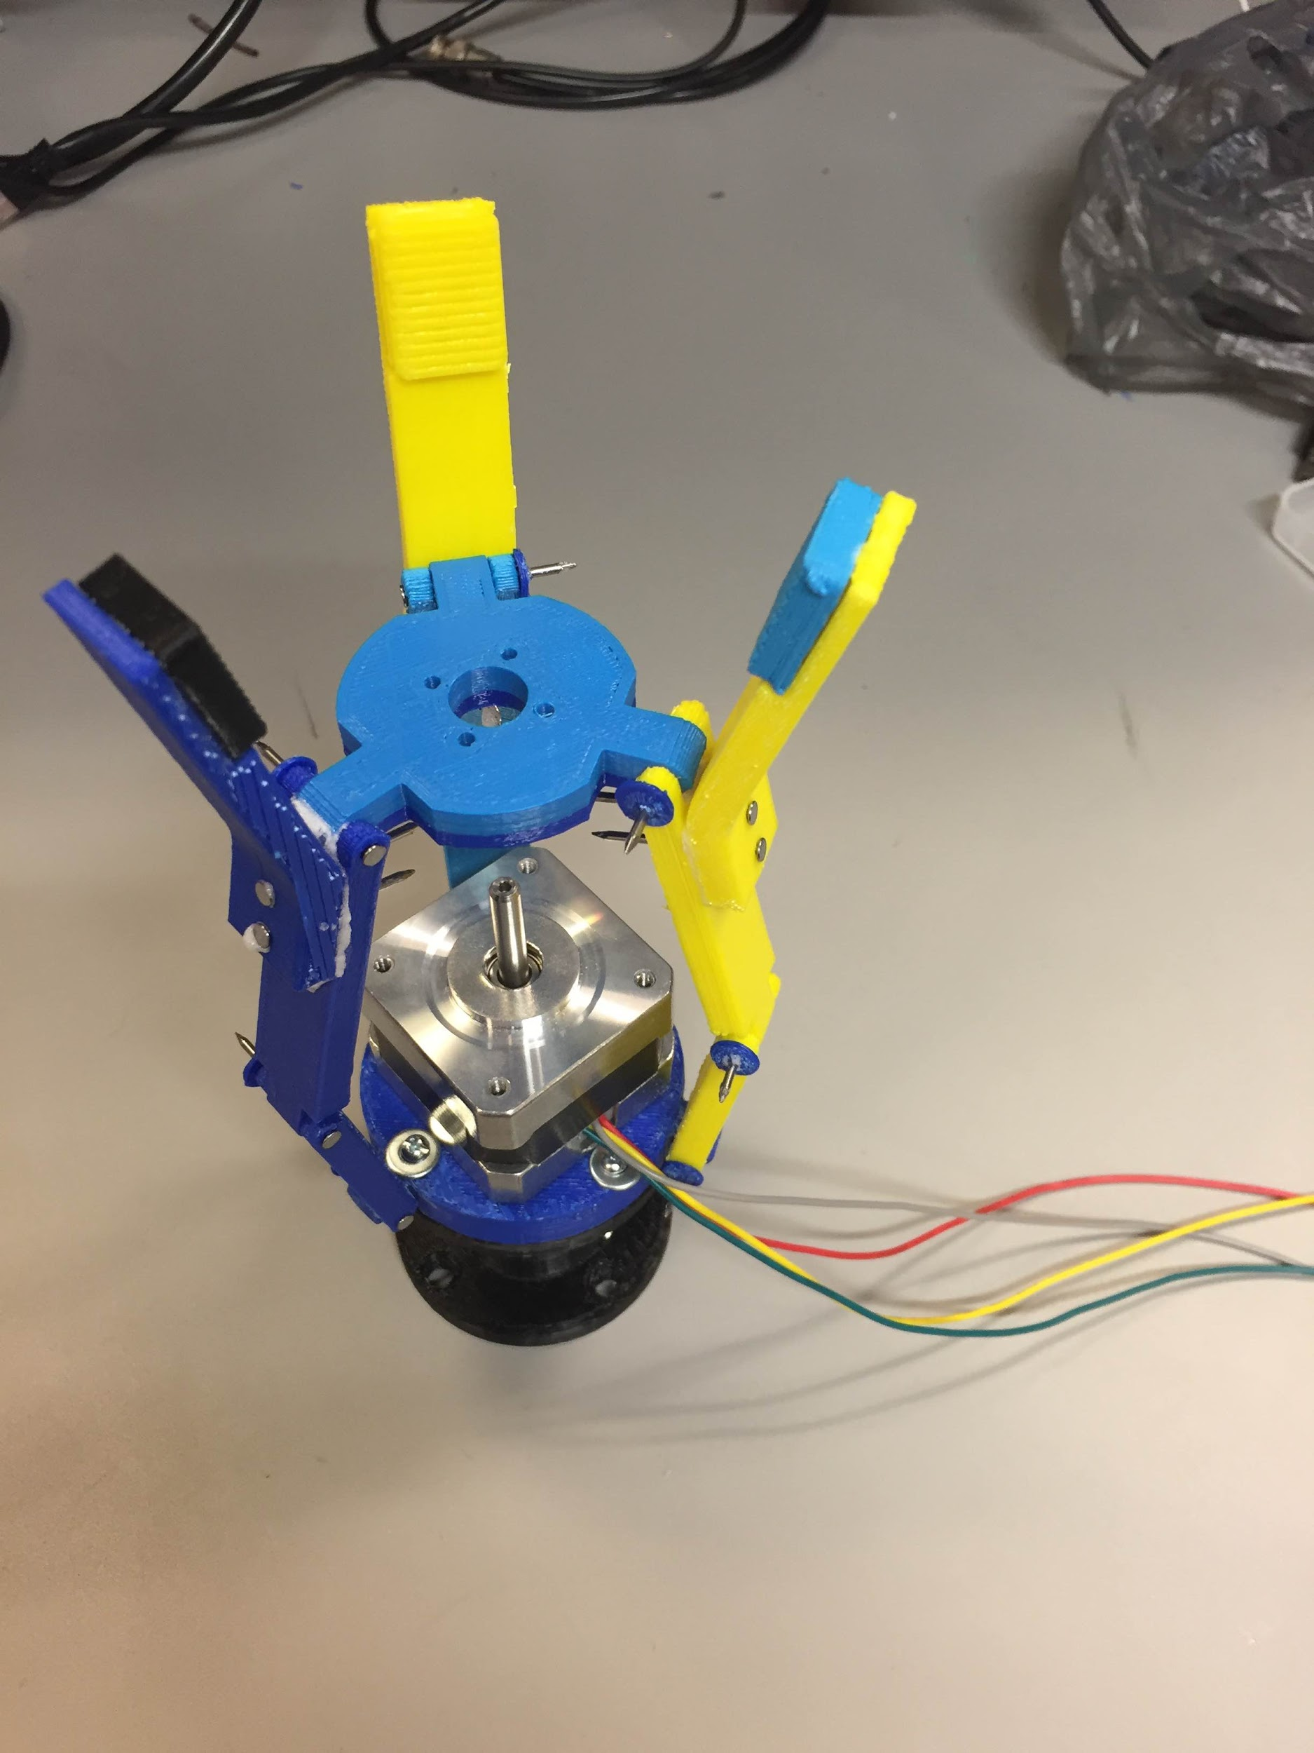

The fingers in open status

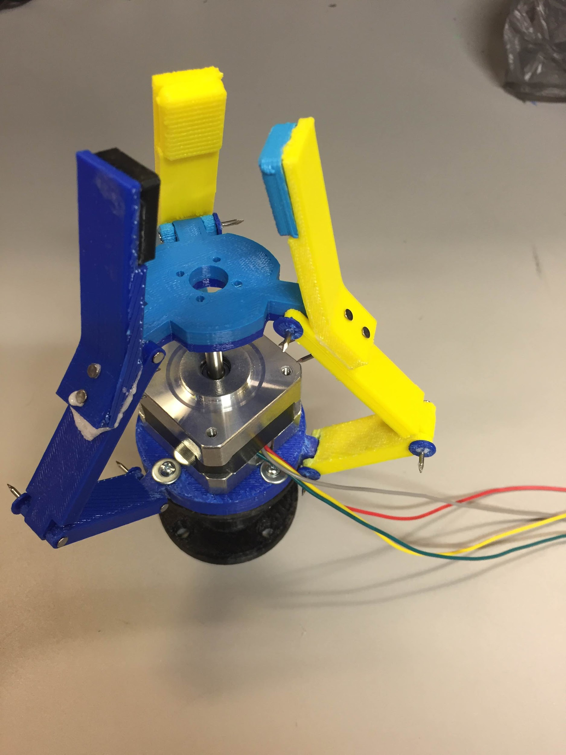

The fingers in close status

*Hand movement control*

Using a stepper motor in the middle part of the structure, a mechanical hand can be built with precision movements. Since a stepper motor can define positions with utilizing multiple toothed electromagnets arranged around a central gear, it can provide a lot of torque at the low end. Control the stepper motor to rotate in clockwise (to grab) or counterclockwise (to release). The stepper motor rotates the middle gear to control the fingers to grab or release.



Hand Control Flowchart

*Stepper Motor Control: Hardware*

EasyDriver is the stepper driver chosen for this part. The driver is connected between the Raspberry 2 and stepper motor as shown in the image below. Between the Pi and the driver board there are power lines (3.3V and GND) and four control lines which are used for stepper motor phases switching). The motor is connected to the driver with four wires.

EasyDriver Board

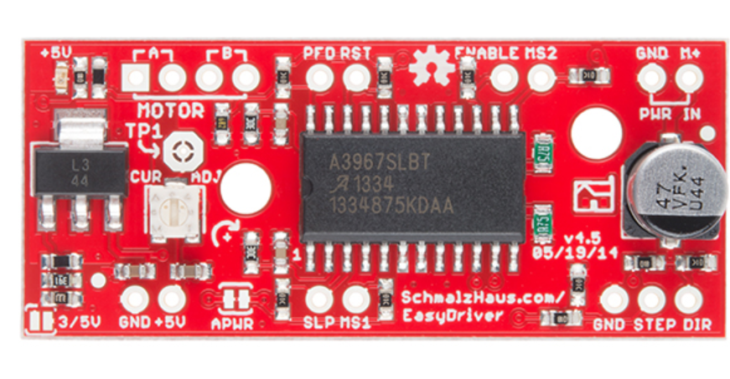

Stepper Motor (XY42STH34 -0354A)

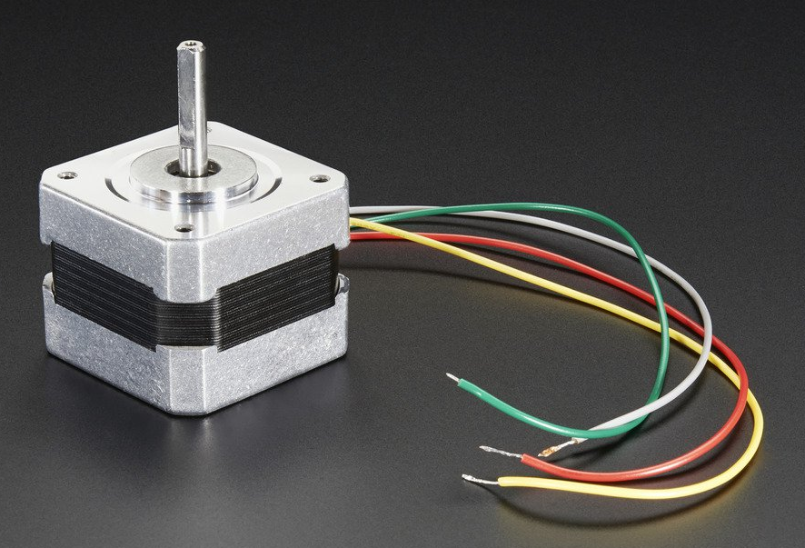

Stepper Motor Connection Diagram

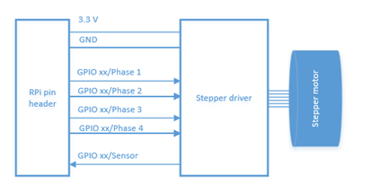

*Stepper Motor Control: Connection*

Motor - Driver: Red and yellow wires are in one loop and connected to loop A on the driver board. Grey and green wires are in one loop and connected to loop B on the driver board.

Driver - RPi: Two GND pins are connected parallelly to the GND pin on Raspberry Pi 2. And M+ pin is connected to the 5V pin on the Raspberry Pi 2. STEP pin is connected to the pin 16 and DIR is connected to the pin 18.

*Force Sensor*

Flexible Force Sensor

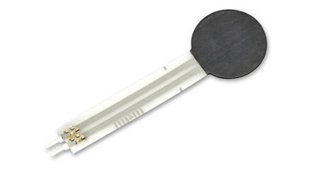

Force sensor characteristic: Resistance vs. Force

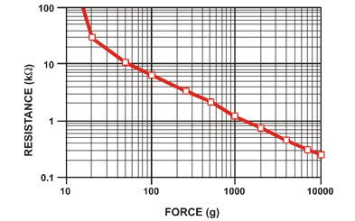

Force Sensor Connection

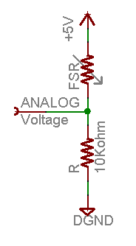

**Appendix F Hand & Myo Armband Subsystem Code**

**Old Version**

*Stepper Motor Control: Software*

*Server side (Raspberry Pi)*

To move the motor shaft, sequence of square wave pulses have to be generated from the GPIO pins on the Pi. The stepper control program is written in Python. The specific code is shown below:

*Code 1* full code on server side

import RPi.GPIO as GPIO, time

GPIO.setmode(GPIO.BOARD)

GPIO.setup(16,GPIO.OUT)

GPIO.setup(18,GPIO.OUT)

p = GPIO.PWM(16,500)

def SpinMotor(direction,num_steps):

GPIO.output(18,direction)

While num_steps > 0:

p.start(1)

time.sleep(0.01)

Num_step -= 1

p.stop()

return True

def getchar(): #return a single character from standard input

import tty, termios, sys

fd = sys.stdin.fileno()

old_settings = terminos.tcgetattr(fd)

try:

tty.setraw(sys.stdin.fileno())

ch = sys.stdin.read(1) # get input from keyboard

finally:

termios.tcsetattr(fd, termios.TCSADRAIN, old_settings)

return ch

print ‘ press q to exit’

while 1:

ch = getchar()

if ch==’a’ or ch==’A’:

SpinMotor(False,270)

elif ch==’d’ or ch==’D’:

SpinMotor(True,270)

elif ch==’q’ or ch==’Q’:

break

else:

print ‘you pressed’, ch

*Client side (Myo)*

Myo triggers specific code to activate and perform specific motion to replace current tool with selected tool. Myo band reads the user’s gestures which are programmed to specific motion. The code is shown below:

*Code 2* client side (Myo SDK Gesture reading)

scriptTitle = "MotorControl"

scriptDetailsUrl = ""

function onPoseEdge(pose,edge)

myo.debug("onPoseEdge:"..pose..","..edge)

if pose == "fist" and edge == "on" then

myo.debug("FIST")

myo.keyboard("a","down")

end

if pose == "fingerSpread" and edge == "on" then

myo.debug("FINGERSPREAD")

myo.keyboard("d","down")

end

end

function onForegroundWindowChange(app,title)

wantActive=false

myo.debug("onForegroundWindowChange:"..app..","..title)

if app == "putty.exe" and title == "pi@raspberrypi: -" then

myo.debug("is putty")

wantActive=true

end

return wantActive

end

function activeAppName()

return "Output Everything"

end

function onActiveChange(isActive)

myo.debug("onActiveChange")

end

###### 

***Code 3*  Client side (Myo SDK Orientation Data reading)**

scriptId = 'outputOrientation'

scriptTitle = "Output Orientation"

scriptDetailsUrl = "" -- We don't have this until it's submitted to the Myo Market

centreYaw = 0

centreRoll = 0

centrePitch = 0

isAct=false

deltaRoll = 0

YAW_DEADZONE = .1

ROLL_DEADZONE = .2

MOUSE_CONTROL_TOGGLE_DURATION = 1000

PI = 3.1416

TWOPI = PI * 2

printCount=0

function onPoseEdge(pose, edge)

myo.debug("onPoseEdge: " .. pose .. ", " .. edge)

end

function split(str, pat)

--myo.debug(str .. "/" .. pat)

local t = {} -- NOTE: use {n = 0} in Lua-5.0

local fpat = "(.-)" .. pat

local last_end = 1

local s, e, cap = str:find(fpat, 1)

myo.debug(s .. " / " .. e .. " / ")

while s do

if s ~= 1 or cap ~= "" then

table.insert(t,cap)

end

last_end = e+1

s, e, cap = str:find(fpat, last_end)

end

if last_end <= #str then

cap = str:sub(last_end)

table.insert(t, cap)

end

return t

end

function centre()

--myo.debug("Centred")

centreYaw = myo.getYaw()

centreRoll = myo.getRoll()

centrePitch = myo.getPitch()

--myo.controlMouse(false);

--myo.vibrate("short")

--myo.keyboard("return", "press")

end

function calculateDeltaRadians(currentYaw, centreYaw)

local deltaYaw = currentYaw - centreYaw

if (deltaYaw > PI) then

deltaYaw = deltaYaw - TWOPI

elseif(deltaYaw < -PI) then

deltaYaw = deltaYaw + TWOPI

end

return deltaYaw

end

function onPeriodic()

--myo.debug("test")

if(isAct) then

if (centreYaw == 0) then

return

end

local currentYaw = myo.getYaw()

local currentRoll = myo.getRoll()

local currentPitch = myo.getPitch()

local deltaYaw = calculateDeltaRadians(currentYaw, centreYaw)

local deltaPitch = calculateDeltaRadians(currentPitch, centrePitch)

if(math.abs(deltaPitch) >0.1 or deltaYaw>0.5 or deltaPitch > 0.5 or deltaYaw<-0.5 or deltaPitch < -0.5 ) then

centre()

end

deltaRoll = calculateDeltaRadians(currentRoll, centreRoll);

--outputKeyboard(math.deg(deltaRoll))

printCount = printCount + 1

if printCount >= 30 then

outputKeyboard(math.deg(deltaRoll))

--x,y,z=

--myo.debug("deltaYaw = " .. deltaYaw .. ", centreYaw = " .. centreYaw .. ", currentYaw = " .. currentYaw)

myo.debug("deltaRoll = " .. math.deg(deltaRoll) .. " currentRoll = " .. math.deg(currentRoll))

printCount = 0

end

--if (deltaYaw < -YAW_DEADZONE) then

-- flyLeft()

--elseif (deltaYaw > YAW_DEADZONE) then

-- flyRight()

--else

-- flyNeutral()

--end

end

end

function outputKeyboard(degree)

--local str4="0"

--local str5="0"

myo.debug(tostring(degree))

strin=tostring(degree)

--stri = string.gmatch(strin,"(.-)\\.")

--myo.debug(stri)

--myo.debug(str)

local count=0

if(string.match(strin,'-')) then

myo.keyboard("minus","press")

strin=string.sub(strin,2,string.len(strin))

end

for s in string.gmatch(strin,'%d') do

if count>=5 then

break

end

if(string.match(string.sub(strin,count+1,count+1),'%.')) then

break

--myo.keyboard("period","press")

end

--myo.debug(s)

myo.keyboard(s,"press")

count=count+1

end

myo.keyboard("return","press")

centre()

end

function onForegroundWindowChange(app, title)

myo.debug("onForegroundWindowChange: " .. app .. ", " .. title)

--if(title=="Untitled - Notepad") then

--=======================================================================

if (title == "pi@raspberrypi: ~/ECEN403") then -- Input putty title here =============================

isAct=true

--myo.keyboard("python")

else

isAct=false

return

end

centre()

return true

end

function activeAppName()

return "Output Everything"

end

function onActiveChange(isActive)

--centre()

myo.debug("onActiveChange")

end

***Code 4*  Communication Integrated (Myo SDK Orientation Data reading) C++ code**

**Client side**

// Copyright (C) 2013-2014 Thalmic Labs Inc.

// Distributed under the Myo SDK license agreement. See LICENSE.txt for details.

#define _USE_MATH_DEFINES

#include <cmath>

#include <iostream>

#include <fstream>

#include <iomanip>

#include <stdexcept>

#include <string>

#include <algorithm>

// The only file that needs to be included to use the Myo C++ SDK is myo.hpp.

#include <myo/myo.hpp>

// Classes that inherit from myo::DeviceListener can be used to receive events from Myo devices. DeviceListener

// provides several virtual functions for handling different kinds of events. If you do not override an event, the

// default behavior is to do nothing.

class DataCollector : public myo::DeviceListener {

public:

DataCollector()

: onArm(false), isUnlocked(false), roll_w(0), pitch_w(0), yaw_w(0), currentPose()

{

}

// onUnpair() is called whenever the Myo is disconnected from Myo Connect by the user.

void onUnpair(myo::Myo* myo, uint64_t timestamp)

{

// We've lost a Myo.

// Let's clean up some leftover state.

roll_w = 0;

pitch_w = 0;

yaw_w = 0;

onArm = false;

isUnlocked = false;

}

// onOrientationData() is called whenever the Myo device provides its current orientation, which is represented

// as a unit quaternion.

void onOrientationData(myo::Myo* myo, uint64_t timestamp, const myo::Quaternion<float>& quat)

{

using std::atan2;

using std::asin;

using std::sqrt;

using std::max;

using std::min;

// Calculate Euler angles (roll, pitch, and yaw) from the unit quaternion.

roll_w = atan2(2.0f * (quat.w() * quat.x() + quat.y() * quat.z()),

1.0f - 2.0f * (quat.x() * quat.x() + quat.y() * quat.y()));

pitch_w = asin(max(-1.0f, min(1.0f, 2.0f * (quat.w() * quat.y() - quat.z() * quat.x()))));

yaw_w = atan2(2.0f * (quat.w() * quat.z() + quat.x() * quat.y()),

1.0f - 2.0f * (quat.y() * quat.y() + quat.z() * quat.z()));

// Convert the floating point angles in radians to a scale from 0 to 18.

/*roll_w = static_cast<int>((roll + (float)M_PI)/(M_PI * 2.0f) * 18);

pitch_w = static_cast<int>((pitch + (float)M_PI/2.0f)/M_PI * 18);

yaw_w = static_cast<int>((yaw + (float)M_PI)/(M_PI * 2.0f) * 18);*/

if (needCentre){

roll_c = atan2(2.0f * (quat.w() * quat.x() + quat.y() * quat.z()),

1.0f - 2.0f * (quat.x() * quat.x() + quat.y() * quat.y()));

pitch_c = asin(max(-1.0f, min(1.0f, 2.0f * (quat.w() * quat.y() - quat.z() * quat.x()))));

yaw_c = atan2(2.0f * (quat.w() * quat.z() + quat.x() * quat.y()),

1.0f - 2.0f * (quat.y() * quat.y() + quat.z() * quat.z()));

needCentre = false;

}

}

// onPose() is called whenever the Myo detects that the person wearing it has changed their pose, for example,

// making a fist, or not making a fist anymore.

void onPose(myo::Myo* myo, uint64_t timestamp, myo::Pose pose)

{

currentPose = pose;

if (pose != myo::Pose::unknown && pose != myo::Pose::rest) {

// Tell the Myo to stay unlocked until told otherwise. We do that here so you can hold the poses without the

// Myo becoming locked.

myo->unlock(myo::Myo::unlockHold);

// Notify the Myo that the pose has resulted in an action, in this case changing

// the text on the screen. The Myo will vibrate.

myo->notifyUserAction();

} else {

// Tell the Myo to stay unlocked only for a short period. This allows the Myo to stay unlocked while poses

// are being performed, but lock after inactivity.

myo->unlock(myo::Myo::unlockTimed);

}

}

// onArmSync() is called whenever Myo has recognized a Sync Gesture after someone has put it on their

// arm. This lets Myo know which arm it's on and which way it's facing.

void onArmSync(myo::Myo* myo, uint64_t timestamp, myo::Arm arm, myo::XDirection xDirection, float rotation,

myo::WarmupState warmupState)

{

onArm = true;

whichArm = arm;

}

// onArmUnsync() is called whenever Myo has detected that it was moved from a stable position on a person's arm after

// it recognized the arm. Typically this happens when someone takes Myo off of their arm, but it can also happen

// when Myo is moved around on the arm.

void onArmUnsync(myo::Myo* myo, uint64_t timestamp)

{

onArm = false;

}

// onUnlock() is called whenever Myo has become unlocked, and will start delivering pose events.

void onUnlock(myo::Myo* myo, uint64_t timestamp)

{

isUnlocked = true;

}

// onLock() is called whenever Myo has become locked. No pose events will be sent until the Myo is unlocked again.

void onLock(myo::Myo* myo, uint64_t timestamp)

{

isUnlocked = false;

}

// There are other virtual functions in DeviceListener that we could override here, like onAccelerometerData().

// For this example, the functions overridden above are sufficient.

// We define this function to print the current values that were updated by the on...() functions above.

void print()

{

// Clear the current line

std::cout << '\r';

// Print out the orientation. Orientation data is always available, even if no arm is currently recognized.

// std::cout << '[' << std::string(roll_w, '*') << std::string(18 - roll_w, ' ') << ']'

// << '[' << std::string(pitch_w, '*') << std::string(18 - pitch_w, ' ') << ']'

// << '[' << std::string(yaw_w, '*') << std::string(18 - yaw_w, ' ') << ']';

if (onArm) {

// Print out the lock state, the currently recognized pose, and which arm Myo is being worn on.

// Pose::toString() provides the human-readable name of a pose. We can also output a Pose directly to an

// output stream (e.g. std::cout << currentPose;). In this case we want to get the pose name's length so

// that we can fill the rest of the field with spaces below, so we obtain it as a string using toString().

std::string poseString = currentPose.toString();

std::cout << '[' << (isUnlocked ? "unlocked" : "locked ") << ']'

<< '[' << (whichArm == myo::armLeft ? "L" : "R") << ']'

<< '[' << poseString << std::string(14 - poseString.size(), ' ') << ']';

} else {

// Print out a placeholder for the arm and pose when Myo doesn't currently know which arm it's on.

std::cout << '[' << std::string(8, ' ') << ']' << "[?]" << '[' << std::string(14, ' ') << ']';

}

std::cout << std::flush;

}

void mainCycle(){ ///main cycle revision

if (currentPose != prevPose){

if (currentPose == myo::Pose::fist){

printToFile(998.0);

std::cout << "a" << std::endl;

}else if (currentPose == myo::Pose::fingersSpread){

printToFile(999.0);

std::cout << "d" << std::endl;

}

prevPose = currentPose;

return;

}

float deltaYaw=calculateDelta(yaw_w,yaw_c);

float deltaPitch = calculateDelta(pitch_w, pitch_c);

float deltaRoll = calculateDelta(roll_w, roll_c);

if (abs(deltaRoll)>0.1 || abs(deltaPitch)>0.5 || abs(deltaYaw)>0.5){

centre();

}

printToFile(deltaRoll*57.3);

// std::cout << deltaRoll << "|" << deltaPitch << "|" << deltaYaw << "|" << std::endl;

// std::cout << roll_w << "|" << pitch_w << "|" << yaw_w << "|" << std::endl;

}

void printToFile(float input){

std:: cout << input << std::endl; //added to gather latency

outF.open("example.txt");

outF << input << std::endl;

outF.close();

// _sleep(100); //added to gather latency

}

void printToFile(std::string input){

outF.open("example.txt");

outF << input << std::endl;

outF.close();

// _sleep(1000);

}

void centre(){

// std::cout << "CENTRED" << std::endl;

needCentre = true;

}

float calculateDelta(float current, float centre){

float delta = current - centre;

if (delta > M_PI){

delta -= M_PI*2;

}

else if (delta < -M_PI){

delta += M_PI * 2;

}

return delta;

}

// These values are set by onArmSync() and onArmUnsync() above.

bool onArm;

myo::Arm whichArm;

// This is set by onUnlocked() and onLocked() above.

bool isUnlocked;

// These values are set by onOrientationData() and onPose() above.

float roll_w, pitch_w, yaw_w;

myo::Pose currentPose;

myo::Pose prevPose;

bool needCentre = false;

std::ofstream outF;

//Use for centre

float roll_c, pitch_c, yaw_c;

};

int main(int argc, char** argv)

{

// We catch any exceptions that might occur below -- see the catch statement for more details.

try {

// First, we create a Hub with our application identifier. Be sure not to use the com.example namespace when

// publishing your application. The Hub provides access to one or more Myos.

myo::Hub hub("com.example.hello-myo");

std::cout << "Attempting to find a Myo..." << std::endl;

// Next, we attempt to find a Myo to use. If a Myo is already paired in Myo Connect, this will return that Myo

// immediately.

// waitForMyo() takes a timeout value in milliseconds. In this case we will try to find a Myo for 10 seconds, and

// if that fails, the function will return a null pointer.

myo::Myo* myo = hub.waitForMyo(10000);

// If waitForMyo() returned a null pointer, we failed to find a Myo, so exit with an error message.

if (!myo) {

throw std::runtime_error("Unable to find a Myo!");

}

// We've found a Myo.

std::cout << "Connected to a Myo armband!" << std::endl << std::endl;

// Next we construct an instance of our DeviceListener, so that we can register it with the Hub.

DataCollector collector;

// Hub::addListener() takes the address of any object whose class inherits from DeviceListener, and will cause

// Hub::run() to send events to all registered device listeners.

hub.addListener(&collector);

collector.centre();

// Finally we enter our main loop.

while (1) {

// In each iteration of our main loop, we run the Myo event loop for a set number of milliseconds.

// In this case, we wish to update our display 20 times a second, so we run for 1000/20 milliseconds.

hub.run(1000/20);

// After processing events, we call the print() member function we defined above to print out the values we've

// obtained from any events that have occurred.

//collector.print();

collector.mainCycle();

}

// If a standard exception occurred, we print out its message and exit.

} catch (const std::exception& e) {

std::cerr << "Error: " << e.what() << std::endl;

std::cerr << "Press enter to continue.";

std::cin.ignore();

return 1;

}

}